Arab American University
Faculty of Graduate Studies

A Fused Multi-Channel Prediction Model of Pressure Injury for Adult Hospitalized Patients to Enhance the Quality of Nursing Care and Patient Safety
By
Eba'a Abdulraziq Mustafa Da'san
Supervisor
Dr. Amani Yousef Owda
Co- Supervisor
Prof. Mohammad Asia

This thesis was submitted in partial fulfillment of the requirements for the Doctoral degree in Nursing
May /2024

© Arab American University –2024. All rights reserved.
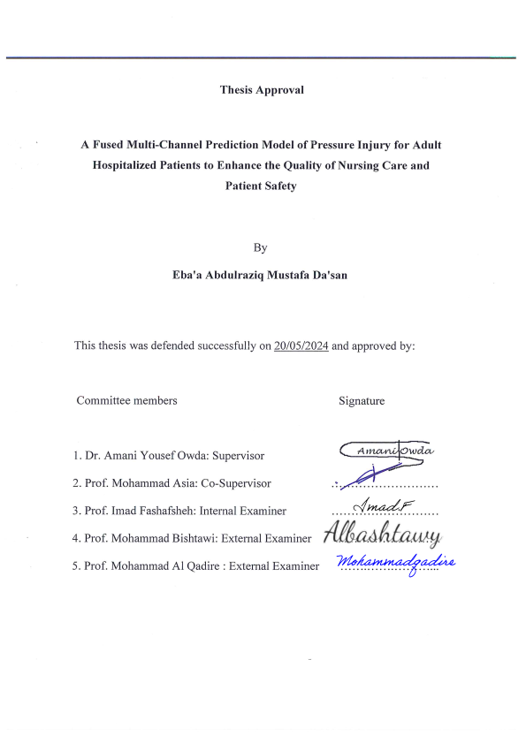

Declaration
I certify that this dissertation submitted for the PhD degree is the result of my research, except when otherwise acknowledged, and that this dissertation has not been submitted to any other university or institution for a higher degree.

The Name of The Student: Eba’a Abdulraziq Mustafa Da’san
ID: 202012736
Signature:
Date: 21/07/2024

Dedication

The sake of Allah.
My great teacher, Mohammed Prophet.
My homeland Palestine.
The great martyrs and prisoners are the symbols of sacrifice.
My great parents who never stop sacrificing themselves in countless ways.
My beloved brothers and sisters.
My dearest wife, who leads me with the light of hope and support.
My beloved kids, Majdoleen, Dareen, Majd, and Toleen, for whom I made this progression.
To all my family, the symbol of love and giving.

I dedicate this dissertation.

Acknowledgment
I would first like to thank my dissertation advisors, Dr. Amani Owda and Prof. Mohammad Asia; their offices, mobiles, and emails were always open whenever I had a question about my research or writing. They steered me in the right direction whenever they thought I needed it.

I would also like to acknowledge Dr. Majdi Owda, Dean of the Data Science Faculty, for his support and guidance.

I would also like to thank the Arab Hospitals Group, which allowed me to collect data for this study: without their permission, the study could not have been successfully conducted.

I would also like to acknowledge Dr. Atef Al-Rimawi, my boss at the Istishari Arab Hospital, for his continuous support and encouragement. Also, thank my colleagues Mr. Ibrahim Mahareeq and Mr. Saleh Abbas from the IT Department at Istishari Arab Hospital for their efforts in data collection and support.

Finally, I must express my profound gratitude to my wife and parents for providing unfailing support and encouragement throughout my study and through researching and writing this dissertation. This achievement would not have been possible without them.

Thank you
Eba’a Abdulraziq Da’san

Abstract
Background: Pressure injuries (PI) are increasing worldwide, and there has been no significant improvement in preventing it. Traditional risk assessment tools are widely used to identify a patient at risk of developing a PI. However, these tools fail to identify valuable risk factors. This study aims to construct a fused multi-channel prediction model of PIs in adult hospitalized patients using machine learning algorithms (MLA).
Methods: A multi-phase quantitative approach involves case-control and experimental designs was used to construct a fused multi-channel prediction model of pressure injuries using MLA. The dataset was collected retrospectively between March / 2022 and August / 2023 from the electronic medical records of three private hospitals in Palestine for patients admitted to the hospitals without pressure injuries on the admission day and screened by the Braden scale. The total number of patients 49,500. A balanced dataset was utilized with a total number of 1,110 patients (80% training and 20% testing). Four models were developed and each model recruited eight MLA have been trained and validated with 5-fold cross-validation technique. Performance metrics were used to evaluate the models, and the best model was selected.
Results: The balance dataset consists of 1110 patients, including all hospital-acquired pressure injury (HAPI) patients (555 patients) and a random sample of patients without hospital-acquired pressure injury (non-HAPI) patients (555 patients). The performance metrics among the four models showed excellent performance. The best model was random forest, in which accuracy was 0.962, precision was 0.942, the recall was 0.922, F1 was 0.931, area under curve (AUC) was 0.922, false positive rate (FPR) was 0.155, and true positive rate (TPR) was 0.782. Finally, the predictive factors were age, moisture, activity, length of stay (LOS), systolic blood pressure (Systolic BP), and albumin.
Conclusion: A novel fused multi-channel prediction models of pressure injury were developed from different datasets, which helps the nurses identify the patients who have the risk of pressure injury earlier, improve the patient satisfaction that affects the quality of nursing care, and promotes patient safety. Furthermore, this study found that some of the predictive factors in the developed model for predicting pressure injuries were not included in the traditional tools, such as age, LOS, Systolic BP, and albumin.

Keywords: Pressure injury, prediction model, nursing care, machine learning, patient safety, quality of care.

Table of Contents
Declaration II
Dedication III
Acknowledgment IV
Abstract V
List of Tables XIII
List of Figures XV
List of Abbreviations and Symbols XX
CHAPTER ONE 1
INTRODUCTION & BACKGROUND 1
1.1 Introduction 1
1.2 Problem Statement and Contribution to the Knowledge 5
1.3 Research Purpose 6
1.4 Specific Aims 7
1.5 Research Goal and Objectives: 7
1.6 Research Question: 8
1.7 Conceptual Framework 8
1.7.1 Conceptual/Theoretical Definitions 11
1.7.2 Operational Definitions 11
1.7.2.1 Independent Variables: 11
1.7.2.2 Dependent Variables: 12
1.8 Summary 12
CHAPTER TWO 14
LITERATURE REVIEW 14
2.1 Introduction 14
2.2 Search Strategies 14
2.3 Search Result 15
2.4 Impact of Nursing Care on Pressure Injury 18
2.5 Pressure Injury 20
2.6 Pressure Injury Risk Factors 21
2.7 Biomarkers of Pressure Injury 23
2.8 Machine Learning in Healthcare 24
2.9 Prediction Models of Pressure Injury 28
2.10 Literature Matrix of Prediction Models of Pressure Injury 46
2.11 Literature Gap 51
2.12 Summary 51
CHAPTER THREE 52
METHODOLOGY 52
3.1 Introduction 52
3.2 Research Methodology and Study Design 53
3.3 Settings 54
3.4 Subjects / Entry Criteria and Recruitment 55
3.5 Study Population and Sample Size 55
3.5 Ethical Considerations and Approval 56
3.6 Data Collection 57
3.7 Data Processing 58
3.8 Features Engineering 60
3.9 Constructing Models by Using Machine Learning Algorithms 61
3.10 Machine Learning Algorithms Used in the Prediction Models 63
3.10.1 Linear Regression 63
3.10.2 Support Vector Regression 63
3.10.3 Logistic Regression 65
3.10.4 Decision Tree 65
3.10.5 Random Forest 65
3.10.6 K-Nearest Neighbors 66
3.10.7 Gradient Boosting 66
3.10.8 Extreme Gradient Boosting 67
3.11 Analysis 67
3.12 Summary 69
CHAPTER FOUR 70
EXPLORATORY DATA ANALYSIS AND MODELING 70
4.1 Introduction 70
4.2 Dataset 70
4.3 Risk Factors 71
4.3.1 Age 73
4.3.2 Gender 74
4.3.3 Length of Stay 75
4.3.4 Department Type 76
4.3.5 Diagnosis 78
4.3.6 Operation 79
4.3.7 Anesthesia 79
4.3.8 Vital Signs 80
4.3.9 Braden Scale 83
4.3.10 Braden Subscales 84
4.3.11 Mechanical Ventilator 88
4.3.12 Medications 89
4.4 Biomarkers (Laboratory Tests) 90
4.5 Pressure Injury 95
4.5.1 Pressure Injury Type 95
4.5.2 Pressure Injury Grade 98
4.5.3 Incidence Rate of Pressure Injury 101
4.6 Correlations with Pressure Injury 105
4.6.1 Correlation of Pressure Injury with Risk Factors 105
4.6.2 Correlation of Pressure Injury with Biomarkers (Laboratory Tests) 111
4.7 Statistical Tests 112
4.7.1 Statistical Test of Pressure Injury with Biomarkers (Laboratory Tests) 113
4.7.2 Statistical Test of Pressure Injury with Risk Factors 114
4.8 Model Developments Methodology 120
4.9 Prediction Models of Pressure Injury 123
4.9.1 Model - Potential Factors That Had High Correlation with Pressure Injury 124
4.9.2 Model - Potential Factors with Significant Statistical Test with Pressure Injury 133
4.9.3 Model - Potential Factors with Features Importance Related to Pressure Injury 142
4.9.4 Model - Potential Factors with High Correlation without Braden Scale Level 151
4.10 Summary 160
CHAPTER FIVE 161
DISCUSSION OF FINDINGS & CONCLUSION 161
5.1 Introduction 161
5.2 Summary of Findings 161
5.3 Results Comparison with Previous Studies 162
5.3.1 The Predictive Risk Factors with Pressure Injury 162
5.3.2 The Predictive Biomarkers with Pressure Injury 165
5.5 Interpretation of Results - Models Comparison and Model Selection 166
5.6 Nursing Implications: 171
5.7 Recommendations 172
5.8 Further Studies 174
5.9 Limitations and Strengths of the Study 175
5.10 Summary 175
REFERENCES 177
Appendices 213
Appendix (1): Letter from AAUP to Arab Hospitals Group 213
Appendix (2): Research Ethical Approval from Arab Hospitals Group 214
Appendix (3): IRB Approval from AAUP 215
الملخص 216

List of Tables
Table 2. 1: Characteristics of the Studies - Detail of the Methodology 47
Table 2. 2: Potential Predictive Risk Factors 48
Table 2. 3: Results of the Predictive Model Studies 50
Table 4.1: Distribution of Potential Risk Factors According to Pressure Injury Status…………………………………………………………………………………....72
Table 4.2: Average of Laboratory Test Results with Interpretation of Results 93
Table 4.3: Sensitivity and Specificity for Laboratory Tests with Pressure Injury 95
Table 4.4: Laboratory Results According to Pressure Injury Status (T. Test) 113
Table 4.5: Risk Factors (Age and LOS) According to Pressure Injury (ANOVA) 114
Table 4.6: Risk Factors (Age and LOS) According to Pressure Injury (ANOVA) 114
Table 4.7: Risk Factors (Vital Signs) According to Pressure Injury (ANOVA) 115
Table 4.8: Risk Factors (Anesthesia Related) According to Pressure Injury (ANOVA) 115
Table 4.9: Risk Factors (Operation Duration) According to Pressure Injury (ANOVA) 116
Table 4.10: Risk Factors (Braden Score and Braden Subscales) According to Pressure Injury (ANOVA) 116
Table 4.11: Risk Factors (Pressure Injury Grade) According to Pressure Injury (ANOVA) 117
Table 4.12: Crosstabulation of Gender and Pressure Injury 117
Table 4.13: Crosstabulation of Department Type and Pressure Injury 117
Table 4.14: Crosstabulation of Performed Operation and Pressure Injury 118
Table 4.15: Crosstabulation of Braden Scale and Pressure Injury 118
Table 4.16: Crosstabulation of Mechanical Ventilators and Pressure Injury 118
Table 4.17: Crosstabulation of Accreditation Status and Pressure Injury 119
Table 4.18: Crosstabulation of Pressure Injury Type and Pressure Injury 119
Table 4.19: Crosstabulation of Medication and Pressure Injury 119
Table 4.20: Risk Factors Distribution into Training and Testing Dataset……..…………………………………………………………………….……122
Table 4.21: Comparison of Performance Metrics of ML Algorithms – Model (A) 127
Table 4.22: Comparison of Performance Metrics of ML Algorithms – Model (B) 136
Table 4.23: Comparison of Performance Metrics of ML Algorithms – Model (C) 145
Table 4.24: Comparison of Performance Metrics of ML Algorithms – Model (D) 154
Table 5.1: Performance Metrics for Developed Models 168

List of Figures
Figure 1.1: Pressure Injury and Stages, Healthwise Staff 1
Figure 1.2: Conceptual Framework of the Study. 10
Figure 1.3: Dissertation Structure Diagram 13
Figure 2.1: PRISMA for systematic review. 17
Figure 3.1: Methodology Structure Diagram 52
Figure 3.2: Method of Construction Prediction Models 64
Figure 3.3: Confusion Matrix and Equations 69
Figure 4.1: Patient Distribution According to Hospital 71
Figure 4.2: Patient Distribution According to Age Across Hospitals 73
Figure 4.3: Patient Distribution According to Age Category 74
Figure 4.4: Distribution of Patients According to Gender Across Hospitals 74
Figure 4.5: No. of Patients According to Gender Per Hospital 75
Figure 4.6: Comparison of Length of Stay by Hospital 75
Figure 4.7: Length of Stay by Hospital Across Hospitals 76
Figure 4.8: No. of Patients According to Hospital Per Department Categories 77
Figure 4.9: Percentage of Patients Per Hospital Per Department Categories 77
Figure 4.10: Top Ten Diagnosis Across Hospitals 78
Figure 4.11: No. of Patients Performed Operations Across Hospitals 79
Figure 4.12: No. of Patients Per Anesthesia Type Across Hospitals 80
Figure 4.13: BP Systolic Distribution Across Hospitals 81
Figure 4.14: BP Diastolic Distribution Across Hospitals 81
Figure 4.15: Temperature Distribution Across Hospitals 82
Figure 4.16: Pulse Distribution Across Hospitals 83
Figure 4.17: No. of Patients Per Braden Scale Level Across Hospitals 84
Figure 4.18: No. of Patients Per Hospital Per Braden Scale Level 84
Figure 4.19: No. of Patients Per Braden Subscale Preception Per Hospital 85
Figure 4.20: No. of Patients Per Braden Subscale Moisture Per Hospital 86
Figure 4.21: No. of Patients Per Braden Subscale Activity Per Hospital 86
Figure 4.22: No. of Patients Per Braden Subscale Mobility Per Hospital 87
Figure 4.23: No. of Patients Per Braden Subscale Nutrition Per Hospital 87
Figure 4.24: No. of Patients Per Braden Subscale Friction Per Hospital 88
Figure 4.25: No. of Patients on M.V Per Hospitals 88
Figure 4.26 Distribution of Medications Across Hospitals 89
Figure 4.27: Top Ten Medications Across Hospitals 90
Figure 4.28: No. of Laboratory Tests Requested 91
Figure 4.29: Percentage of Laboratory Tests Requested Across Hospitals 91
Figure 4.30 No. of Laboratory Tests Requested Per Hospital 92
Figure 4.31: Laboratory Tests Results Across Hospitals 94
Figure 4.32: Percentage of Pressure Injury Status Across Hospitals 96
Figure 4.33: No. of Pressure Injury Status Per Hospital. 96
Figure 4.34: Percentage of HAPI For NX Hospital 97
Figure 4.35: Percentage of HAPI For RX Hospital 97
Figure 4.36: Percentage of HAPI For JX Hospital 98
Figure 4.37: Percentage of HAPI Grade Across Hospitals 98
Figure 4.38: No. of Patients Per Pressure Injury Grade Per Hospital 99
Figure 4.39: Percentage of HAPI Grade One Across Hospitals 100
Figure 4.40: Percentage of HAPI Grade Two Across Hospitals 100
Figure 4.41: Percentage of HAPI Grade Three Across Hospitals 101
Figure 4.42: Incidence Rate of HAPI Across Hospitals 102
Figure 4.43: Incidence Rate of HAPI Per Gender Per Hospital 102
Figure 4.44: Incidence Rate of HAPI Per Department Type Per Hospital 103
Figure 4.45: Incidence Rate of HAPI for Performed Operations Per Hospital 104
Figure 4.46: Incidence Rate of HAPI for Patients on M.V Per Hospital 104
Figure 4.47: Incidence Rate of HAPI Per Accreditation Status 105
Figure 4.48: Heat map Correlation for Numeric Variables 107
Figure 4.49: Cramer’s V Correlation for Categorical Variables with Laboratory 108
Figure 4.50: Cramer’s V Correlation for Categorical Variables with Medications 110
Figure 4.51: Correlation Between Pressure Injury and Lab Results 111
Figure 4.52: Model Results Extraction Methodology 121
Figure 4.53: Comparison Between ML Algorithms: Accuracy – Model (A) 128
Figure 4.54: Comparison Between ML Algorithms: Precision – Model (A) 128
Figure 4.55: Comparison Between ML Algorithms: Recall – Model (A) 129
Figure 4.56: Comparison Between ML Algorithms: F1 Score – Model (A) 129
Figure 4.57: Comparison Between ML Algorithms: AUC – Model (A) 130
Figure 4.58: Comparison Between ML Algorithms: FPR – Model (A) 130
Figure 4.59: Comparison Between ML Algorithms: TPR – Model (A) 131
Figure 4.60: Comparison Between ML Algorithms – Model (A) 131
Figure 4.61: ML Algorithms for Model (A) - ROC Curves 132
Figure 4.62: Comparison Between ML Algorithms: Accuracy – Model (B) 137
Figure 4.63: Comparison Between ML Algorithms: Precision – Model (B) 137
Figure 4.64: Comparison Between ML Algorithms: Recall – Model (B) 138
Figure 4.65: Comparison Between ML Algorithms: F1 Score – Model (B) 138
Figure 4.66: Comparison Between ML Algorithms: AUC – Model (B) 139
Figure 4.67: Comparison Between ML Algorithms: FPR – Model (B) 139
Figure 4.68: Comparison Between ML Algorithms: TPR – Model (B) 140
Figure 4.69: Comparison Between ML Algorithms – Model (B) 140
Figure 4.70: ML Algorithms for Model (B) - ROC Curves 141
Figure 4.71: Comparison Between ML Algorithms: Accuracy – Model (C) 146
Figure 4.72: Comparison Between ML Algorithms: Precision – Model (C) 146
Figure 4.73: Comparison Between ML Algorithms: Recall – Model (C) 147
Figure 4.74: Comparison Between ML Algorithms: F1 Score – Model (C) 147
Figure 4.75: Comparison Between ML Algorithms: AUC – Model (C) 148
Figure 4.76: Comparison Between ML Algorithms: FPR – Model (C) 148
Figure 4.77: Comparison Between ML Algorithms: TPR – Model (C) 149
Figure 4.78: Comparison Between ML Algorithms – Model (C) 149
Figure 4.79: ML Algorithms for Model (C) - ROC Curves 150
Figure 4.80: Comparison Between ML Algorithms: Accuracy – Model (D) 155
Figure 4.81: Comparison Between ML Algorithms: Precision – Model (D) 155
Figure 4.82: Comparison Between ML Algorithms: Recall – Model (D) 156
Figure 4.83: Comparison Between ML Algorithms: F1 Score – Model (D) 156
Figure 4.84: Comparison Between ML Algorithms: AUC – Model (D) 157
Figure 4.85: Comparison Between ML Algorithms: FPR – Model (D) 157
Figure 4.86: Comparison Between ML Algorithms: TPR – Model (D) 158
Figure 4.87: Comparison Between ML Algorithms – Model (D) 158
Figure 4.88: ML Algorithms for Model (D) - ROC Curves 159
Figure 5.1: Comparison of Models Performance Metrics 167

List of Abbreviations and Symbols
No. | Abbreviation | Meaning
 | AAUP | Arab American University of Palestine
 | ACL | Anterior Cruciate Ligament
 | AI | Artificial Intelligence
 | Alb | Albumin
 | ANOVA | Analysis of Variance
 | APACHE II | Acute Physiology and Chronic Health Evaluation
 | ASA | American Society of Anesthesiologists
 | ASF | Advanced Systems Format
 | AST | Aspartate Aminotransferase
 | AUC | Area Under Curve
 | AUROC | Area Under the Receiver Operating Curve
 | BART | Bayesian Additive Regression Trees
 | BI | Business Intelligence
 | BMI | Body Mass Index
 | BN | Bayesian Network
 | Bp | Blood Pressure
 | BUN | Blood Urea Nitrogen
 | CAUTI | Catheter-Associated Urinary Tract Infections
 | CCU | Cardiac Care Unit
 | CHF | Congestive Heart Failure
 | CINAHIL | Cumulative Index to Nursing and Allied Health Literature
 | CK | Creatine Kinase
 | CLABSI | Central Line-Associated Blood Stream Infections
 | COVID | Coronavirus Disease
 | CRP | C-Reactive Protein
 | D | Direct
 | DALY | Disability-Adjusted Life Years
 | DM | Diabetes Mellitus
 | DT | Decision Tree
 | DV | Dependent Variables
 | EBM | Explainable Boosting Machine
 | EMBASE | Excerpta Medica Database
 | et al. | And Others
 | ETT | Endotracheal Tube
 | F1 score | F1 Score (a measure of a test's accuracy)
 | FABP4 | Fatty Acid-Binding Protein
 | FBS | Fasting Blood Sugar
 | GB | Gradient Boosting
 | GBM | Gradient Boosting Machine
 | GCS | Glasgow Coma Scale
 | Glu | Glucose
 | GM-CSF | Granulocyte-Macrophage Colony-Stimulating Factor
 | HA1c | Hemoglobin A1c
 | HAPI | Hospital-Acquired Pressure Injuries
 | Hb | Hemoglobin
 | HCT | Hematocrit
 | H-FAB | Heart-Type Fatty Acid Binding Protein
 | HIS | Hospital Information System
 | HTN | Hypertension
 | ICU | Intensive Care Unit
 | ID | Identification
 | IEEE | Institute of Electrical and Electronics Engineers
 | IFN- a | Interferons – Alpha
 | IL-15 | Interleukin-15
 | IL-1a | Interleukin-1 Alpha
 | IMAT | Intramuscular Adipose Tissue
 | IRB | Institutional Review Board
 | IT | Information Technology
 | IV | Independent Variables
 | JCIA | Joint Commission International Accreditation
 | KNN | K-Nearest Neighbors
 | KPI | Key Performance Indicators
 | LOS | Length of Stay
 | LR | Logistic Regression
 | MAP | Mean Arterial Pressure
 | Mb | Myoglobin
 | MISSCARE | Missed Nursing Care
 | ML | Machine Learning
 | MLA | Machine Learning Algorithms
 | MLP | Multi-Layer Perceptron
 | MRI | Magnetic Reasoning Image
 | MSE | Mean Squad Error
 | NB | Naive Bayes
 | NN | Neural Network
 | No. | Number
 | NPV | Negative Predictive Value
 | NR | Not Reported
 | NSTEMI | Non-ST Segment Elevation Myocardial Infarction
 | OP | Operation
 | P-Value | P value
 | PI | Pressure Injury
 | PLT | Platelets
 | PPV | Positive Predictive Value
 | PRISMA | Preferred Reporting Items for Systematic Review & Meta-Analyses
 | R2 | Coefficient of Determinants
 | RDW | Red Cell Distribution Width
 | RF | Random Forest
 | ROC | Receiver Operator Characteristics
 | SAPS | Simplified Acute Physiology Score
 | SAS | Statistical Analysis System
 | SCI | Spinal Cord Injury
 | SD | Standard Deviation
 | SE | Standard Error
 | SEM | Sub-Epidermal Moisture
 | SGOT | Serum Glutamic Oxaloacetic Transaminase
 | SPSS | Statistical Package for the Social Science
 | SQL | Structured Query Language
 | SVR | Support Vector Regression
 | SVM | Support Vector Machine
 | T | Total
 | T. Test | Student’s T. Test
 | TNF- a | Tumor Necrosis Factor Receptor - Alpha
 | TPR | True Positive Rate
 | UAE | United Arab of Emirates
 | UK | United Kingdom
 | USA | United States of America
 | USD | United States Dollar
 | Cramér's V | Statistical Value
 | V Correlation | Validity Correlation
 | VAP | Ventilator-Associated Pneumonia
 | VIP | Variable Importance in Projection
 | VSA | Visual Skin Assessment
 | WBC | White Blood Cells
 | WHO | World Health Organization
 | XGBoost | eXtreme Gradient Boosting
 | YLD | Years Living with The Disease
 | χ2 | Chi-Square Test
List of Symbols
 | € | Euro
 | α | Alpha

CHAPTER ONE

INTRODUCTION & BACKGROUND

1.1 Introduction
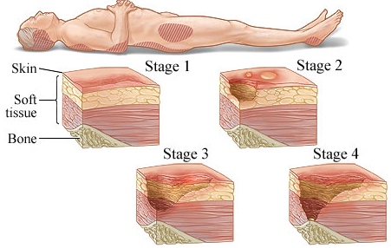
A pressure injury is defined as "localized damage to the skin and underlying tissue caused by pressure or pressure combined with shear and friction, generally over a bony prominence.” (Hoogendoorn et al., 2017). It is also known as a pressure ulcer, decubitus ulcer, or bedsore. It can range from skin erythema to injured muscle and underlying bone, depending on the impacted tissue layer’s size and degree (Hoogendoorn et al., 2017), as shown in Figure (1.1).
Figure 1.1: Pressure Injury and Stages, Healthwise Staff
Grades of pressure injuries assist in identifying the severity of harm or the area that affect by the pressure injury and are classified into four main grades: grade I, the pressure injury affects the tissue perfusion or circulatory or skin erythema; grade II, the pressure injury affects the thickness of the tissue and causes loss of dermis; grade III the necrosis to the tissue or loss of the deep layer of tissue; and grade IV the pressure injury affects the full thickness of the tissue, destroys the tissue layer and subcutaneous fat becomes visible (Barghouthi et al., 2023).
Prolonged pressure causes changes in body position in people with normal movement and sensory feedback to prevent injury. On the other hand, persistent pressure can cause tissue ischemia, damage, and necrosis when this feedback mechanism is compromised, which can result in pressure injuries. These injuries usually begin when the pressure from the body weight presses against the skin covering bony parts, or when pressure from medical devices exceeds the threshold required for venous and arterial blood flow, causing local tissue hypoxia. Furthermore, reperfusion injury, which results from the resumption of blood flow following ischemia, can worsen injury by inducing oxidative stress and inflammation, especially after repeated cycles of ischemia-reperfusion, which are more harmful than continuous ischemia (Mervis & Phillips, 2019).
Due to the increased metabolic demands of muscles, this damage frequently advances deeper before impacting the skin, so early symptoms are generally a warning of a more serious underlying damage. The failure in the local circulation lying at an angle causes friction and shear, which exacerbates hypoxia. Furthermore, sweat or incontinence-related wetness increases the vulnerability of the skin to harm during repositioning, hence elevating the risk of pressure injuries (Bain, et al., 2020).
Pressure injury causes a significant issue in providing healthcare and maintaining patient safety, with a global prevalence of 12.8% and hospital-acquired pressure injuries (HAPI) of 8.4% (Siotos et al., 2022). Moreover, 2.5 million patients in the United States of America (USA) develop pressure injuries annually in acute care settings (Padula & Delarmente, 2019).
Pressure injuries impact patients' quality of life, morbidity, and mortality, and increase the burden on healthcare expenditures (Hoogendoorn et al., 2017). In addition to the harm that affects the patient who seeks help and care, it affects patients' safety negatively and extends the hospitalization period (Triantafyllou et al., 2021).
Many factors are associated with pressure injuries, like age, gender, hospital length of stay, limited mobility, disease severity, skin condition, medications, anesthesia, type of surgery, diagnosis, and nursing workload (Hu et al., 2020; Dunyach-Remy et al., 2021, Rondinelli, et al., 2018).
The complexity of a pressure injury mainly refers to the multi factors accompanying the affected patient and the treatment environment. In other words, a hospital-acquired pressure injury results from the dynamics process of nonlinear contributing factors of the care process and patient interaction (Tschannen & Anderson, 2020).
The global incidence rate of pressure injury is 5.4% per 10 thousand patient days, and the prevalence is 12.8% among adult hospitalized patients (Wang et al., 2022). Most of pressure injuries are preventable, and expenditures for the measures to prevent pressure injuries are lower than treatment expenditures. This led to pressure injuries being a vital quality indicator in healthcare organizations (Hu et al., 2020).
In the United States, complications from hospital-acquired pressure injuries result in 60,000 deaths and undesirable events per year, with an estimated cost to the financial health system ranging from 3.5 billion USD to 11 billion USD (Padula & Delarmente, 2019). In Europe, the prevalence rate was 35 % among hospice patients, and the incidence rate ranges from 7- 71.6% (Moore et al., 2015). Treating one patient varies from €1.71 to €470.49 per patient, costing €2.5 billion annually (Yang et al., 2020).
In Asia, with China as an example, the prevalence of pressure injuries was 1.58 percent, ranging from 0.94 to 2.97 % (Jiang et al., 2014). The prevalence of pressure injuries in African countries was 4% based on the studies surveys. Compared with the medical record, it was 11%, and the pooled prevalence was 5%, except the spinal cord injury had a higher prevalence rate of 44% (Anthony et al., 2021).
For Arabic countries, the prevalence of pressure injuries in Saudi Arabia was 35% in the Intensive Care Unit (ICU) (Amirah et al., 2019). In the United Arab Emirates (UAE), in 2018, it was 10.8%, and the estimated cost for 8 cases in Abu Dhabi is about 65 thousand USD per month (Tariq et al., 2019). In Jordan, in 2024 the prevalence of pressure injuries among critically ill patients was 38.1% (Najjar et al., 2024). In Palestine, a study was conducted by Qaddumi et al. (2019) to assess the incidence rate of pressure injury; the incidence of pressure injury was 30% of patients who developed pressure injuries in ICU patients.
The high prevalence and the high incidence rates of pressure injuries among the hospitalized patients, and the high impact of patient outcomes lead to finding new methods that assist healthcare providers in predicting pressure injuries in adult hospitalized patients and helping healthcare providers to identify the patient at risk of pressure injury early. In addition to the population growth, there was massive pressure on hospitals and health services, all trying to minimize hospital admissions.
Therefore, the importance of having such a prediction model with high accuracy is the early detection of pressure injuries, which will reduce the risk, the cost, the time of health services, and the period of the patient being in the hospital. This research is going to develop and investigate the feasibility of using fused-multi channel prediction models of pressure injury to enhance the quality of nursing care and patient safety in hospitals.

1.2 Problem Statement and Contribution to the Knowledge
Patients who suffer from pressure injuries complain of pain, recurrent infections, recurrent hospital admissions, ongoing use of antibiotics or treatments, prolongation of hospitalization days, discomfort, and psychosocial impact (Wang et al., 2022; Yang et al., 2020).
Hospital-acquired pressure injury (HAPI) is considered one of the quality indicators and specific nursing quality indicators. The cornerstone in the prevention strategies, to protect patients from any serious complications that may affect patient safety, is to identify the risks of pressure injury earlier and implement prevention measures interventions (Gunningberg et al., 2017).
Risk assessment tools are available and widely used to identify patient at risk of developing a pressure injury. However, these traditional tools (Braden, Norton, and Waterlow Scales) fail to identify valuable risk factors for pressure injury, such as age and hemoglobin (Ladios-Martin et al., 2020); these assessment tools rely on subjective measures such as the condition of the skin, the range of friction between skin and the beds, in addition to the workload on nursing stuff and the shortage in nursing staff (Hu et al., 2020).
Electronic medical records are becoming more common, positively impacting nurses’ learning process, practice, and research. To improve patient safety, the benefits of electronic medical record shall be utilized as a data source (Pruinelli, 2021). With the rapid progress of healthcare technology and the promise of big data analysis and predictive models based on machine learning algorithms, the legitimate questions to be asked are: How can nurses benefit from this progression? How much impact can this data have on nursing care? How can machine learning be utilized from data? What is the best machine learning algorithm to predict pressure injuries? What is the best possible accuracy to achieve?
Machine learning (ML) algorithms assist in predicting the risk of pressure injury by effectively and efficiently utilizing vast amounts of data embedded in the electronic medical record effectively and efficiently. Machine learning is a subset of artificial intelligence (AI) that can be utilized to develop a predictive model; this approach is still not prevalent in pressure injury research (Alderden et al., 2018).
To the best of the researcher’s knowledge, this research is the first to construct a fused multi-channel prediction of pressure injury for adult hospitalized patients. This research will provide an important implication for healthcare providers, mainly the nursing staff, to identify the patients at risk of pressure injury during hospitalization, and to consider the pressure injury risk factors and biomarkers for early detection.
Fused multi-channel prediction models that could identify the risk of pressure injury in the early stages are of great interest to patients, healthcare professionals (doctors and nurses), humanity, and public healthcare hospitals. This would reduce the risk, cost, pain, and distress caused by long periods of hospital stay and allow more space for patients suffering from serious diseases.

1.3 Research Purpose
This study aims to construct fused multi-channel prediction models to identify the risks of pressure injury in adult hospitalized patients using machine learning algorithms. The researcher aims to enhance the quality of nursing services, maintain patient safety, improve patient outcomes, and assist healthcare providers in assessing patients and providing them with the required data for assessment of the risk factors and biomarkers of pressure injury.

1.4 Specific Aims
- To examine pressure injury risk factors (age, gender, length of stay, diagnosis, department type, vital signs, medications, anesthesia, mechanical ventilator, Braden score, Braden subscales (sensory perception, moisture, activity, mobility, nutrition, friction & shear), stages of pressure injury (stage one, stage two, stage three, stage four) in adult hospitalized patients to develop fused multi-channel prediction models for pressure injury.
- To examine pressure injury biomarkers (Hemoglobin (Hb), White Blood Cells (WBC), C-reactive protein (CRP), Aspartate Aminotransferase (AST), Blood Urea Nitrogen (BUN), Creatinine, Hemoglobin A1c (HbA1c), Bilirubin, Albumin (Alb), Uric-Acid, and Protein) in adult hospitalized patients to develop fused multi-channel prediction models for pressure injury.

1.5 Research Goal and Objectives:
The goal/s and objectives of this research that will be achieved through fused multi-channel prediction models for pressure injury are summarized as follows:
- To investigate the effect of risk factors and biomarkers in predicting pressure injury.
- To develop fused multi-channel prediction models for pressure injuries in adult hospitalized patients using machine learning algorithms (linear regression, SVR, LR, RF, GB, KNN, DT, and XG boost).
The research goal and objectives achieved through a predefined plan starting with ethics application, determination the criteria for data extraction, data collection, data transformation, feature selection, data preprocessing, data cleaning, data exploration, modeling with than one proposed model, performance measurement, modeling tuning, model comparison, model selection, findings of the analysis, conclusion, and recommendations.

1.6 Research Question:
- Are the fused multi-channel machine learning-based prediction models identifying the patient at risk of pressure injury in hospitalized adult patients?
- What is the best machine learning algorithm to predict pressure injury?
- What is the best accuracy achieved?
- Are there correlations between risk factors - such as age, gender, length of stay, diagnosis, department type (open units and intensive units), vital signs, medications, anesthesia, mechanical ventilator, Braden score, Braden subscales (sensory perception, moisture, activity, mobility, nutrition, friction & shear), stages of pressure injury (stage one, stage two, stage three, stage four) and pressure injury in adult hospitalized patients?
- Are there correlations between biomarkers - such as Hb, WBC, CRP, AST, BUN, Creatinine, HA1c, Bilirubin, Alb, Uric-Acid, and Protein) and pressure injury in adult hospitalized patients?

1.7 Conceptual Framework
The framework is based on the Systems Theory, which asserts that an organization, like a hospital, may be thought of as a collection of interrelated components that cooperate to accomplish a single objective (Pihal et al., 2022). This theory facilitates comprehension of the interactions between different hospital circumstances (components) and patient outcomes. The systems theory encourages the investigation of the various risk variables that influence the development of pressure injuries acquired in hospitals, both clinical (e.g. vital signs, drugs) and environmental (e.g. mobility, nutrition).
The updated framework clearly delineates biomarkers (such as hemoglobin and CRP) and independent variables (risk factors such as age, gender, length of stay, and Braden Subscales) interact. These are directly connected to demonstrate how each one increases the probability of pressure injuries occurring. As an example of a multi-pathway impact on patient health, the decline in mobility and nutritional status, when combined with important biomarkers such as higher CRP levels, can directly increase the risk of pressure injuries.
The structure and procedures of the study are informed by knowledge of these interactions; the structure is determined by the variables used. For instance, the study used an experimental design to develop a prediction model of pressure injuries, acknowledging the big data overtime with impact of risk factors and biomarkers.
For the procedure based on the detected interactions, data collection techniques (e.g. biomarker analysis, routine medical evaluations) and analytical strategies (e.g. multivariate regression analysis to examine the relevance and strength of these correlations) are determined.
Diagrammatic Representation: The conceptual indicating the systems theory, the detailed arrows show interconnections among risk factors and between risk factors and biomarkers, illustrating their combined effect on the outcome of pressure injuries. A clear visual representation of the theoretical and empirical foundations of the research is ensured by a description of how the study's processes and structure are derived from these interactions.
This modification improves the clarity and depth of the framework, highlighting the many interconnections that result in hospital-acquired pressure injuries, while also being in line with the theoretical foundations of the systems theory. This methodology reinforces the scientific integrity of the research and guarantees a thorough analysis of the phenomenon being studied.
This conceptual framework and study variables are illustrated in Figure (1.2), and the theoretical definitions and operational definitions of the study variables are identified. Based on the literature reviewed, the researcher expects that the independent variables (risk factors and biomarkers of pressure injury) may correlate with the dependent variable (pressure injury).
Risk Factors
(Age, Gender, Length of Stay, Diagnosis, Department Type, Vital Signs, Medications, Anesthesia, Mechanical Ventilator, Braden Score, Braden Subscales (Sensory Perception, Moisture, Activity, Mobility, Nutrition, and Friction & Shear).

Hospital Acquired Pressure Injury

Independent Variables
Dependent Variables

Biomarkers
(Hb, WBC, CRP, AST, BUN, Creatinine, HbA1c, Bilirubin, Alb, Uric-Acid, and Protein).

Figure 1.2: Conceptual Framework of the Study.

1.7.1 Conceptual/Theoretical Definitions
- Pressure injury: "Localized damage to the skin and underlying tissue caused by pressure or pressure combined with shear and friction, generally over a bony prominence” (Hoogendoorn et al., 2017).
- Risk factors of pressure injury: “A characteristic, condition or habit that increases a person’s chances to develop a particular disease or injury.” The risk factors include mechanical boundary conditions, susceptibility to the individual’s tolerance, and an additional domain: diagnosis and treatment (Chung et al., 2022).
- Grades of pressure injuries are classified into four main grades: grade I: the pressure injury affects the tissue perfusion or circulatory or skin erythema; grade II: the pressure injury affects the thickness of the tissue and causes loss of dermis; grade III: necrosis to the tissue or loss of the deep layer of tissue; and grade IV: the pressure injury affects the full thickness of tissue, destroys the tissue layer, and subcutaneous fat becomes visible (Barghouthi et al., 2023).
- The biomarkers are diagnostic, monitoring, pharmacodynamic/response, predictive, prognostic, safety, and susceptibility/risk biomarkers (García-Gutiérrez et al., 2020). Moreover, the biomarkers can fall into several types based on different parameters, such as genetic, immune, metabolic, imaging, nutritional, and molecular biomarkers (Wang et al., 2022).

1.7.2 Operational Definitions

1.7.2.1 Independent Variables:
- Risk factors of adult patients admitted to the Hospital: Refers to measurable or observable attributes, conditions, or exposures that increase the likelihood of pressure injuries among adult patients admitted to a hospital. These risk factors which is retrieved from medical record for patients included in this study include: demographic characteristics (age and gender of the patient), hospitalization characteristics (length of stay and department type), clinical and health history (diagnosis), vital signs and clinical observations (vital signs), functional and cognitive assessments (Braden score, Braden subscales (sensory perception, moisture, activity, mobility, nutrition, friction & shear), stages of pressure injury (stage one, stage two, stage three, stage four), and medication and treatment exposure (medications, anesthesia, mechanical ventilator, performed operation).
- Biomarkers of pressure injury for adult patients admitted to the hospital: Biomarkers for pressure injury refers to specific measurable substances in the blood that may predict or indicate the development of pressure injuries. The biomarkers are quantitatively assessed through blood tests and providing data that can correlate with incidences of pressure injuries which is retrieved from medical record for patients included in this study; these biomarkers are (Hb, WBC, CRP, AST, BUN, Creatinine, HbA1c, Bilirubin D, Bilirubin T, Alb, Uric-Acid, Protein).

1.7.2.2 Dependent Variables:
- Hospital Acquired Pressure injury (HAPI): The incidences of pressure injuries reported by nurses include all grades (grade I, grade II, grade III, grade IV) during hospitalization of an adult patient (aged 18 years old and above).

1.8 Summary
Pressure injury is considered a significant issue in the healthcare industry and affects patient safety and quality of care. Therefore, utilizing machine learning prediction models will help healthcare providers, mainly nurses, to predict pressure injuries earlier. To the best of the authors’ knowledge, none of the reviewed studies in the open literature developed fused multi-channel prediction models of pressure injury for adult hospitalized patients for early detection of pressure injury. The researcher in this study developed a novel fused multi-channel prediction model of pressure injury using different types of machine learning algorithms, namely linear regression, SVR, LR, RF, GB, KNN, DT, and XG boost. These models and algorithms were evaluated by different performance metrics, which included accuracy, precision, recall, F1, AUC, FPR, TPR, MSE, and R².
The overall structure of the dissertation is illustrated in Figure (1.3); the following diagram presents the five chapters of the dissertation with the sections related to each chapter.
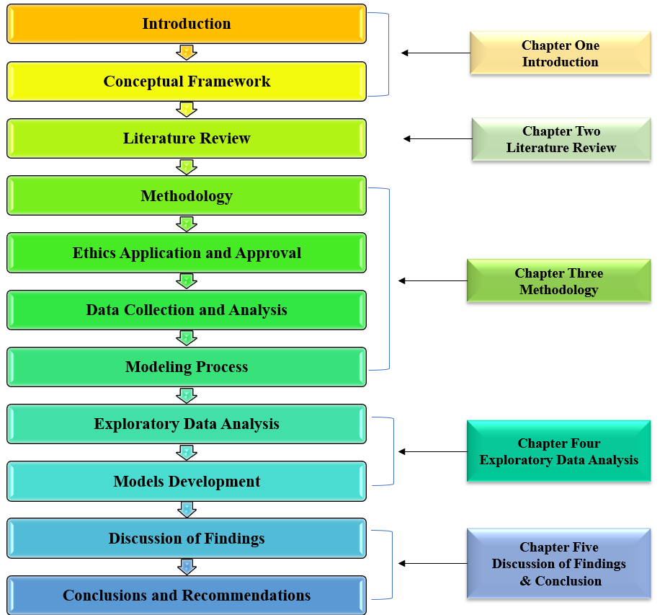
Figure 1.3: Dissertation Structure Diagram

CHAPTER TWO

LITERATURE REVIEW

2.1 Introduction
This chapter presents the literature review, which focuses on the concepts and variables included in previous studies and studies that examine the related variables. The summary identified the main challenges and gaps in the literature.
The literature review chapter presents the search strategy utilized to review previous work and related articles, search terms utilized in the search strategy, the main themes such as: (impact of nursing care on pressure injury, pressure injury, pressure injury risk factors, biomarkers of pressure injury, machine learning in healthcare, and prediction models of pressure injury), the gap that has resulted from the previous work, and summary of the literature review.

2.2 Search Strategies
In this section, the literature review is conducted on different domains and in a systematic review in relation to the main topic related to the prediction models of pressure injury. This search aims to identify previous studies conducted to predict the pressure injury using MLA in adult hospitalized patients.
Different databases were used in this research, namely Cumulative Index to Nursing and Allied Health Literature (CINAHIL), PubMed, Science Direct, Institute of Electrical and Electronics Engineers (IEEE), and Google Scholar. The keywords utilized in the search process were: [pressure injury, pressure ulcer, bedsore, decubitus ulcer, risk factors of pressure injury, biomarkers of pressure injury, machine learning, machine learning in healthcare, and prediction model of pressure injury]. The Boolean operators used were (OR & AND), and the search dates included studies relevant to the topic between 2017 to 2023. The inclusion criteria were set for the studies that developed prediction models for pressure injury, adult patients, and hospitalized patients, and the language of the study was English.

2.3 Search Result
The existing literature focused on different aspects of pressure injury and the prediction model of pressure injury. The studies conducted to discuss nursing care were: (Nyelisani et al., 2023; Renghea et al., 2022; Blasdell, 2017; DalPezzo, 2009; Kalisch et al., 2009; Aslan & van Giersbergen,2016; Chaboyer et al., 2021). The studies conducted to discuss the impact of nursing care on pressure injury were: (Alanazi et al., 2023; Pasandideh et al., 2021; Getie et al., 2020; Recio‐Saucedo et al., 2018; Valles et al., 2016; Hallaj, 2017).
Studies conducted on the incidence and prevalence of pressure injury were (Tariq et al., 2019; Qaddumi et al., 2019; Rondinelli et al., 2018; Gunningberg et al., 2017; Amirah et al., 2019). Some studies discussed the burden and costs of pressure injury discussed, which included: (Padula & Delarmente, 2019; Siotos et al., 2022; Roth et al., 2018; Han et al., 2019). Furthermore, there were studies that were conducted to investigate the risk factors of pressure injury (Ahmad et al., 2023; Anthony et al., 2021; Aghazadeh et al., 2021; Kim et al., 2022; Alderden et al., 2018; Aloweni et al., 2019; Chung et al., 2022; Galetto et al., 2021; Popow et al., 2019; Park & Park, 2017; Ateeq et al., 2022; DecubICUs Study Team European Society of Intensive Care Medicine Trials Group, 2021; Pittman et al., 2021).
The studies that focused on the biomarkers of pressure injury were: (Wang et al., 2022; McEvoy et al., 2022; Schwartz et al., 2020; Bogie et al., 2020; Bader & Oomens, 2018). There were also studies conducted to discuss prevention measures (Floyd et al., 2022; Alshahrani et al., 2021; Kottner et al., 2019; Gefen, 2018; Lovegrove, Fulbrook & Miles, 2018).
Some studies have focused on using electronic medical records and machine learning in healthcare (Manc, 2015; Negro-Calduch et al., 2021; Gamage et al., 2020; Sharma et al., 2022; Habehh & Gohel, 2021; Bhardwaj, 2022; Plana et al., 2022; Parashar, Chaudhary & Rana, 2021; Lao et al., 2019; Ferizi et al., 2019; McKinney et al., 2020).
The literature search yielded 494 studies (485 articles from four databases and 8 from Google searches). After removing 19 duplicate records, 426 studies were excluded because they did not pertain to the predictive modeling of pressure injuries. We thoroughly reviewed 48 studies for the inclusion criteria, of which two were excluded due to the lack of available reports; this left 46 articles to screen further. Of these, 2 focused solely on developing protocols rather than models, 7 targeted pediatric patients, and 10 addressed community-acquired pressure injuries. Ultimately, 27 studies met all inclusion criteria, including the availability of free full texts, and were thus included in the literature review related to the prediction models of pressure injury by using machine learning. The findings of searching and the inclusion and exclusion method were explained in the PRISMA for systematic review as in Figure (2.1).
Finally, the following studies had been reviewed in the literature using machine learning to predict pressure injury (Hyun et al., 2019; Cramer et al., 2019; Alderden et al., 2018; Hu et al., 2020; Jiang et al., 2021; Walther et al., 2022; Xu et al., 2022; Nakagami et al., 2021; Tang & Xu, 2021; Ji-Yu et al., 2021; Ladios-Martin et al., 2020; Tschannen & Anderson, 2020; Anderson et al., 2021; Song et al., 2021; Sun et al., 2020; Shui et al., 2021; Deschepper et al., 2022; James, 2021; Šín et al., 2022; Yang et al., 2020; Cheng et al., 2020; Choi et al. 2020; Xu et al., 2022).
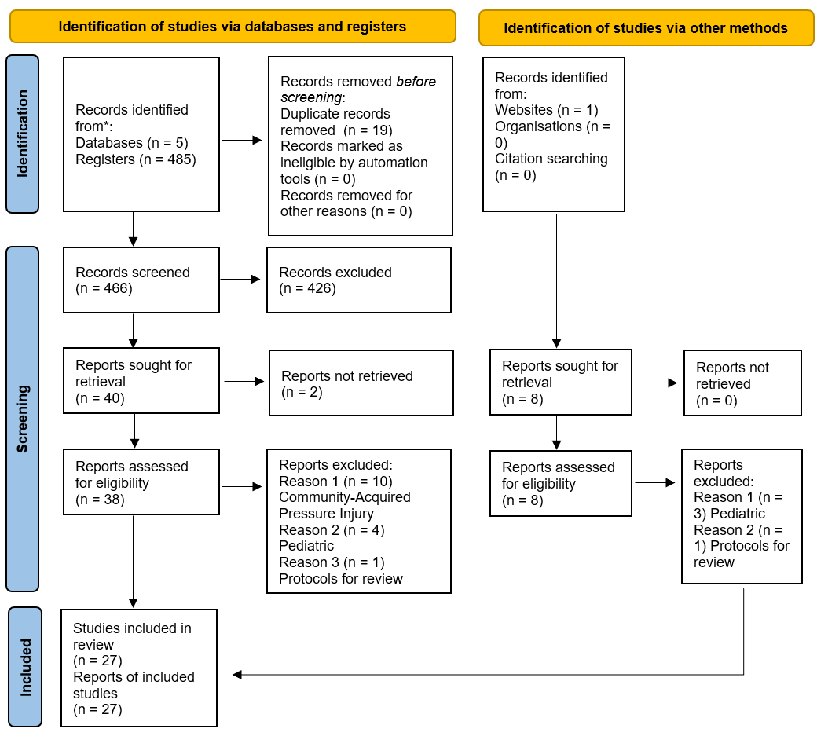
Figure 2.1: PRISMA for systematic review (Cohen et al., 2021).
To the best of the authors’ knowledge, none of these studies developed or even suggested fused multi-channel prediction models of pressure injury for adult hospitalized patients to enhance the quality of nursing care and patient safety. Therefore, the following section discusses the literature listed above.

2.4 Impact of Nursing Care on Pressure Injury
The concept of nursing care or quality of nursing care has been used from multiple dimensions for the concept of nursing care and defined it with comprehensive care under professional behaviors based on meeting the patient needs and fulfillment with an integrative care plan, which enhance the quality of care and prevent the patient’s harm (Nyelisani et al., 2023; Renghea et al., 2022; Blasdell, 2017).
According to the literature, nursing care has a significant impact on the quality of care and patient safety (Alsubhi et al., 2020), and missed nursing care impacts patient safety and quality of care; missed nursing care has been classified into delays, partially implemented, or not implemented at all (Chaboyer et al., 2021). In addition, several studies discussed the impacts of nursing care and missed nursing care on patient safety and quality of care.
The operational definition of the term “nursing care” is: “Nursing care is a skilled, safe, high quality, holistic, ethical, collaborative, individualized, interpersonal caring process that is planned and designed based on the best evidence available, and results in positive patient outcomes, optimization of health, palliation of symptoms, or a peaceful death.” The attributes of nursing care were categorized into three categories: 1) tasks, 2) nature, and 3) nursing care functions (DalPezzo, 2009).
Missed nursing care impacts quality and patient safety and is defined as an “error of omission.” Missed nursing care is a universal phenomenon impacting patient safety and can be the commission or omission of errors which affect patient outcomes and safety (Kalisch et al., 2009). Pressure injury has been identified as the outcome of missed nursing care (Chaboyer et al., 2021).
Missed nursing care impacts patient outcome; e.g. patient satisfaction, patient experiences, and pressure injury (Recio‐Saucedo et al., 2018). Hence, the impact of missed nursing care on pressure injury was measured by a special tool called “missed nursing care” (MISSCARE) to determine its relation to pressure injuries and identified missed nursing care is included in the assessment of risk factors of pressure injury, changing patient position, and skincare. Finally, that missed nursing care is mainly in assessing pressure injury and implementing prevention measures related to the nursing perception of pressure injury (Valles et al., 2016).
Nursing care impacts the patient’s safety, mainly missed nursing care increases pressure injury rates (Alanazi et al., 2023). Also, the literature showed that the nurses’ knowledge, perception, and quality of care provided impact the rate of pressure injury (Pasandideh et al., 2021). Furthermore, pressure injury prevention practices are positively linked to low incidences of pressure injury (Getie et al., 2020).
Pressure injury prevention measures aim to prevent harm and maintain patient safety, and focus on prevention methods and treatment methods. Prevention guidelines were implemented to decrease the incidence rate and prevalence rate of pressure injuries; 53% of the patients at risk of pressure injuries followed these guidelines and concluded that the implementation was effective in reducing the high rate of prevention of pressure injuries (Gunningberg et al., 2017).
The literature showed that the impact of nursing care prevention measures on pressure injury indicates that nursing care prevention measures such as scheduled patient positioning, adequate fluid resuscitation, applying cream on the skin, using pillows between legs, and preventing skin moisture significantly prevent pressure injury (Hallaj, 2017). The prevention measure of pressure injury improves the utilization of health care resources (Han et al., 2019). Moreover, the nursing attitude towards pressure injury is interrelated positively with pressure injury (Aslan & van Giersbergen, 2016).

2.5 Pressure Injury
According to the literature, pressure injuries are increasing worldwide, and even if they are preventable, there has been no significant improvement in their prevention (Siotos et al., 2022). Hospital-acquired pressure injury (HAPI) among patients admitted to intensive care units (ICU) ranged from 14.3% to 43.2%, and in traumatic patients ranged from 20.3% to 38.5% (Park & Park, 2017). Global prevalence ranged from 6% to 18.5% (Siotos et al., 2022). Moreover, the deaths related to pressure injuries increased from 13,700 in 1990 to 20,300 in 2017 (Roth et al., 2018). The literature showed that 41% of the patients developed a pressure injury that was unavoidable, and 59% were avoidable (Pittman et al., 2021).
Two studies were conducted to highlight the burden and magnitude of pressure injuries (Siotos et al., 2022; Padula & Delarmente, 2019). The first study was conducted by Siotos et al. (2022), which discussed the burden globally. The findings showed no statistical significance of decreasing burden of pressure injury nor the incidence, prevalence, disability-adjusted life years (DALY), or years living with the disease (YLD). Furthermore, the findings present no significant differences among age and gender of the incidence.
The other study by Padula & Delarmente (2019) explored the burden in the United States of America (USA). The incidence rate was 8.3 per 100 patients: 61.5% with stage 1 classification, 25.2% with stage 2, 10.5% with stage 3 or 4, and 2.7% progressed to stage 3/4 that required surgical interventions. In addition, the study showed that the length of stay prolonged the hospital-acquired pressure injury (HAPI) based on the pressure injury stages; stage 1 extends two days, stage 2 extends it by four days, stage 3 extends by 7 days, and stage 4 required surgery intervention and extends by 14 days. Also, the national average cost of care for patients in USA is around 10,708 USD, which reflects the burden on the national cost of 26.8 billion USD annually (Padula & Delarmente, 2019).
The pressure injury impacted patient outcomes, length of stay (LOS), burden costs, mortality, and readmission rates. This increases the healthcare cost of patients, the risk of mortality, the risk of prolonged hospitalization and LOS was increased significantly and delay the discharge patient to home (Han et al., 2019).
The incidence and prevalence of pressure injuries was evaluated worldwide in many studies, such as (Qaddumi et al., 2019; Tariq et al., 2019; Anthony et al., 2021). In Palestine, a study was conducted in 2019 by Qaddumi et al. to assess the incidence rate of pressure injury and its related variables through utilized prospective studies for 140 admitted adult patients to ICU. It assessed them by Braden scale to identify the risk of pressure injuries during a stay at ICU, and the findings of the study showed that 30% of patients developed pressure injuries. This study (Qaddunmi et al., 2019) was the first study conducted in Palestine related to pressure injury and provided healthcare providers with indicators of pressure injury in the context of Palestinian healthcare system. The study’s limitations were the small sample size and the data collection method. In addition, it depended on the nurses working in those hospitals, which compromised data quality.

2.6 Pressure Injury Risk Factors
The identification of risk factors for pressure injury enables the utilization of preventive measures at the proper time and before the occurrence of pressure injury (Park & Park, 2017); various risk factors affect pressure injury, and some of them are predictor variables (Popow et al., 2019). Those factors may include but are not limited to age, gender, body mass index, length of stay, medications, vital signs, anesthesia, Braden scale score, Braden subscale (sensory perception, moisture, activity, mobility, nutrition, and friction & shear) and diagnoses such as cancer, cardiovascular, diabetes mellitus (DM), renal failure, respiratory (Alderden et al., 2018; Chung et al., 2022; Galetto et al., 2021; Popow et al., 2019; Park & Park, 2017; Aghazadeh et al.,2021; Ahmad et al., 2023).
The literature showed that atherosclerosis, urgent admissions, paralysis, congestive heart failure, and procedures performed in the lower limbs or amputation posed as high-risk factors with pressure injuries (Ahmad et al., 2023). Also, the most risk factors for pressure injuries are anemia, hypoalbuminemia, and staff knowledge about the possible risk factors (Chung et al., 2022). Also, falls, repositioning, and oxygen level (Kim et al., 2022). The pressure injury correlated with the knowledge about the healing process and its length after receiving effective treatment strategies (Ateeq et al., 2022).
Finally, the literature showed that some of the risk factors correlate with the period in which patients acquired a pressure injury. For example, patients with low level of consciousness or on ventilators acquired pressure injuries at an early stage of hospital stay. While sedative patients, patients in need of nutrition interventions, patients with a tracheostomy tube, patients suffering from diarrhea, patients on medications such as steroids, anticoagulants, anti-inflammatory, and patients with gastric tubes acquired pressure injuries at a late stage of hospital stay (Park & Park, 2017).

2.7 Biomarkers of Pressure Injury
Visual skin assessment (VSA) to predict pressure injury relies on assessment tools that cannot be reliable prediction methods (Wang et al., 2022), and these methods are limited and problematic because pressure injuries develop from the deep tissue; they cannot be noticed until they reach the skin layer (McEvoy et al., 2022). This will lead to an incidence of pressure injury, and the patient will have already sustained a pressure injury by that time (Wang et al., 2022). Thus, the method needs to be improved to detect pressure injury earlier through a different way to help healthcare providers set and implement prevention measures for pressure injury (McEvoy et al., 2022).
Objective measures to predict pressure injury called biomarkers, defined as the normal reaction to physiological skin irritation (Wang et al., 2022), have significant potential to identify the risks of pressure injury through identifying inflammation activated by the inflammation biomarkers such as keratinocytes before the skin changes and skin injury (Bader & Oomens, 2018).
The study by Schwartz et al. (2020) was conducted to identify the correlation between pressure injury and biomarkers after spinal cord injury. It showed that the circulatory biomarkers and muscle-based biomarkers could identify patients with a high risk of recurrent pressure injury, which found that muscle quality is an effective biomarker. The biomarkers of fatty acid-binding protein (FABP4) circulator inflammatory factor had a significant effect on recurrent pressure injury after spinal cord injury. Another study by Bogie et al. (2020) investigated the adipogenic and myogenic circulatory biomarkers and found that both have significant relationships and pressure injury. In addition, the study concludes that the intramuscular adipose tissue (IMAT) is considered a significant indicator of recurrent pressure injury.
Two studies conducted by (McEvoy et al., 2022; Bader & Oomens, 2018) assessed the potential of biomarkers for early detection of pressure injuries. Both studies critiqued the current method of assessment for pressure injury. They showed that it would not improve prevention measures of pressure injury, while the evaluation relied on subjective data. 30% of inpatients are classified incorrectly according to those scales. Those studies focus on inflammatory biomarkers. The first study by McEvoy et al. (2022) investigates IL-1α (Total protein) with sub-epidermal moisture (SEM) and finds a weak correlation between IL-1α and SEM (McEvoy et al., 2022). While the second study by Bader & Oomens (2018) investigates the creatine kinase (CK), heart-type fatty acid binding protein (H-FAB), and myoglobin (Mb) for the control and spinal cord injury (SCI) groups. The study concludes that in the two groups (Control and SCI), there is a positive relationship between the CK and H-FAB and between the Mb and H-FAB. Only H-Fab and CRP had higher concentrations than other subjects.
According to Wang et al. (2022), biomarkers are used to detect pressure injury and the role of the biomarkers in early detection, this review conducted without limitation for the date of publication, language, and age of patients. The reviewed biomarkers involved (Albumin, Waterlow score, Hb, CRP, Age, Gender, H-FABP, granulocyte-macrophage colony-stimulating factor (GM-CSF), IL-15, TNF-α, and IFN-α in urine). The combination of gender, age, Hb, Albumin, and CRP is the significant biomarker, with 0.79.

2.8 Machine Learning in Healthcare
The flourishing advancement in technology has impacted the digitalization of the healthcare industry, increased the rapid progress of electronic medical records, and made electronic medical records mandatory (Negro-Calduch et al., 2021). Electronic medical records are used to keep medical information and provide healthcare providers with patient data; the electronic medical record assists in transforming healthcare and traditional medical records (Gamage et al., 2020).
The availability of electronic medical records enables the utilization of other benefits such as the efficiency of resources, support decision making, and improvement in the quality of care and the work life of family physicians (Negro-Calduch et al., 2021).
Based on the widespread utilization of electronic medical records, and in order to maximize their benefits, artificial intelligence (AI) is implemented in healthcare with different categories; this approach emerged in 1950, and then, machine learning applications have been implemented in the healthcare industry (Habehh & Gohel, 2021).
The promising aspects of artificial intelligence and its applications were shown in different domains, such as the transformational role of machine learning as one of the vital usages, predicting the risks of events and disease, helping in the diagnosis of diseases, accuracy in therapeutic approaches, analysis of the complex data pattern and enhancement of the quality of clinical trials (Sharma et al., 2022; Habehh & Gohel, 2021; Bhardwaj, 2022, Weissler et l., 2021).
Artificial intelligence, deep learning, or machine learning are used interchangeably, aiming to learn the machine intelligence of humans without programming (Habehh & Gohel, 2021). Machine learning data is randomly distributed to the training, test, and validation sets to maintain reliability and eliminate prediction bias (McKinney et al., 2020). The learning method is categorized into supervised, unsupervised, or semi-supervised, which are types utilized based on the research purposes and the research question; the supervised method is widely used to predict the disease or risk, the unsupervised method is utilized to evaluate data by reduction, and the semi-supervised used to build a strategy from the data (Habehh & Gohel, 2021).
Two studies (Parashar et al., 2021; Assadi et al., 2022) were conducted to elaborate on the use of machine learning in the health industry and provide a proper direction for utilizing machine learning in the future. The studies revealed that machine learning might provide interpretation and evaluation of diagnostic tests, transformation, processing of electronic medical records, and the framework in the electronic medical record. Also, the integration of the machine learning framework needs to be considered with the three dimensions of integration context; patients, users, and technical staff. Finally, the model design must be facilitated and guided by an engineering method in order to improve the model’s success in the integration phase.
Many studies implement and apply machine learning in healthcare studies of from different types, such as randomized clinical trials that utilize machine learning technology. The prediction model was used in many studies, such as the study conducted by McKinney et al. (2020) aimed to detect breast cancer earlier as experimental research. The study findings showed that the prediction model had 5.7% false positives and 9.4% false negatives in the United States of America (USA) and 1.2% false positives and 2.7% false negatives in the United Kingdom (UK). In contrast, the prediction model was compared between six radiologists was 11.5%, enhancing the quality of the clinical results of the screening. Also, implementing this application reduced the workload by 88% for the second radiologist, thus improving efficiency.
The diagnostic accuracy of machine learning was discussed in the Lao et al. (2019) systematic review and meta-analysis study, which was conducted to assess the accuracy in diagnosis of anterior cruciate ligament (ACL) injury; this study provided a significant protocol to utilize the prediction model of an ACL injury based on the magnetic reasoning image (MRI).
According to Gefen (2018), technology is available to prevent pressure injury. The study highlights the absence of biomedical technology to assist in screening or identifying cell or tissue damage early. The study also highlights that there is no technology to detect inflammation, damage, and poor perfusion for the affected area of pressure injury.
The ethical issues in machine learning are rising, especially with the rapid progression of the utilization of machine learning in the healthcare industry; this issue was discussed mainly with the principles of ethics such as equity, justice, beneficence, and nonmaleficence (Chen et al., 2021a).
A study conducted by Chen et al. (2021) highlighted and discussed the ethical challenges in utilizing machine learning technology in healthcare to balance the advantages of machine learning with the ethical considerations. In addition, the study proposed guidelines that need to be followed during the development of the machine learning model to ensure that the model will be safe to operate, explain the procedures of model development, provide detailed documentation for the section of data analysis, and develop a checklist to determine if the model is valid and reliable. The proposed guidelines solve the following issues: 1) problem selection: to be reviewed by different experts, 2) data collection process: to be well-designed to treat problems like imbalanced datasets, 3) The predicted outcomes: predefined outcomes and objectives to mitigate the risk of bias after development, 4) models and algorithms developments: to link the models and algorithms with the development outcome, and 5) post deployment of the developed product: to be reviewed and audited to ensure that the developed product model is an effective, safe, and sustainable product (Chen et al., 2021)
The ethical considerations have been divided into three groups: 1) the data source, 2) the development process, and 3) the clinical use. Those concerns are derived originally from ethical principles; as the data source concern is related to confidentiality, privacy, informed consent, and patient-sensitive data. The development process is based on the scientific approaches in the development and coding process with validation and testing process. And the deployment needs to be introduced well, engage the concerned health staff in the process, and ensure that the patients are safe and aware of the deployment (Vayena et al., 2018).

2.9 Prediction Models of Pressure Injury
The prediction model of pressure injury aimed to identify the predictive risks factors that impact pressure injury without relying on traditional assessment methods (Ladios-Martin et al., 2020). Furthermore, pressure injury risk factors are vast, and the staff cannot predict all cases or scenarios that lead to or cause pressure injury due to the uniqueness and variation of patients (Nakagami et al., 2021; Alderden et al., 2018; Tschannen & Anderson, 2020).
Pressure injury affects patient outcomes and treatment plans. It may lead to serious complications before the staff can identify a pressure injury occurrence, so the prediction method of pressure injury identifies it earlier and alarms the nurses and system of the risk of pressure injury for the admitted patients according to certain factors and biomarkers (Tschannen & Anderson, 2020).
The current method of assessing pressure injury relies on skillful or qualified nurses to determining the risks of pressure injury. Unfortunately, the shortage of qualified specialized nurses is an ongoing problem (Tamata & Mohammadnezhad, 2023), which leads the health scientists, nursing leaders, and treating physicians to seek applying a new methodology that is capable of identifying all risk factors and predict pressure injury earlier, before the skin changes the patients is harmed, in order to take necessary measures to prevent a hospital-acquired pressure injury and maintain patient safety (Bhardwaj, 2022; Jiang et al., 2021).
According to Sir William Osler, “medicine is a science of uncertainty and an art of probability.” This evolution of a new approach to medicine indicates the importance of machine learning in the healthcare industry and formulates the promising future of artificial intelligence (James, 2021; Bhardwaj, 2022).
The utilization of machine learning to construct a prediction model for pressure injury is discussed in the literature, and a prediction model for pressure injury was developed. And yet, there are differences in the risk factors and biomarkers that have been discussed and included in the model.
The following studies showed the unique potential risk factors and biomarkers used in the developed models in each study, such as reason for admission and medical history which was studied by Xu et al. (2022); medications and ventilation studied by Shui et al. (2021); admission weight studied by Cramer et al. (2019); vasopressor medications, sedation, and oxygenation studied by Alderden et al. (2018); Hb, and comorbidities studied by Tang & Xu (2021); oral mucosal, endotracheal tube (ETT), vasopressor, and hematocrit (HCT), steroids was studied by Choi et al. (2020); severity of illness was studied by Anderson et al. (2021); diet, pain, paralysis, skin condition, comorbidities, and department type studied by Nakagami et al. (2021); cancer, anti-cancer therapy, Waterlow score, acute physiology and chronic health evaluation (APACHE) II score, and blood purification studied by Sun et al. (2020); place of birth and hospital type studied by Ladios-Martin et al. (2020); and immunocompromised status studied by Deschepper et al. (2022).
The common risk factors and biomarkers used in most of developed models studies were age, gender, weight, diagnoses, length of stay, albumin, comorbidities, Braden scale, level of consciousness, incidence of pressure injury, clinical laboratory results, patients’ demographics, diagnosis, body mass index, heart rate, mean arterial pressure, and temperature (Hyun et al., 2019; Cramer et al., 2019; Alderden et al., 2018; Hu et al., 2020; Jiang et al., 2021; Walther et al., 2022; Xu et al., 2022; Nakagami et al., 2021; Tang & Xu, 2021; Ji-Yu et al., 2021; Ladios-Martin et al., 2020; Tschannen & Anderson, 2020; Anderson et al., 2021; Song et al., 2021; Sun et al., 2020; Shui et al., 2021; Deschepper et al., 2022; James, 2021; Šín et al., 2022; Yang et al., 2020; Cheng et al., 2020; Choi et al. 2020; Xu et al., 2022).
Machine learning and artificial intelligence have a promising future in predicting pressure injuries and assisting healthcare providers in detecting pressure injuries earlier. For example, Ji-Yu et al. (2021) developed a prediction model for patients undergoing cardiovascular operations, and the model predicts pressure injury based on the clinical data; Ladios-Martin et al. (2020) which set a prediction model for patients in ICU and the model effectively predicts pressure injury; Hyun et al. (2019) developed a prediction model for patients in ICU and compared it to the Barden score, and the model showed an acceptable level of pressure injury prediction; Hu et al. (2020) developed three prediction models for inpatients that are predict pressure injury; Yang et al. (2020) set a prediction model for ICU patients and showed the feasibility of using the electronic medical record to predict pressure injury.
The summary of the studies that developed prediction models for pressure injury with a full description of the methods and explain the target group, data collection methodology, sample size or census, data preprocessing, distribution of the data into different datasets, modeling, analysis, and conclusion, is the follows:
A retrospective cohort study was conducted by Aloweni et al. (2019) to determine the predictive risk factors of pressure injury from previous studies. The researcher compared the known risk factors of pressure injury for patient-acquired pressure injuries and patients who do not have pressure injuries; both groups had undergone surgery. Two trained nurses collected the data. The findings showed that 80 patients had pressure injuries and 189 patients who performed surgeries had no pressure injuries. The known factors were analyzed, and the results found that the following factors correlate with pressure injuries: age > 74 years, female, American Society of Anesthesiologists (ASA) ≥ 3, BMI < 23, Braden score, anemia, respiratory disease, and hypertension (HTN). The researcher developed the LR model: positive predictive value (PPV) was 73.2%, and negative predictive value (NPV) was 80.7%. The study concluded that a Braden’s score of more than 6 predicts pressure injury, and the LR may be used to predict and ensure that nurses must implement prevention measures before Braden score increases to more than 6.
Tang et al. (2021) conducted a prospective cohort study to identify pressure injury risk factors for patients who underwent surgeries and were transferred to the ICU after surgeries. The study was conducted in a teaching hospital, and recruited 648 patients who met the inclusion criteria. The data was collected from medical records for three phases: preoperative, intraoperative, and postoperative. In addition, the patients were monitored after being transferred to the ICU for 24, 48, and 72 hours. The researcher analyzed the data through frequencies, percentages, Chai-squared, t-test, univariate, and logistic regression (LR) via SPSS version 21. The study’s findings indicated that 121 patients had acquired pressure injuries in ICU post-operative phase, yielding in an incidence rate of 18.4%. The model constructed in the study was successful and could predict pressure injury for this group with the following performance metrics: The Youden index was 0.495, sensitivity was 0.635, specificity was 0.860, and AUC under receiver operator characteristics (ROC) was 0.74. The study concluded that the predisposing risk factors for the patient who underwent surgeries and transferred to ICU are High Fasting Blood Sugar (FBS), vasoactive drugs, the urgency of the surgery, and the duration of surgery.
Sun et al. (2020) conducted a retrospective study on critically ill patients with cancer to identify the risk factors of pressure injury for them patients. The data was collected retrospectively for two years (2018 and 2019), and the prediction model was created based on 486 patients. The findings indicate that 15 patients acquired pressure injuries during the hospitalization period. The APACHE score was the highest risk factor that affected those patients (a higher score means more critical), and moist skin and edema were found to contribute to pressure injury. The model constructed in the study was successful and could predict pressure injury for the group with the following performance metrics: sensitivity of 100%, specificity of 83.4%, and accuracy of 83.4%.
A systematic review study was conducted by Jiang et al. (2021) to review the studies related to ML to identify pressure injuries. The researcher examined studies from nine databases up to June 2020, and quality appraisal was used to eliminate the risk of bias. 32 studies were included according to the criteria; these studies discussed three topics, 12 studies utilized the ML to identify the risk of pressure injury, 9 studies utilized ML in the analysis of pressure injury images to classify them, and 11 studies used ML to detect the pressure injury earlier. The electronic health records ranged from 147 to 125,000 records, and the minimum incidence of pressure injury rate was 0.6; the decision tree algorithm was the dominant approach. Moreover, the highest accuracy for those studies was 90%, and the lowest was 63%; for the sensitivity, the lowest was 47.8%, and the highest was 84.8%. For specificity, the highest was 94.7%, and the lowest was 70.3%. The study concludes that using ML in pressure injury prediction models showed promising results, and it may be used in the future to predict and calculate the burden of pressure injury when it occurs.
Hyun et al. (2019) conducted a retrospective cohort study to identify the predictive risk factors of pressure injury in ICU patients and compare the performance of the predictive model with the results of the traditional assessment scale of pressure injury (Braden scale). The researcher utilized the data from electronic medical records from 2007 to 2010, and the power analysis required was calculated to determine sufficient data to conduct the study, which was 5731. The data was collected from a sample of 12654 patient records, and analyzed through the frequencies, percentages, chi-squared T. Test univariate, and binary LR. The study findings indicate that the pressure injury rate was 5.81 (735 patients), the predictive risk factors were patient’s age, patient’s gender, patients on ETT, on a mechanical ventilator, patient weight, isolation status, vasopressor medication, Braden score, and number of days on a ventilator. The prediction model (LR) performance metrics are: accuracy 91.7%, sensitivity 65%, specificity 69%, PPV 21%, NPV 34%, and AUC 73%. The study concludes that prediction models may assist healthcare providers in reducing the pressure injury rate.
Qu et al. (2022) conducted a systematic review and meta-analysis study to identify the effectiveness of ML in predicting pressure injury and determine the best algorithm utilized by the researchers. The study reviewed four reputable databases to identify all studies that constructed prediction models from retrospective and prospective approaches, the search process resulted in 25 studies that include 237,397 patients. The study findings showed that five algorithm approaches were utilized (DT, RF, SVM, neural network (NN), and LR), and all algorithms had acceptable and effective prediction models of pressure injuries. The performance metrics of the five approaches’ results are as follows: sensitivity (0.66 – 0.90), specificity (0.78 – 0.96), diagnostic odds ratio (9, 95 – 56.95), and AUC (0.82 - 0.95). Finally, the RF was the best algorithm to predict pressure injury.
In another retrospective cohort study conducted by Cramer et al. (2019) to identify pressure injury risk factors from electronic medical records. Data was extracted from 50,851 admitted patients to a hospital in the USA from 2001 to 2012. The researcher utilized 40 features and excluded patients under 18 years old. The data was divided into training and testing data, with a ratio of (80:20), the analysis was included frequencies, percentages, and binary LR. Six algorithms were used to develop the prediction model of pressure injury (LR, SVM, RF, gradient boosting machine (GBM), NN, and Elastic Net) and compare the results with the Braden Score. The study findings indicate that the pressure injury rate was 7.8 (1,690 patients), and the performance metrics of the model were 0.09 (0.11 – 0.18) for precision and 0.71 (0.17 – 0.52) for recall; the LR was the best algorithm and was better than Braden score prediction. The study concludes that the model may improve the quality of care and be used as decision support for nurses.
Alderden et al. (2018) conducted a cohort retrospective study to construct a prediction model for pressure injury by utilizing electronic medical records from a teaching hospital. The data was extracted by queries to bring the required data from the data warehouse. The data was validated by manual check for 30 random sample medical records to validate the results of the data extracted, and the agreement (validation result) was 100%. The data was cleaned by Stata software version 13 and analyzed by Stata software version 9. The data included 6376 patients per the predetermined inclusion criteria (adult, surgical patients, and admitted to the ICU). The data was split into two sets: 67% for training and 33% for testing the random forest (RF) model. The study findings indicate that the model successfully predicts pressure injury and the AUC measured the performance under the receiver operating curve (ROC), which yielded in a result of 0.79. The study concluded that the prediction model of pressure injury is better than the traditional tool that relies only on the clinician's input.
An experimental study was conducted by Hu et al. (2020) to construct a prediction model for pressure injury by utilizing data from 2014 to 2016 from a teaching hospital and recruiting the machine learning algorithms; the data collected excluded patients less than 18 years old, and the sample size was 11677 patients. This data was randomly divided into two datasets (50% training dataset and 50% testing dataset) to validate the prediction model, and the prediction models were DT, LR, and RF for 54 features. The findings of the study indicate that the performance metrics to measure the results of the experiments were as follows: sensitivity (0.69 – 1), specificity (0.721 – 0.99), precision (0.79 - 0.99), recall (0.82 – 1), and AUC (0.876 – 1); the RF was the best model. The study concluded that the quality of care and patient safety can be maintained through constructing prediction models that identify pressure injury earlier and may be effective solutions for the complexity of the determining risk factors that developed the pressure injury and helping the nurses cover the shortage of qualified nurses serving the patients.
A prospective study was conducted by Deschepper et al. (2022) to determine the risk factors of pressure injury and construct a prediction model in ICU for elective and emergency types; the study included 1110 patients from 89 countries in the world. The data was split into two sets (90% training and 10% testing) to validate the random forest (RF) prediction model of pressure injury. The study’s findings revealed that the risk factors for this study group were identified; out of 42 potential risk factors, the study determined the common risk factors are the length of stay in the ICU, DM, male gender, BMI, and maximum lactate. Also, the model identified the pressure injury based on the risk factors in the electronic medical record. The performance metrics were measured to evaluate the prediction model of pressure injury: accuracy 0.83 and the AUC (0.785 - 0.792).
Yang et al. (2020) conducted a synthesis study to set a protocol for a systematic review study to identify the risk factors of pressure injury for immobile patients; the researcher reviewed articles from two databases, a quality appraisal was performed, and the final number of articles was 11. The findings showed that the systematic review provides evidence of the risk of a prediction model.
Walther et al. (2022) conducted a study to predict the risk factors of pressure injury by utilizing machine learning technology. Data was collected retrospectively from 2014 to 2018 from four data warehouses, and the sample size was 149,006. The machine learning algorithms were LR, RF, and Bayesian Additive Regression Trees (BART); the data was split into two sets (training 80% and testing 20%). The study's results showed the incidence of pressure injury related to ventilation, anesthesia, age, and type of department, and the performance metrics to evaluate the prediction model were: accuracy (0.52 – 0.55), sensitivity (0.04 – 0.10), specificity (1), PPV (0.39 – 0.58), NPV (0.98 – 0.99), and AUC (0.89 – 0.90); BART was the best algorithm. The study concluded that the routine data may be a challenge to the sensitivity of the prediction model.
James (2021) conducted a retrospective cohort study in the USA to construct a prediction model for pressure injury through a time series up to 72 hours after admission. The data was collected based on the predetermined inclusion criteria: adult patients over 18 years with no pressure injury at the admission time. The researcher extracted the data from two data warehouses at different times; the first set of data was for the patients’ information, after 24 hours of admission, and set after from 24 to 72 hours. The sample size was 100,355, and the extracted data was validated manually by two trained staff by compared data of 10 patients (five with a pressure injury and five without a pressure injury). The researcher utilized three machine learning algorithms (explainable boosting machine (EBM), DT, LR); the EBM was the best model. The study findings indicate that 29 out of 139 features were included in the prediction model of pressure injury, and the evaluation of the model was measured by the AUC (0.60 – 0.79). The study concluded that the impact of time series on acquiring pressure injury is implemented in the prediction model.
In another retrospective cohort study conducted by Xu et al. (2022) to construct a nomogram early prediction model of pressure injury in the ICU. The data was collected from electronic medical records from the data warehouse of the general hospital and the sample size was 618 patients. The predetermined inclusion criteria were: adult patients who were admitted to the ICU. The researcher utilized the machine learning algorithms LR, DT, and RF. The data was split into two sets (training 70% and testing 30%). The prediction model was evaluated through accuracy (0.68 – 0.75), sensitivity (0.39 – 0.61), specificity (0.59 – 0.66), PPV (0.80 – 0.91), NPV (0.74 – 0.82), and the AUC (0.72 – 0.82); LR was the best model. The study concluded that routine clinical data in electronic medical records may substitute for traditional pressure injury assessment.
Šín et al. (2022) conducted a retrospective cohort study in Czech Republic to develop a practical prediction model of pressure injury and extract the data from two data warehouses (electronic health record and intensive care units) from two hospitals; the total patient was 4,652. The researcher utilized five approaches of the machine learning algorithms in this study: LR, KNN, RF, BN, and SVM. The study findings indicate that the performance metrics were: accuracy (0.84 – 0.96), precision (0.75 – 0.94), recall (0.59 – 0.91), and AUC (0.77 – 0.94); RF was the best model. The study concluded that the most predictive factor for the prediction model of pressure injury is the length of the patient’s stay in the ICU and fluid balance.
Nakagami et al. (2021) conducted a retrospective cohort study in Japan to develop a pressure injury prediction model from data available in the electronic medical record in a teaching hospital. The data was collected from 2010 to 2017, the inclusion criteria was: adult patients over 20 years old, and the sample size was 75,353 patient’s records; the data was divided into two datasets (70% training and 30% testing). The researcher utilized four machine learning approaches: LR, RF, SVM, and XGBoost. The study findings indicate that the prediction model was evaluated with following performance metrics: sensitivity (0.66 – 0.79), specificity (0.69 – 0.81), PPV (0.013 – 0.019), NPV (0.998), and AUC (0.76 – 0.82): XGBoost was the best model. The study concluded that the prediction model is successful and that the routine health data utilized can predict pressure injury.
Cheng et al. (2020) conducted a case-control study on 2341 patients in China to construct a nomogram of a prediction model of pressure injury, and the data was collected from electronic medical records of university hospitals between 2018 and 2019 (18 months). Furthermore, the data was split randomly into two sets (training 83% and testing 17%). The machine learning approach was LR. The study findings indicated that AUC of LR was (0.87 - 0.94). The study concluded that the constructed model is reliable for predicting pressure injury risk factors.
Choi et al. (2020) conducted a prospective cohort study to identify risk factors for oral-mucosal pressure injury and construct a prediction model of pressure injury for oral mucosal. The data was collected between 2017 to 2019 from surgical ICU and medical ICU patients at secondary and tertiary hospitals. The study inclusion criteria was: patients over 18 years old, patients with orally-attached endotracheal tube (ETT), and patients’ families agreeing to participate. The data was split into two sets (80% training and 20% testing). The sample size was 194 patients, and the researcher utilized two machine learning algorithms (Gaussian Naïve Bayes and LR). The study findings indicate that the performance metrics of the prediction model were: accuracy (0.79), sensitivity (0.60 – 0.85), specificity (0.76 – 0.89), precision (0.86), recall (0.91), and AUC (0.68 – 0.82). The study concluded that the large data required to decrease the sensitivity of the predictive model and the predictive factors were poor nutrition, corticosteroids, and immobility.
Shui et al. (2021) conducted a retrospective cohort study in the USA to develop a prediction model of pressure injury for Adult ICU patients. The data was collected from tertiary hospitals for ICU patients between 2013 to 2017 and the required data was extracted from electronic medical records for five major aspects (demographics, laboratory tests, administered medications, diagnosis, date of pressure injury, and vital signs). This data was categorized into three levels (24 hours, 72 hours, and 168 hours of ICU stays). The sample size was 18,019 ICU patients based on the inclusion criteria; the data was split into two sets (70% training and 30% testing). The researcher utilized the Fine-Gray Model to develop the prediction model. The study findings indicate the prediction model’s performance success, valid results, and an AUC of (0.56 – 0.92). The study concluded that this model can help clinicians predict the ICU patients who are at risk, in order to pay more attention to those patients.
Do et al. (2022) conducted a retrospective cohort study in the USA to identify the patients at risk of developing a pressure injury; the data was extracted from electronic medical records for the patients with and without pressure injury for the period between 2017 to 2020; the sample size was 6,742 patients. The data was split into two sets (70% training and 30% testing). The researcher utilized five machine learning algorithms (LR, KNN, naive bayes (NB), DT, and RF), and 24 features were included in the prediction model. The study findings indicate the performance metrics of the prediction model were excellent, as follows: accuracy (0.90 – 0.97), sensitivity (0.86 – 0.98), specificity (0.87 – 0.97), precision (0.81 – 0.96), recall (0.92 – 0.99), and AUC (0.90 – 0.97); the DT and RF models had the highest metrics among the rest. The study concluded that the pressure injury prediction model applies mainly to large healthcare facilities and large data.
Ji-Yu et al. (2021) conducted a prospective cohort study in China to develop a prediction model of pressure injury for patients who underwent surgery; the study was set in a teaching hospital, and the data extracted from electronic health records, 149 patients were followed prospectively. The researcher used the XGBoost as a machine learning algorithm in the prediction model, and performed a secondary data analysis method. The study findings indicate that the performance metrics of the prediction model were: accuracy (0.80), sensitivity (0.81), specificity (1), PPV (1), NPV (0.76), and AUC (0.50 - 1); the Youden Index was 0.081. The study concluded that utilizing this prediction model will give a better chance of identifying pressure injury for the patients who underwent surgeries early, and provide the required intervention to prevent pressure injury.
Song et al. (2021) conducted a retrospective cohort study in the USA to develop a pressure injury prediction model; this study extracted data from a data warehouse of five hospitals with a sample size was 15,130 patients. The hospital-acquired pressure injury (HAPI) and community-acquired pressure injury were compared and used in the prediction model of pressure injury. The data was split into two sets (80% training and 20% testing). The researcher utilized five machine learning algorithms (LR, SVR, NN, and RF). The study findings indicate that the performance metrics of the prediction model were excellent, as follows: accuracy (0.78 – 0.91), sensitivity (0.77 – 0.87), specificity (0.79 – 0.88), and AUC (0.80 – 0.94); the random forest was the best machine learning algorithm among the four algorithms utilized. The study concludes that the prediction model of pressure injury will help the nurses identify the patient at risk of pressure injury and determine the most predictive risk factors.
Xu et al. (2022) conducted a retrospective cohort study in the USA to develop a nomogram prediction model for pressure injury. The data was extracted from a public data warehouse for ICU patients, and the sample size was 9,644 patients based on the following inclusion criteria: (ICU patients, who had stayed at least one day in the ICU, assessed on admission for pressure injury, and have a diagnosis). The data was split into training and testing (67% and 33%). The study analyzed the data through frequencies, percentages, means, SD, T. Test, chi-squared, and AUC. The researcher utilized the LR to predict pressure injury. The study findings indicate that the performance metrics of the prediction model were excellent, as follows: sensitivity (0.69), specificity (0.72), and AUC (0.77). The study concludes that the prediction model of pressure injury can be used to prevent pressure injury.
Another retrospective cohort study was conducted by Alderden et al. (2021) in the USA to construct a prediction model of pressure injury for surgical ICU patients. The data was collected between 2014 and 2018 from electronic medical records for cardiovascular surgical ICU through special queries from data warehouses. The sample size was 5,101 patients, and the data was divided into two sets (80% training and 20% testing). The researcher utilized five machine learning algorithms (NN, LR, RF, GB, and Adaboost) to construct the prediction model of pressure injury. The study findings indicated that the performance metrics of the prediction model were as excellent as the AUC (0.76 – 0.81); and the RF and LR had the highest scores among the models. The study concluded that the prediction model of pressure injury is good and can predict the predictable factors of pressure injury.
Tschannen & Anderson (2020) conducted a literature review and conceptual framework study to investigate the literature on prediction models with evidence-based available literature. Two different databases were utilized to search on the topic, and “Walker and Avant’s theory” was adopted as the approach used to evaluate the prediction models. The researcher used a structured theory process to build the conceptual framework to identify the concept and review the related literature. The researcher used the following keywords in the search process: “hospitalization, nursing theory, predictive model, pressure injury, pressure ulcer, theory synthesis.” The search process was for literatures from 2006 to 2016, and according to the following inclusion criteria: adult patients above 18 years, inpatients, English language, risk of pressure injury, and prediction models of pressure injury. The researcher used the (Preferred Reporting Items for Systematic Reviews and Meta-Analyses) PRISMA to illustrate the study review, screening, included and excluded articles from the study. The search process resulted in 662 studies; only 59 studies were included. The study’s findings indicate that the current literature differs from the prediction model of pressure injury in the ability to predict pressure injury with the complexity of the care environment. The gap in the prediction models is related to missing the full picture or features utilized that may be included in the future to cover all risks related to pressure injury. The study concluded that the prediction models enable the prediction of pressure injury more than the current method, and can provide an optimal solution for the sophisticated environment, complexity of the episode of care, and fluctuation in the care process.
Anderson et al. (2021) conducted a retrospective cohort study to construct a pressure injury prediction model for surgical ICU patients or patients who underwent cardiac surgical ICU. The data was extracted from data warehouses according to the predetermined inclusion criteria (above 18 years old, surgical ICU patients, and patients who underwent cardiac surgery and were admitted to ICU); the period of data was between 2014 and 2018. The sample size was 18,943 patients, and the data was divided into two sets (80% training and 20% testing). The study findings indicate that the pressure injury rate was 6.5% of the total sample size in the study. The performance metrics of the prediction model were excellent, as follows: accuracy (0.86 – 0.99), sensitivity (0.67 – 1), specificity (0.91 – 0.99), precision (0.82 – 0.98), recall (0.88 - 1), and AUC (0.71 – 0.72); RF was the best model. The study concluded that the prediction model of pressure injury can predict the pressure injury of routine health data from electronic medical records.
Ladios-Martin et al. (2020) conducted a retrospective and prospective cohort study in Spain to develop a prediction model of pressure injury for ICU patients; the study setting was two teaching hospitals. The data was extracted from the electronic medical records; the first period of study (retrospective) conducted between 2016 and 2017, and the second phase (prospective) in 2018. The total sample was 6,694 patients (4227 in the retrospective phase and 2467 in the prospective phase); the data was split into two sets (70% training and 30% testing). The researcher utilized five machine learning algorithms (LR, SVM, RF, DT, and NN), and seven features were included in the prediction model. The study findings indicate that the performance metrics of the prediction model were excellent, as follows: accuracy (0.65 – 0.68), sensitivity (0.90), specificity (0.74), precision (8.76 – 10.87), recall (0.99 – 1), and AUC (0.89). The study concluded that the developed prediction model can help nurses identify patients at risk of developing pressure injuries if integrated with electronic medical records.
Eshetie et al. (2023) conducted a retrospective cohort study in Australia to identify pressure injury risk factors and construct a prediction model for pressure injury. The data was extracted from electronic medical records, collected between 2009 and 2016. The sample size was 206,540 patients, and the potential factors included in the prediction model were (individual, medications, healthcare, and facility-related factors). The researcher utilized the Fine-Gray Model to predict pressure injury, and 17 features were included in the prediction model. The data was split into two sets randomly (80% training and 20% testing). The study findings indicate the prediction model’s successful performance, valid results, and AUC of (0.72 – 0.75). The study concludes that identifying risk factors via the prediction model of pressure injury reduces pressure injury incidence and assists in providing the required prevention of pressure injury, mainly in vulnerable patients.
A systematic review study was conducted by Dweekat et al. (2023) to identify the usage of ML in the prediction of pressure injury. The researcher utilized four popular databases to search between 2007 and 2022 via the following keywords: “pressure ulcer, pressure injury, bedsores, machine learning, deep learning, systematic review, clinical decision support, hospital-acquired pressure injuries, predictive analytics, PRISMA, wound image analysis, artificial intelligence.” The PRISMA approach was utilized to map the reviewing technique and determine the included and excluded studies. The search process yielded 90 studies categorized into three groups: pressure injury prevention, risk assessment, and intervention to prevent pressure injuries. The study’s findings indicate that there were only 30 studies that discussed the prediction model of pressure injury: 29 utilized machine learning and one used deep learning. The sample size for the studies included in the study ranged between (168 - 188,512). The algorithms utilized by the included studies in the systematic review were DT, LR, SVM, LD, RF, multi-layer perceptron (MLP), and KNN. Finally, different performance metrics were utilized in those studies to evaluate the predictive models, such as accuracy, sensitivity, specificity, AUC, PPV, and NPV. The study concluded that all studies discussed risk factors that may predict pressure injuries, and no studies investigated or tracked the impact of changing the status of the risk factors during the hospitalization period.

2.10 Literature Matrix of Prediction Models of Pressure Injury
The literature review related to the prediction models was categorized into three tables to summarize the important information of the literature as follows: Table (2.1) discusses the study design, sample size, and statistical analysis, which includes the author’s name and year of the study, research design, sample size, and statistical analysis and performance metrics. Table (2.2) shows the potential risk factors that were examined by the prediction models, which include the author’s name with year of the study and potential predictive risk factors. Finally, Table (2.3) presents the results of the prediction model of pressure injury, which includes the author’s name, year of the study, algorithms, training%, testing%, Accuracy%, Sensitivity %, specificity %, precision (PPV)%, recall (NPV) %, and AUC.
Table (2.1) showed that the most common research methods in the literature were cohort retrospective studies, which formulated 59% of the total studies, followed by cohort prospective studies, about 19%, and 7% experimental design. The dataset ranged between 206,540 patients and 149 patients, and the most common data balancing method was random oversampling, which comprised 34% of the developed model and was followed by synthetic minority oversampling at 14%. Furthermore, the data collected from the hospital's electronic medical records (EMR) was the dominant approach at 74% of total other databases. Finally, the developed prediction models recruited the sample from hospital settings, and most hospital settings were the intensive units, with 52% of total developed models, as 37% did not report the setting type or department type.
Table 2. 1: Characteristics of the Studies - Detail of the Methodology

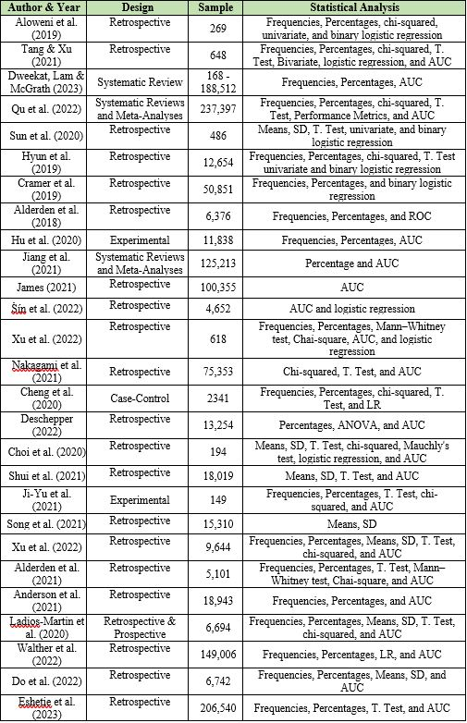
The potential risk factors recruited by developed prediction models in the previous literature ranged from 6 to 50 risk factors; the common risk factors were diseases, laboratory results, Braden scale, use of medications, age, vital signs, gender, BMI, LOS, duration of surgery, critical condition, GCS, weight, mechanical ventilation, anesthesia and sedation, oxygenation, history of PIs, and department type (open or closed unit). Dweekat, Lam & McGrath's (2023) study, which was highest study recruited risk factor among the rest with 50 risk factors, as presented in Table (2.2).
Table 2. 2: Potential Predictive Risk Factors

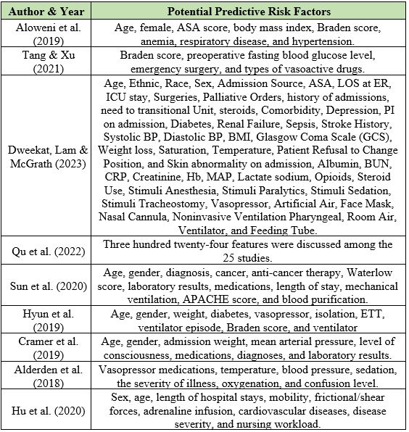
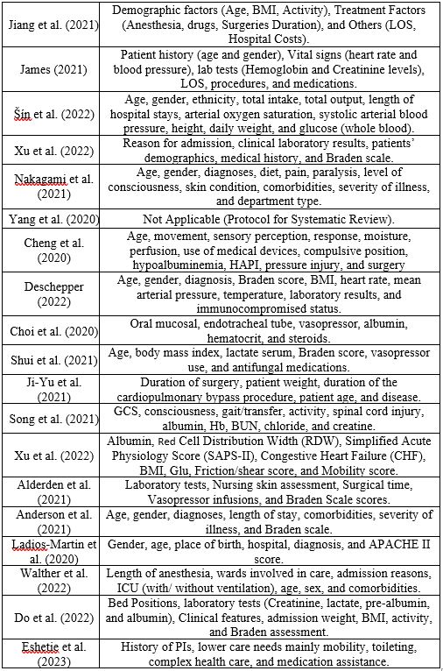

Table 2. 3: Results of the Predictive Model Studies
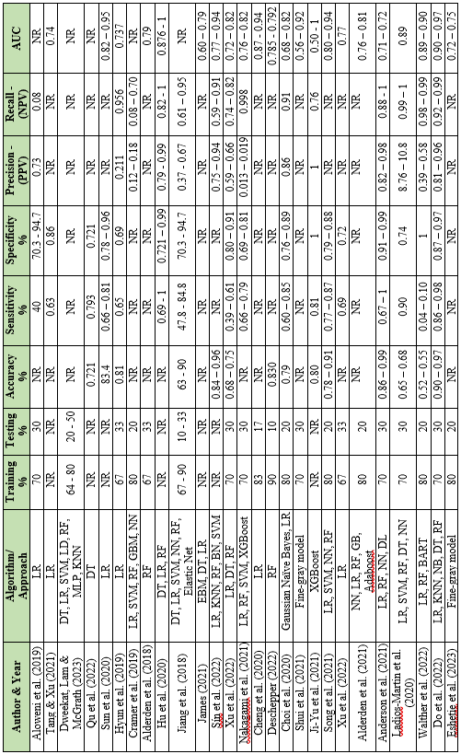
LR: Logistic Regression, SVM: Support Vector Machine, RF: Random Forest, DT: Decision Tree, GBM: Gradient Boosting Machine, XGBoot: Extrrem Gradient Boosting, KNN: K-Nearest Neighbors, NN: Neural Network, BN: Batch Normalization, MLP: Multi-Layer Perceptron, NR: Not Reported, AUC: Area under the curve, PPV: Positive Predictive Value, NPV: Negative Predictive Value, BART: Bidirectional and Auto-Regressive Transformers.

2.11 Literature Gap
However, although the results obtained from these studies are promising, none of these studies successfully utilized a fused multi-channel prediction model of pressure injury. From the previous literature and based on the variables, features, performance metrics, and context discussed in these studies, I found that the previous works needed to include some of the organizational-related factors that are unique in this study.
Furthermore, the literature review from the previous work on the prediction model of pressure injury showed that the prediction model predicts which patients may develop pressure injury based on their risk factors, but does not predict when the patients may acquire the pressure injury.
Finally, the prediction model must track changes in the patient status, condition, or biomarkers resulting in pressure injury to identify which patients may acquire the pressure injury during hospitalization. Additionally, one of the gaps found in the previous works is that none of them had studied, or investigated, the accreditation status as a variable or feature in the prediction model developed in those studies.

2.12 Summary
In the literature review, different studies that identified the methodologies, approaches, results, and gaps of previous works were presented and discussed. The literature discussed different domains related to the prediction models of pressure injury; these domains include the impact of nursing care on pressure injury, pressure injury, risk factors of pressure injury, biomarkers of pressure injury, machine learning algorithms, and the prediction model of pressure injury. This research identifies the risk of pressure injury and the feasibility of using fused multi-channel prediction models of pressure injury.

CHAPTER THREE

METHODOLOGY

3.1 Introduction
Chapter Three presents the research methodology and design, setting, population, sampling, inclusion and exclusion criteria, method of data analysis, and ethical considerations. This chapter explains the research process step by step. It highlights the data collection process, preprocessing, transformation, analysis, modeling, metrics used to compare between models, analysis of performance measures to identify the best model, and finally, model tuning and selections.
The general methodology structure that is utilized to achieve the goals and objectives is explained in Figure (3.1). This methodology is discussed in detail in the ethical considerations and approval section, data collection section, data processing section, and features engineering section in this chapter. The exploratory data analysis, models development, and performance measuring are discussed in chapter four. Finally, the model comparison, model selection, the conclusion and recommendations are discussed in chapter five.

Figure 3.1: Methodology Structure Diagram

3.2 Research Methodology and Study Design
Research is a scientific method of analysis, developing knowledge, and determining the cause and effect through a structured process. Therefore, the study design is essential and relies on the research question, objective, and subject. The quantitative method determines the questions, hypotheses, variables, and analysis before the data collection phase (Mehrad & Zangeneh, 2019). In this research, case control design and an experimental design were utilized.
A multi-phase quantitative approach involves conducting research in distinct, sequential phases where each phase relies on quantitative data and analysis. This method allows for a progressive refinement of research questions, hypotheses, and methods based on accumulating evidence. It is particularly useful in complex fields such as healthcare, where initial exploratory analyses (like a case-control study) can inform more focused, hypothesis-driven experimental designs (Kumar, 2018).
The methodology for phase one of this study adopts a case-control design, a retrospective approach particularly suitable for identifying and examining factors that may contribute to the development of pressure injuries. This design is widely recognized for its efficiency in studying rare outcomes and its capacity for handling multiple exposures related to a single outcome (Setia, 2016).
In the context of nursing and healthcare research, case-control studies provide a foundational understanding of associative relationships between risk factors and health conditions, which is crucial for developing prediction models for pressure injuries (Ranganathan, Pramesh, & Aggarwal, 2017).
In this phase, cases will consist of patients who have developed pressure injuries during their hospital stay, while control variables will be patients from the same environment who did not develop pressure injuries. Matching the controls to the cases based on variables such as age, gender, and overall health status minimizes confounding and strengthens the reliability of the findings (Xin et al., 2019).
This approach allows for a detailed comparison between groups, facilitating a better understanding of how and why certain patients develop pressure injuries and not others. Such insights are vital for formulating hypotheses regarding potential interventions, which will be tested in the subsequent experimental phase of the study. This phase not only enhances the understanding of the predictors of pressure injuries but also sets the stage for phase two, where these predictors are manipulated in an experimental design to develop the prediction model.
The experiment investigates for the relationship or association between the variables, while the descriptive observes or describes the sample and establishes a correlation between variables. Next, a selection of these types will be assigned or recruited based on the type and research purpose (Mehrad & Zangeneh, 2019).
This research aims to construct a novel fused multi-channel prediction model for the early detection of pressure injuries using machine learning algorithms. Thus, the experimental design posttest-only control group is the appropriate design for the research objective (Flannelly et al., 2018); this design was utilized for its features related to the ability to test and validate the relationship between variables, and establish a relationship between the independent and dependent variables (Aufenanger, 2017).

3.3 Settings
The study was conducted at Private Hospitals Group (Istishari Arab Hospital which is coded as RX Hospital, Specialized Arab Hospital which is coded as NX Hospital, and Ibn Sina Specialized Hospital which is coded as JX Hospital). These hospitals are private sector facilities located in the middle and north of the West Bank with a total bed count of 450 and total admissions of 42,500 patients annually (Barghouthi, 2024). These hospitals utilize the same electronic medical record system, which offers the required data to develop the prediction model for pressure injury. In addition, these hospitals have a similar scope of services and provide patients with general and specialized services; these hospitals also have a quality program, and their patient standards of care are unified, which means that the patient receives the same level of care.

3.4 Subjects / Entry Criteria and Recruitment
The data was collected retrospectively from the databases of the hospitals. This data was collected from the patients’ electronic medical records and reporting system based on the inclusion and exclusion criteria. No participants or patients were required in this study.
The inclusion criteria for the study included adult patients admitted to the hospitals, patients without pressure injuries on the day of admission, and patients screened on admission for pressure injury by the Braden scale.
In addition, the study excluded patients younger than 18 and those admitted to the hospital with pressure injuries acquired from outside the hospital (Home or other facilities before admission).

3.5 Study Population and Sample Size
The study population includes a sample of patient medical records who were treated at three private hospitals in Palestine (Istishari Arab Hospital, Specialized Arab Hospital, and Ibn Sina Specialized Hospital). Hospital statistics showed that there are about 85,500 admissions annually for all three hospitals (Barghouthi, 2024).
The minimum sample size was calculated to generate a balanced dataset, the calculation taking into consideration the effect size, significance level, and statistical power. The effect size measure was based on Cohen’s d formula (Cohen, 2013) and was estimated as small at 0.2 (Chen et al., 2010), whereas the desired significance level alpha (σ) was 0.05 and statistical power was 0.95 (Spurlock et al., 2018).
A priori sample size calculator (Soper, 2024) was used to identify the minimum sample size required; this calculation relied on effect size at 0.2, significance level at 0.05, and statistical power at 0.95, and was based on the formula (3.1) (Lakens, 2013). The recommended sample size was 650 patient medical records.
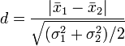 (3.1)
where x₁ and x₂ are the means of group 1 and group 2, and σ₁² and σ₂² are the variances of group 1 and group 2.

3.5 Ethical Considerations and Approval
A formal letter was obtained from the dean of graduate studies of the Arab American University (AAUP) to request formal approval from the hospital for ethical permission to conduct the study and collect the data (See Appendix 1).
The hospital's ethical permission was obtained to conduct the study, and no patient consent was needed because the data was obtained from the electronic medical records database without the patients’ names. Therefore, no interventions or interviews were conducted with patients (See Appendix 2). Finally, Ethical approval was obtained from the Arab American University's (AAUP) IRB committee under number 2023/A/92/N (See Appendix 3) after ensuring that all procedures and the study design and data collection method-maintained data confidentiality.
Data confidentiality is maintained for all types of data, and confidentiality was assured for the hospitals, in that the data would not be available for anyone who was not involved in the study. The data was maintained in a secure file and a locked computer. Additionally, the patients’ names, ID numbers, and dates of birth were not included in the data collection and were not required in the study. Finally, that data and information was utilized for research purposes only, and the researcher encrypted the hospital name through codes after mapping those codes with hospitals in the data collection process to maintain the privacy of the hospitals.

3.6 Data Collection
In this study, the researcher didn’t obtain data from patients; the researcher provided the IT department (who manage the databases for the three hospitals) with a list of all required predictable variables data with complete definitions of each item and provided them with a structured Excel document to export the data according to the template. This excel is aimed to guide the IT staff and to ensure that all required data is extracted from the database. Moreover, the researcher explained all the variables and required data to the IT staff to ensure that the extracted data were compatible with researcher request.
The IT department utilized a common tool which structured query language (SQL) to extract the data from hospital databases based on the research needs, and the researcher reviewed a sample of the data which was extracted to ensure that all required variables and data were extracted based on the predefined structured Excel template. The researcher performed a quality check on the quality of the data extracted, and the missing or irrelevant data was corrected and changed with the IT department. The final sample of the extracted data met all requirements, and the IT staff had completed the data extraction of all records based on the retrieving period.
The collection period included all data (census) according to the inclusion criteria from 01/03/2021 till 31/08/2023 retrospectively for the three hospitals as a primary data source (from the hospital’s database), which means that the data was extracted by the IT staff based on the researcher’s request and on the data extraction sheet, and for research purposes and first-hand dataset use.
The data extracted included all the risk factors (age, gender, length of stay, diagnosis, department type (open units and intensive units), vital signs, anesthesia, mechanical ventilator, Braden score, Braden subscales (sensory perception, moisture, activity, mobility, nutrition, and friction & shear), biomarkers of pressure injury (Hb, WBC, CRP, AST, BUN, Creatinine, HA1c, Bilirubin, Alb, Uric-Acid, and Protein), and medication management system (to extract all medications were applied to patients during hospital stay).
In addition, data of hospital-acquired pressure injury incidences was extracted from the incident management system retrospectively available in the three hospitals, including the stages of pressure injury (stage one, stage two, stage three, or stage four). All the extracted variables they linked together with a unique identifier number called (encounter ID), which was autogenerated by the system used by the three hospitals to facilitate linking of the variables and datasets together.

3.7 Data Processing
After the data collection, data preprocessing and cleaning was conducted. The data cleaning aimed to clean irrelevant and missing data. The data in the datasets was checked for duplication, which was linked with the unique number of each patient in these datasets; those steps were performed by the researcher using the Visual Studio program with assist the Python programming language.
The data collected consisted of three datasets with an overall count of 1,900,132 rows and 45,990 patient records. Those datasets were generated separately due to the nature of the data and its size (a dataset for laboratory tests, a dataset for medications, a dataset for patient records, and a dataset for incident reports). Those datasets were merged into one dataset, which includes patient records with laboratory tests and medications.
The researcher used the Microsoft Excel and Python programming languages to perform the data preprocessing and transformation to ensure that all columns' names were correct and the content of columns was clear to the reader. Furthermore, mapping of the hospitals with accreditation status and department categories was carried out.
The researcher performed data visualization in three phases: phase one aimed to check the quality of data and the effectiveness of data cleaning and preprocessing; this phase showed some absence or errors in the data, which was brought back to the IT department in order to fill the missing data and all issues were cleared.
Phase two of the data visualization was carried out on three programs (Microsoft Excel, Power BI, and Python programming) to understand the data, visualize all variables or features, and ensure that all required data was well prepared. The researcher and supervisors reviewed these phases to understand the data of the four datasets and ensure that the methodology of the visualization was proper; all notes were discussed, with some of the notes related to the type of charts and the appropriate method of data visualization, and the methods of the visualization were approved, all notes were reviewed and corrected.
Phase three of the data visualization was performed to provide the researcher with a better understanding of the variables or features that correlated with pressure injury, and the possible features that need to be included in the phase of feature engineering and selection to develop the prediction models.
The researcher extracted a balanced dataset with a total of 1,110 patients (the total number of patients) with an overall count of 92,417 rows. The researcher also a extracted a balanced dataset that included all patients with hospital-acquired pressure injury (555 patients) and a random sample of patients without hospital-acquired pressure injury (555 patients) via a simple random sampling technique from the original dataset which included 45,900 patients. This method was utilized to prevent the data size effect on the model’s development and training of the algorithms.
Finally, the analysis of data was performed using Microsoft Excel, Python programming software, and SPSS version 26; the results of the analysis were documented and will be discussed in detail in the next chapter (Chapter four - exploratory data analysis and models development).

3.8 Features Engineering
Feature engineering and selection were needed, as well as model selection. The researcher utilized the results of the visualization and analysis to determine or target the features that correlated with pressure injury. Those features were categorized into three divisions (risk factors, biomarkers, and medications), and the researcher developed four different subgroups of features (variables) to be assigned in the proposed models.
The feature subgroups are split into four based on correlation with pressure injury, statistical significance, feature importance, and potential factors without the Braden scale as follows: group one (potential factors that had high correlation with pressure injury), group two (potential factors that had statistical significance with pressure injury), group three (potential factors that had high importance of features), and group four (potential factors that had high correlation with pressure injury without Braden scale). Each group of features was used in one model and eight different algorithms to determine the predictive features of the success model based on the performance metrics of those models and algorithms.

3.9 Constructing Models by Using Machine Learning Algorithms
Machine learning was categorized into three types of learning: supervised, unsupervised, and semi-supervised. Supervised machine learning was utilized where the algorithms learn from the seen dataset with the title of the features. Then, testing was performed on the unseen data (testing dataset), in which the data has the same structure as the original dataset and the same features, and the algorithms can predict correctly (Parashar et al. 2021).
The data was prepared to be randomly assigned into three sets: training, test, and validation, with a ratio of (80% training and 20% testing). Moreover, the model’s design was proposed and developed. This experiment was repeated to generate four models, and each model used one of the feature subgroups in the proposed model.
Each model is a new experiment and is identified with a unique number that is linked to one of the subgroup features. Each new model is trained in selected subgroup features with predictive modeling approaches in the Python program software.
The researcher used eight algorithms of predictive modeling approaches that were categorized into two types: regression algorithms and classification algorithms. Each type has unique algorithms that can be utilized in the predictive model. The regression algorithms included linear regression and support vector regression (SVR), and the classification included logistic regression, random forest, gradient boosting, K-Nearest Neighbors (KNN), decision tree, and extreme gradient boosting (XG boost). These algorithms are popular in prediction, and the classification refers to the dependent variable. The target of the prediction is categorical (HAPI or No HAPI), and the regression is used to predict the output of the model (Brownlee, 2016, p.16).
In each experiment, the model was trained, and the eight algorithms generated results of the training based on performance metrics; these metrics were divided into two types: classification and regression. For the regression, the performance metrics were mean squared error (MSE) and coefficient of determination (R²); and for the classification accuracy, recall, precision, F1 score, the area under the curve (AUC), true positive rate (TPR), and false positive rate (FPR). The trained model was validated through a common technique called 5-fold cross-validation. All results of the models were validated. All of those proposed models and their findings are explained in detail in the next chapter (Chapter four - exploratory data analysis and modeling).
After each experiment and generating the model results, the model needed to be tuned and regenerated again, in order to compare the performance metrics between the first experiment (before model tuning) and the second experiment (after model tuning). The different models were trained after the treatment and modified based on the results.
Furthermore, the best models were applied again to save in another folder. The same dataset with the same data structure and features was reuploaded again to test the prediction models, and these models were compared based on the performance metrics; the best test results of the models were selected.

3.10 Machine Learning Algorithms Used in the Prediction Models
The machine learning algorithms used in the prediction models include 1) linear regression 2) support vector regression (SVR) 3) logistic regression (LR) 4) random forest (RF) 5) gradient boosting (GB) 6) K-Nearest Neighbors (KNN) 7) decision tree (DT) and 8) extreme gradient boosting (XG boost). These algorithms are part of a complete set that can be used from the library of machine learning, which consists of ten major approaches, and each approach consists of multiple algorithms. These algorithms determine that the way to deal with the data in the model and how the process of the learning from the data is achieved to accomplish the model (Brownlee, 2016, p.8-11).
Figure (3.2) illustrates the method used in constructing the models of this study. The method is divided into four main phases (data collection, data preprocessing, features engineering, and training and deploying the developed models).

3.10.1 Linear Regression
Linear regression is used to predict the dependent (y) from the independent (X), and this prediction assumes that the two variables have an association such as a linear association; this algorithm is measured by MSE and R² (Maulud & Abdulazeez, 2020). It uses the common formula as in the (3.2):
Equation: 𝑦 = β0+β1𝑥+𝜀 (3.2)
Y: Dependent, X: Independent, β0: Intercept, β1: Slope, 𝜀: Error Term.

3.10.2 Support Vector Regression
Support vector regression (SVR) is identified as part of the regression technique, and is considered a supervised learning algorithm. The SVR can be predicted from training and test datasets, and its aim is to identify a function that is as flat as possible while also matching all of the training data. It works to find the fit line and decrease the error or gap between the predicted and actual value, and the performance measured by MSE and R² (Parveen et al., 2016). It uses the common formula as in the (3.3):
Equation: z (α, w) = (w. Ø (α) + c) (3.3)
Z (α, w): Output of the SVR model, w: weight vector, Ø (α): function maps the input with higher-dimensional space, c: bias term.
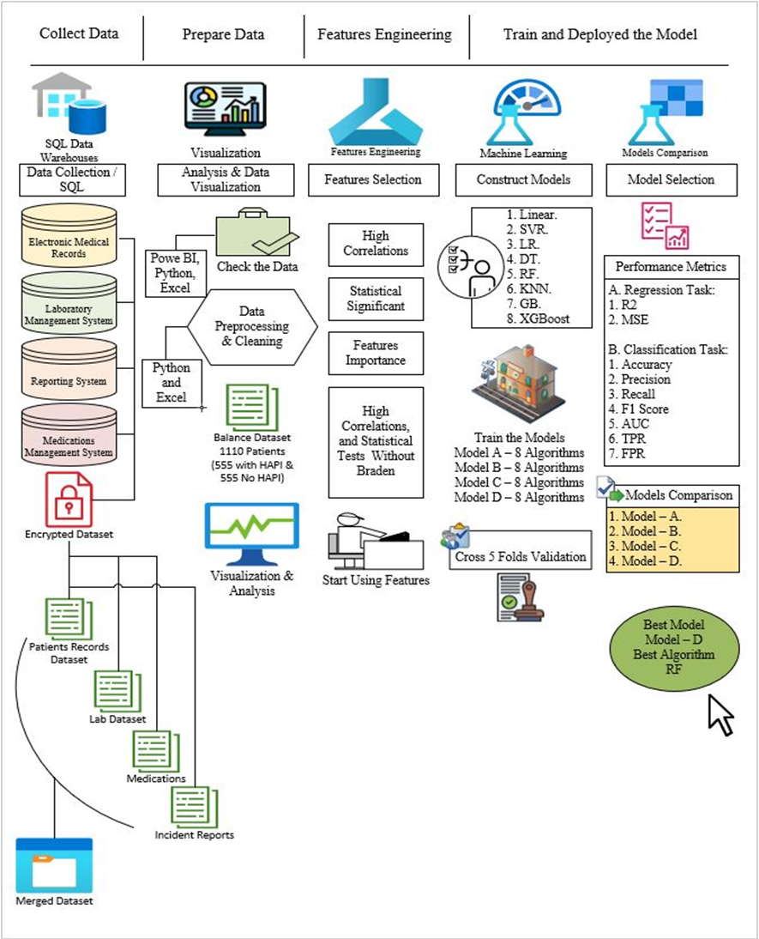
Figure 3.2: Method of Construction Prediction Models

3.10.3 Logistic Regression
As part of the classification, logistic regression (LR) is utilized, which compares the data to a logistic function; it makes predictions about the chance that an incidence will occur and the results will be between 0 and 1 (Brownlee, 2016, p.51). This algorithm’s performance is measured by accuracy, recall, precision, F1 score, AUC, FPR, and TPR. The common formula used is the one in formula (3.4):
Ln (p(X)/1 - p(X)) = B0 + B1 × X (3.4)
B_{0:} intercept, B_{1:} slope, X: predictor, P(X): probability.

3.10.4 Decision Tree
A decision tree (DT) is a flowchart-like tree; each branch in the tree is considered a rule, and each leaf is considered an outcome for each rule. This algorithm works on selecting the best feature or attribute from all available features and considering the results of maximum information. This algorithm did not rely on a straightforward formula, and each path from the root to the leaf represents a decision tree. The paths classify the new entree or instance determined previously and based on the feature values in the original tree until the leaf node is built (Misra et al., 2020).

3.10.5 Random Forest
The Random Forest (RF) is one of the classification algorithms and can be used for regression tasks. This algorithm works as the DT algorithm and generates many trees in the training phase and testing phase, which results in stable results; for this reason, the RF is also used in cross-validation. No equation is used in regression (Misra et al., 2020).
Its purpose to construct a model that uses basic decision rules deduced from data attributes to forecast the value of a target variable. It divides the data according to specified criteria; there is no set formula for this, but instead, metrics, such as information gain (Charbuty & Abdulazeez, 2021). This algorithm’s performance is measured by accuracy, recall, precision, F1 score, AUC, FPR, and TPR.

3.10.6 K-Nearest Neighbors
K-Nearest Neighbors (KNN) is a basic instance-based learning method. A new instance is categorized using similarity metrics (such as distance functions). A query point is allocated to the data class with the greatest number of representatives among its nearest neighbors. Classification is determined by a simple majority vote of each point nearest neighbors. (Syriopoulos et al., 2022). This algorithm’s performance is measured by accuracy, recall, precision, F1 score, AUC, FPR, and TPR. The common formulas used is as in the (3.5 & 3.6):
Euclidean Distance: d(p,q)=∑i=1n​(qi​−pi​)2 (3.5) ​
Manhattan Distance: d(p,q)=∑i=1n​∣qi​−pi​∣ (3.6)
N: number of dimensions, d(p,q): distance between straight lines, q_{i:} feature value of point q, p_{i}: coordinate point of p dimension.

3.10.7 Gradient Boosting
Gradient boosting (GB) is an ensemble technique where new models are created which predict the residuals or errors of prior models, and then added together in a stage-wise fashion. It combines the weak learners and creates a strong predictive model, and is used to minimize errors for the new model; “boosting” means that each model corrects the errors of the previous model. The key idea is to set the target outcomes for this new model to minimize the loss function (Zhang et al., 2019). This algorithm’s performance is measured by accuracy, recall, precision, F1 score, AUC, FPR, and TPR. The common formula used is as in the (3.7):
Equation: Fm​(x)=Fm−1​(x)+α⋅hm​(x) (3.7)
Fm​(x): Model iteration, Fm−1​(x): Model iteration -1, α: learning rate, hm​(x): decision tree at iteration m.

3.10.8 Extreme Gradient Boosting
XGBoost is an efficient implementation of a gradient-boosting framework. This algorithm uses a GB framework at the core but is optimized for speed and performance. Like GB, it involves creating new models that predict the residuals of prior models. It has unique features like handling missing data, regularization to avoid overfitting, and tree pruning (Alshboul et al., 2021). This algorithm’s performance is measured by accuracy, recall, precision, F1 score, AUC, FPR, and TPR. Its formula is the same as in GB, with regularization terms to avoid overfitting as in formula (3.8):
Equation: Fm​(x)=Fm−1​(x)+α⋅hm​(x)+Regularization Terms (3.8)
Fm​(x): Model iteration, Fm−1​(x): Model iteration -1, α: learning rate, hm​(x): decision tree at iteration m, Regularization Terms: to smooth the final learned weights.

3.11 Analysis
The analysis conducted in the study to identify the predictive risk factors and predict pressure injury was carried out on Microsoft Excel, SPSS version 26, and Python programming language software. The analysis used descriptive statistics for all variables (means, frequencies, percentages).
The hypothesis was tested by a T. Test to compare the means between two groups, which included the biomarkers. ANOVA was used for the continuous variables and for more than two categories which included age, LOS, age category, type of anesthesia, operation duration, anesthesia duration, Bp systolic and diastolic, temperature, pulse, pressure injury grade, Braden score, and Braden subscales (perception, moisture, activity mobility, and nutrition).
The Chai squared test was used for the categorical variables, which included gender, department type, performed operation, Braden scale, mechanical ventilator, accreditation status, pressure injury type, and medications.
The statistical tests were checked before conducting the analysis based on different assumptions, such as the normality, homogeneity of variances, and independence of observations (Mishra, et al., 2019).
The performance metrics accuracy, precision, recall, F1 score, AUC, FPR, and TPR were utilized to measure the performance of each experiment to develop the predictive model and to compare the performances of the developed models. In addition, the confusion matrix true positive rate and false positive rate were used to compare the predictive values with the targeted values in this research, in order to test the performance of the prediction model (Miao & Zhu, 2022; Hamsagayathri & Sampath, 2017; Chicco et al., 2021) as presented in the Figure (3.3).
Figure (3.3) illustrates the confusion matrix with the probabilities for the predicted and the actual. It shows that the matrix has four probabilities, which may be true positive (TP), false positive (FP), false negative (FN), and true negative (TN), in addition to the equation used in the prediction model and the metrics equation with the meanings of the symbols used in those equations.
Finally, based on the data analysis and visualization, in addition to the findings of the models and the determined predictive features (variables) from the best model, the study conclusion and the recommendations for future direction were made. They are discussed in a separate chapter (Chapter five: discussion of findings and conclusion).
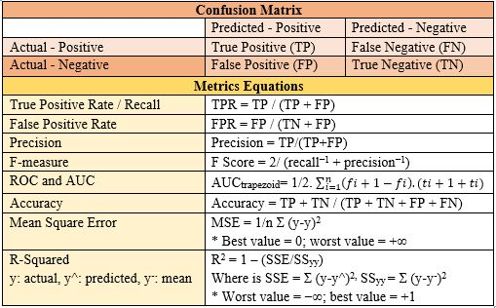

Figure 3.3: Confusion Matrix and Equations

3.12 Summary
In the methodology chapter, the methodology of this research is explained: a quantitative design with two phases: case-control for exploratory data analysis phase and experimental for construct a prediction model of pressure injury phase. The data was collected retrospectively from three hospitals and assigned randomly into four datasets. The methodology process, which includes data preprocessing, cleaning, transforming, feature selection, exploratory data analysis, model design (four models, each with eight algorithms), model selection, model tuning, performance metrics, and evaluation, was carried out in order to achieve the research objectives.

CHAPTER FOUR

EXPLORATORY DATA ANALYSIS AND MODELING

4.1 Introduction
This chapter presents a descriptive analysis of the variables or features includes means, standard deviation (SD), frequencies, percentages, correlation, and rates. Different approaches were used in the exploratory data analysis. The analysis and exploratory data analysis include the risk factors, biomarkers, and incidence of pressure injuries; and aims to visualize and investigate the interrelationships of those features, understand the data pattern, and determine the suitable approach for the prediction model. The features used in the model are presented with selection criteria and the predictive features of each model. Moreover, the developed models are presented along with their findings and a comparison between them.

4.2 Dataset
The data collected consisted of four datasets with an overall count of 1,900,132 rows and 45,990 patient records. Those datasets were generated separately due to the nature of the data and data size (one dataset for laboratory tests, one for medications, one for complete patient records, and one for incident reports).
The researcher extracted a balanced dataset for a total of 1,110 patients, which included all patients with hospital-acquired pressure injury (555 patients) and a random sample of patients without hospital-acquired pressure injury (555 patients), and an overall count of 92,417 rows. The total number of patients from the RX hospital was (475 patients; 43%), from NX hospital (382 patients; 34%), and from JX hospital (253 patients; 23%). Moreover, patients from the non-accredited hospitals (NX and JX) were (635 patients; 57.2%), and (475 patients; 42.8 %) of the dataset were from the accredited hospital (RX), as presents in Figure (4.1).

Figure 4.1: Patient Distribution According to Hospital

4.3 Risk Factors
The risk factors in this study were age, gender, length of stay, department type, diagnosis, operation, anesthesia, vital signs, Braden score, Braden subscales, mechanical ventilator, and medications. All these risk factors were collected from the hospitals during the data collection process, and the datasets included all these features for all patients who were applicable. The following paragraphs present the information and details of those risk factors.
The distribution of the potential risk factors according to the dataset collected in relation to the categorization of pressure injury is presents in Table (4.1). This table shows the potential risk factors split into (555) patients with hospital-acquired pressure injury and (555) patients without hospital-acquired pressure injury. Table (4.1) includes the number of patients, with percentages, according to hospital, gender, age, accreditation status, department type, anesthesia type, performed operation, mechanical ventilator, Braden scale level, and pressure injury grade. It also contains the means of vital signs, LOS, and operation duration per hospital
Table 4.1: Distribution of Potential Risk Factors According to Pressure Injury Status

Risk Factor | Sub Risk Factor | Total & Percentages |  | Total
Risk Factor | Sub Risk Factor | Non-HAPI | HAPI | Total
Hospital | RX | 262 (55.2) % | 213 (44.8) % | 475
Hospital | JX | 108 (22.7) % | 145 (30.5) % | 253
Hospital | NX | 185 (38.9) % | 197 (41.5) % | 382
Gender | Female | 237 (49.9) % | 230 (48.4) % | 467
Gender | Male | 318 (66.9) % | 325 (68.4) % | 643
Age | Adults (25-64 years) | 366 (77.1) % | 218 (45.9) % | 584
Age | Elderly (65 years and over) | 128 (26.9) % | 306 (64.4) % | 434
Age | Young Adult (18-24 years) | 61 (12.8) % | 31 (6.5) % | 92
Accreditation Status | Accredited | 262 (55.2) % | 213 (44.8) % | 475
Accreditation Status | Non-Accredited | 293 (61.7) % | 342 (72) % | 635
Department Type | Intensive Units | 154 (32.4) % | 302 (63.6) % | 456
Department Type | Open Unit | 401 (84.4) % | 253 (53.3) % | 654
Anesthesia Type | General | 169 (35.6) % | 176 (37.1) % | 345
Anesthesia Type | Local Anesthesia | 109 (22.9) % | 54 (11.4) % | 163
Anesthesia Type | Spinal | 15 (3.2) % | 3 (0.6) % | 18
Anesthesia Type | Sedation | 3 (0.6) % | 10 (2.1) % | 13
Anesthesia Type | Combined Spinal Epidural | 0 (0) % | 1 (0.2) % | 1
Anesthesia Type | Epidural | 1 (0.2) % | 0 (0) % | 1
Performed Operation | No | 258 (54.3) % | 311 (65.5) % | 569
Performed Operation | Yes | 297 (62.5) % | 244 (51.4) % | 541
Braden Scale Level | High Risk | 31 (6.5) % | 441 (92.8) % | 472
Braden Scale Level | Low Risk | 524 (110.3) % | 114 (24) % | 638
Pressure Injury Grade | Grade 1 | 0 (0) % | 179 (37.7) % | 179
Pressure Injury Grade | Grade 2 | 2 (0.4) % | 279 (58.7) % | 281
Pressure Injury Grade | Grade 3 | 0 (0) % | 97 (20.4) % | 97
Mechanical Ventilators | No | 536 (112.8) % | 442 (93.1) % | 978
Mechanical Ventilators | Yes | 19 (4) % | 113 (23.8) % | 132
Risk Factor | Hospital | Mean |  | Avg.
LOS  (days) | RX | 3.2 | 13.6 | 7.8
LOS  (days) | JX | 3.3 | 14.9 | 9.9
LOS  (days) | NX | 1.6 | 15.9 | 8.9
Operation Duration  (hours) | RX | 1.2 | 2.2 | 1.6
Operation Duration  (hours) | JX | 1.3 | 2.4 | 1.9
Operation Duration  (hours) | NX | 0.4 | 1.1 | 0.8
Systolic BP  (millimeters of mercury) | RX | 123 | 118 | 120
Systolic BP  (millimeters of mercury) | JX | 123 | 123 | 123
Systolic BP  (millimeters of mercury) | NX | 119 | 120 | 120
Diastolic BP  (millimeters of mercury) | RX | 71 | 67 | 69
Diastolic BP  (millimeters of mercury) | JX | 73 | 72 | 72
Diastolic BP  (millimeters of mercury) | NX | 70 | 67 | 69
Temperature  (centigrade) | RX | 36.5 | 36.5 | 36.5
Temperature  (centigrade) | JX | 36.4 | 36.5 | 36.5
Temperature  (centigrade) | NX | 36.5 | 36.5 | 36.5
Pulse  (beats per minute) | RX | 73 | 76 | 74
Pulse  (beats per minute) | JX | 68 | 71 | 70
Pulse  (beats per minute) | NX | 73 | 70 | 72

4.3.1 Age
The average age of the patients was 55 years (with a SD of 19.61), the maximum patient age was 94 years, and the minimum patient age was 18 years. The average age in RX hospital was 56.4 years (with a SD of 18.23), in NX hospital 54.9 years (with a SD of 19.62), and in JX hospital 53.7 years (with a SD of 19.61) as presents in Figure (4.2).
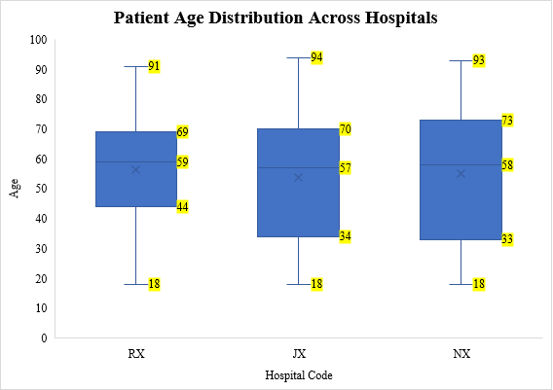
Figure 4.2: Patient Distribution According to Age Across Hospitals
Figure 4.3 shows the distribution of age, where 92 patients representing (8.3%) were young adults (18-24 years), 584 patients representing (52.6%) were adults (25-64 years), and 434 patients representing (39.1%) were elderly (65 years and above).

Figure 4.3: Patient Distribution According to Age Category

4.3.2 Gender
The patients’ gender distribution showed that the number of female patients was 467, representing 42.1% of patients, and the number of male patients was 643, representing 57.9%. The number of female patients for each hospital was 175 at NX hospital, 204 at RX hospital, and 88 at JX hospital. In comparison, the number of male patients for each hospital was: 207 representing (32.2%) at NX hospital, 271 representing (42.2%) at RX hospital, and 165 representing (25.6%) at JX hospital, as presents in Figures (4.4) and (4.5).

Figure 4.4: Distribution of Patients Ac cording to Gender Across Hospitals

Figure 4.5: No. of Patients According to Gender Per Hospital

4.3.3 Length of Stay
The average length of a patient's stay (LOS) was 6.5 days (with a SD of 14.61); the average LOS at RX hospital was 7.8 days (with a SD of 13.34), at NX hospital 8.9 days (with a SD of 15.99), and at JX hospital 9.9 days (with a SD of 15.13), as presents in Figures (4.6) and (4.7).

Figure 4.6: Comparison of Length of Stay by Hospital
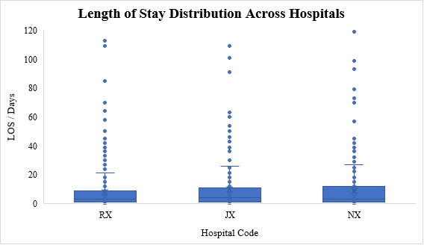
Figure 4.7: Length of Stay by Hospital Across Hospitals

4.3.4 Department Type
The data from the balanced dataset showed that the patients were admitted to different departments in each hospital. These departments were titled based on the hospitals’ preferences, such as (specialized surgery, medical-surgical, medical oncology, intensive care unit, cardiac care unit, inpatient male, inpatient female, heart-medical intensive care unit, intermediate care unit, heart-surgical unit, VIP unit, postnatal care, obstetrics, and gynecology). Thus, the departments were categorized based on the department's scope of services and classified into (open and intensive care units).
The data showed that the patients admitted to the “open units” across all hospitals were 654, representing 58.9% of total patients, and 456 patients to the “intensive units”, representing 41.1%. Those patients were distributed according to the department category in each hospital as follows: 225 patients representing (59%) in “open units” at NX, 346 patients representing (73%) in “open units” at RX, and 83 patients representing (33%) in “open units” at JX. In comparison, 157 patients representing (41%) were in “intensive units” at NX, 129 patients representing (27%) were in “intensive units” at RX, and 170 patients representing (67%) were in “intensive units” at JX, as presents in Figures (4.8) and (4.9).

Figure 4.8: No. of Patients According to Hospital Per Department Categories

Figure 4.9: Percentage of Patients Per Hospital Per Department Categories

4.3.5 Diagnosis
The number of unique diagnoses in the dataset was about 469 diagnoses for 1,110 patients in the three hospitals. The data showed that the top 10 diagnoses were (chest pain, unstable angina, full-term delivery, person injured in vehicle accident, malignant neoplasm of colon, shortness of breath, non-ST elevation (NSTEMI) myocardial infarction, delivery by elective cesarean section, coronavirus infection, and driver of vehicle injured), as presents in Figure (4.10).
The top 10 diagnoses among hospitals occurred 325 times, representing 29.3% of the total patients in the dataset, and these ten diagnoses were related to the following categories: cardiac, gynecological, respiratory, oncological, and trauma sustained in traffic accidents. The JX hospital had a higher number of patients with diagnoses related to people injured in vehicle accidents. In contrast, the NX hospital had higher patients with shortness of breath diagnoses, and the RX hospital had higher frequencies of patients with oncological diagnoses and chest pain.

Figure 4.10: Top Ten Diagnosis Across Hospitals

4.3.6 Operation
The data categorizes the patients who performed operations by their number in each hospital, totaling 541 and representing 49.2% of total patients, as presents in Figure (4.11). The average operation duration was 66 minutes.

Figure 4.11: No. of Patients Performed Operations Across Hospitals

4.3.7 Anesthesia
The number of patients who performed operations under anesthesia was 541 representing 49.2% of the total. The types of anesthesia were general, local, spinal, sedation, epidural, and combined spinal epidural as follows: general anesthesia with 345 patients representing 63.8%, local with 163 patients representing 30.1%, spinal with 18 patients representing 3.3%, sedation with 13 patients representing 2.4%, epidural one patient representing 0.2%, and one patient with combined spinal epidural representing 0.2%, as presents in Figure (4.12). The average anesthesia duration was 85 minutes (with a SD of 1.91).

Figure 4.12: No. of Patients Per Anesthesia Type Across Hospitals

4.3.8 Vital Signs
The patient's vital signs in the datasets were systolic blood pressure, diastolic blood pressure, temperature, and pulse. These vital signs were distributed as follows: the average systolic blood pressure was 120.6 with a SD of 18.32 (the maximum was 197 and the minimum 45), the average diastolic blood pressure was 69.5 with a SD of 12.01 (the maximum was 118 and the minimum 26), the average temperature was 36.4 with a SD of 0.31(the maximum was 40 and the minimum 33.7), and the average pulse was 72.3 with a SD of 14.39 (the maximum was 180 and the minimum 33).
The mean of systolic BP in JX was 123 mmHg (with a SD of 21); in this hospital, 34 out of 253 patients had outliers readings in the systolic BP (23 high and 11 low). The mean systolic BP in NX was 120 mmHg (with SD 16.4); in this hospital, 16 out of 382 patients had outliers readings in the systolic BP (11 high and 5 low). And the mean systolic BP in RX was 121 mmHg (with SD 18.2); in this hospital 49 out of 475 patients had outliers reading in the systolic BP (24 high and 25 low), as presents in Figure (4.13).
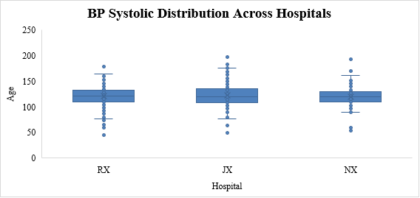
Figure 4.13: BP Systolic Distribution Across Hospitals
The mean diastolic BP in JX was 72 mmHg (with a SD of 12.8); in this hospital, 32 out of 253 patients had outliers readings in the diastolic BP (22 high and 10 low) The mean diastolic BP in NX was 69 mmHg (with SD 11.6); in this hospital, 19 out of 382 patients had outliers readings in the diastolic BP (13 high and 6 low). And the mean diastolic BP in RX was 69 mmHg (with SD 11.7); in this hospital, 43 out of 475 patients had outliers reading in the diastolic BP (22 high and 21 low), as presents in Figure (4.14).
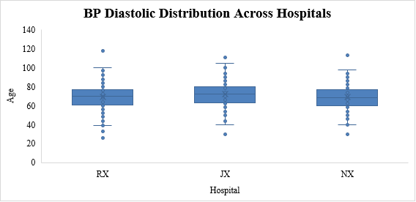
Figure 4.14: BP Diastolic Distribution Across Hospitals
The mean temperature in JX was 36 (with a SD of 0.2); in this hospital, 5 out of 253 patients had outlier’s readings in the temperature (5 high). The mean temperature in NX was 37 (with a SD of 0.3); in this hospital 15 out of 382 patients had outlier’s readings in the temperature (9 high and 6 low). And the mean temperature in RX was 37 (with a SD 0.3); in this hospital 17 out of 475 patients had outliers reading in the temperature (10 high and 7 low), as presented in Figure (4.15).
The mean pulse in JX was 70 (with a SD of 13.8); in this hospital, 22 out of 253 patients had outliers readings in the pulse (21 high and 1 low), and the mean pulse in NX was 72 (with a SD 12.3); in this hospital, 16 out of 382 patients had outliers readings in the pulse (16 high). And the mean pulse in RX was 74 (with a SD 16); in this hospital, 41 out of 475 patients had outliers reading in the pulse (41 high), as presents in Figure (4.16).
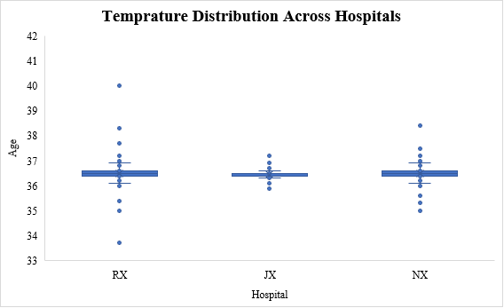
Figure 4.15: Temperature Distribution Across Hospitals
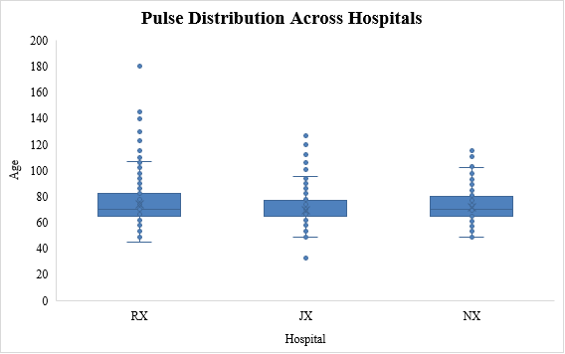
Figure 4.16: Pulse Distribution Across Hospitals

4.3.9 Braden Scale
The Braden scale consists of six subscales, and the results of the scores were divided into two levels (high-risk and low-risk). The summative score ranges between 6 and 23, and the cut-off score is 16. Moreover, when the Barden score is above 16, it means that the patient is considered at a low risk of acquiring pressure injury. And when the Braden score is below 16, it means that the patient is considered at a high risk of acquiring pressure injury. The sensitivity and specificity of the Braden score are considered high, 100% and 90% respectively (González-Ruiz et al., 2014).
The data shows that the number of patients at a high-risk level was 472, representing 42.5% of all patients across all hospitals, while the number of patients low-risk was 638, representing 57.5%. The Braden scale levels among hospitals were as follows: RX (179 high-risk, 296 low-risk), JX (120 high-risk, 133 low-risk), and NX (173 high-risk, 209 low-risk), as presents in Figures (4.17) and (4.18).

Figure 4.17: No. of Patients Per Braden Scale Level Across Hospitals

Figure 4.18: No. of Patients Per Hospital Per Braden Scale Level

4.3.10 Braden Subscales
The Braden scale consists of six sub-scales (sensory perception, moisture, activity, mobility, nutrition, and friction). The data showed that the highest category in sensory perception subscale was “no impairment”, at 589 patients representing 53.1%. In the moisture subscale, it was “rarely moist”, at 510 patients representing 45.9%. In the activity subscale, it was “walks frequently”, at 487 patients representing 43.9%. In the mobility subscale, it was “no limitations”, at 520 patients representing 46.8%. In the nutrition subscale, it was “excellent”, at 498 patients representing 44.9%. And in the friction subscale, it was “no potential problem, no apparent problem”, at 885 patients representing 79.7% as presents in Figures (4.19 - 4.24).
The RX hospital had a higher count of patients at risk in several categories, which may relate to the complexity of cases that were admitted to the hospital and the scope of services. The NX hospital generally had the highest number of patients with no impairments or limitations, which could indicate the nature of the patient's condition on the day of admission. Finally, JX hospital showed mixed of results with some areas of concern, especially in nutrition and very limited mobility. It may relate to the hospital-received cases that needed rehabilitation based on the scope of services.

Figure 4.19: No. of Patients Per Braden Subscale Preception Per Hospital

Figure 4.20: No. of Patients Per Braden Subscale Moisture Per Hospital

Figure 4.21: No. of Patients Per Braden Subscale Activity Per Hospital

Figure 4.22: No. of Patients Per Braden Subscale Mobility Per Hospital

Figure 4.23: No. of Patients Per Braden Subscale Nutrition Per Hospital

Figure 4.24: No. of Patients Per Braden Subscale Friction Per Hospital

4.3.11 Mechanical Ventilator
The number of patients on mechanical ventilators was 132, representing 11.9% of total patients. The number of patients on mechanical ventilators in each hospital were as follows: RX (51 patients, 10.7%), JX (29 patients, 11.5%), and NX (52 patients, 13.6%), as presents in Figure (4.25).

Figure 4.25: No. of Patients on M.V Per Hospitals

4.3.12 Medications
The data showed that the number of unique medications applied to patients was 1151 medications; the total number of medication doses for all patients was 29,009. The distribution of these medications among the three hospitals was: RX at 42.1%, NX at 34.8%, and JX at 23.1%, as presents in Figure (4.26).

Figure 4.26 Distribution of Medications Across Hospitals
The top ten medications among all medications ordered 6906 represented 23.8%, as follows: Nexium (1301 orders, 4.5%), Perfalgan (1169 orders, 4%), Fentanyl (658 orders, 2.3%), Furosemide (605 orders, 2.1%), Clexane (601 orders, 2.1%), Metoclopramide (531 orders, 1.8%), Meropenem (514 orders, 1.8%), Potassium Chloride (512 orders, 1.8%), Dexamethasone (508 orders, 1.8%), and Propofol (507 orders, 1.7%). The distribution of these medications among the three hospitals was: RX at 42.1%, NX at 34.8%, and JX at 23.1%, as presents in Figure (4.27).

Figure 4.27: Top Ten Medications Across Hospitals

4.4 Biomarkers (Laboratory Tests)
The data showed that 12 unique laboratory tests were requested for the patients in the dataset as follows: Hb, WBC, CRP, AST, BUN, Creatinine, HA1c, Bilirubin Total (T), Bilirubin Direct (D), Alb, Uric Acid, and Protein.
The number of tests in the dataset was 50,895 tests. Most of those tests were the WBC and Hb (11,664 tests, 22.92% and 10,402 tests, 20.44% respectively), followed by creatinine (8,208 tests, 16.13%), BUN (4,871 tests, 9.57%) CRP (4487 tests, 8.82%), AST (3,267 tests, 6.42%), albumin (3,207 tests, 6.30%), bilirubin total (1,981 tests, 3.89%), bilirubin direct (1,885 tests, 3.70%), HbA1c (367 tests, 0.72%), protein (301 tests, 0.59%), and uric acid (255 tests, 0.50%), as presented in Figure (4.28). 42.9% these tests were requested by RX, followed by NX at 34.7% and JX at 22.4%, as presents in Figures (4.28), (4.29), and (4.30).

Figure 4.28: No. of Laboratory Tests Requested

Figure 4.29: Percentage of Laboratory Tests Requested Across Hospitals

Figure 4.30 No. of Laboratory Tests Requested Per Hospital
According to Table (4.2), the average laboratory results for the patients in the dataset were abnormal (above normal range or below normal range according to the hospital's criteria). This includes the following tests: Alb was 2.98 (with a SD of 0.64), bilirubin (D) was 1.56 (with a SD of 3.81), bilirubin (T) was 2.33 (with a SD of 5.06), Bun was 31.31 (with a SD of 26.20), creatinine was 1.59 (with a SD of 1.55), CRP was 89.17 (with a SD of 83.83), Hb was 10.30 (with a SD of 2.15), protein was 5.91 (with a SD of 3.01), AST was 111.51 (with a SD of 600.32), Hb A1c was 7.25 (with a SD of 2.14), and WBC was 11.13 (with a SD of 5.73). With the exception of uric acid, which was 5.85 (with a SD of 3.14), and within the normal range, as presents in Table (4.2).

Table 4.2: Average of Laboratory Test Results with Interpretation of Results

Tests Name | Average Result | Normal Range | Interpretation
Albumin | 2.98 | 3.5-5.2 | Below Normal
Bilirubin (D) | 1.56 | 0-0.2 | Above Normal
Bilirubin (T) | 2.33 | 0.2-1.2 | Above Normal
Blood Urea Nitrogen (Bun) | 31.13 | 6-20 | Above Normal
Creatinine | 1.59 | 0.7-1.2 | Above Normal
CRP | 89.17 | <5 | Above Normal
Hb | 10.30 | 12.0-14.0 | Below Normal
Hb A1c | 7.25 | <5.7 | Above Normal
Protein | 5.91 | 6.4-8.3 | Below Normal
SGOT (AST) | 111.51 | 0-40 | Above Normal
Uric Acid | 5.85 | 3.4-7 | Normal
WBC | 11.13 | 4-11 | Above Normal

The result of each lab test was different, and the values of the results were based on the test normal range; thus, box plots were utilized to present the lab test results, maximum, minimum, median, Q1, and Q3 percentile, as shows in Figure (4.31).
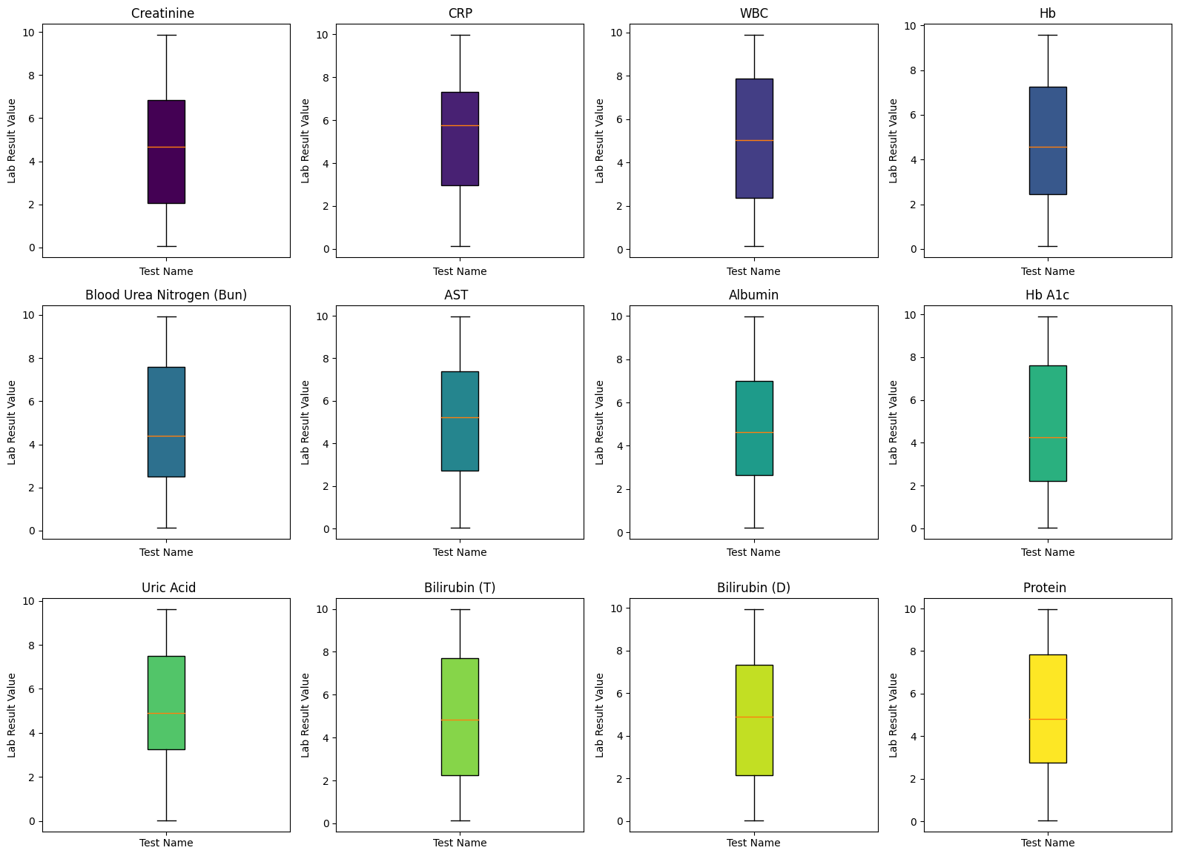
Figure 4.31: Laboratory Tests Results Across Hospitals
The sensitivity and specificity for the laboratory tests in the dataset to examine the ability to identify the pressure injuries correctly. Most of the laboratory tests showed high sensitivity, such as uric acid, Hb A1c, Hb, Alb, uric acid, BUN, and AST, which were all 1.0, indicating the ability to identify the pressure injury correctly. The sensitivity of WBC was 0.99, CRP was 0.99, creatinine was 0.84, bilirubin (T) was 0.64, and bilirubin (D) was showed the lowest sensitivity at 0.33.
The specificity is zero for the laboratory tests uric acid, Hb A1c, Hb, Alb, uric acid, BUN, and AST, which indicates that they did not identify any negative pressure injuries. Some of the laboratory tests showed better results in specificity, even when the sensitivity was low, like bilirubin (T) at 0.529 and bilirubin (D) at 0.742 as presents in Table (4.3).
Table 4.3: Sensitivity and Specificity for Laboratory Tests with Pressure Injury

Tests Name | Sensitivity | Specificity
Hb | 1.000 | 0.000
BUN | 1.000 | 0.000
AST | 1.000 | 0.000
Albumin | 1.000 | 0.000
Hb A1c | 1.000 | 0.000
Protein | 1.000 | 0.000
Uric Acid | 1.000 | 0.000
WBC | 0.990 | 0.004
CRP | 0.990 | 0.032
Creatinine | 0.840 | 0.073
Bilirubin (T) | 0.640 | 0.529
Bilirubin (D) | 0.330 | 0.742

4.5 Pressure Injury
The balanced dataset showed that half the patients had hospital-acquired pressure injuries at 50% and no pressure injuries at 50%. These results are expected due to the use of the balanced dataset type.

4.5.1 Pressure Injury Type
The pressure injury status from the dataset was categorized as hospital-acquired pressure injury and no pressure injury, as presents in Figure (4.32).

Figure 4.32: Percentage of Pressure Injury Status Across Hospitals
The balanced data showed the pressure injury status for patients across hospitals: the number of hospital-acquired pressure injuries at RX was 213 patients out of 475, comprising 44.8%; at JX 145 patients out of 253, comprising 57.3%; and at NX 197 patients out of 382, comprising 51.6%. The number of patients with no pressure injury at RX was 262 patients, JX was 108 patients, and NX was 185 patients, as shows in Figures (4.33 - 4.36).

Figure 4.33: No. of Pressure Injury Status Per Hospital.

Figure 4.34: Percentage of HAPI For NX Hospital

Figure 4.35: Percentage of HAPI For RX Hospital

Figure 4.36: Percentage of HAPI For JX Hospital

4.5.2 Pressure Injury Grade
The pressure injury grades in the dataset were categorized into three types (Grade 1, Grade 2, and Grade 3) which were distributed as follows: grade 1 with 197 patients (comprising 35.5% of HAPI patients), grade 2 with 213 (comprising 38.4% of HAPI patients), and grade 3 with 130 (comprising 26.1% of HAPI patients) as presents in Figure (4.37).

Figure 4.37: Percentage of HAPI Grade Across Hospitals
Figure (4.38) shows the distribution of pressure injuries among the three hospitals as follows: the number of patients with pressure injury grade 1, at RX was 71 (representing 36% of HAPI at RX), at JX 53 (representing 24.9% of HAPI at JX), and at NX 55 (representing 37.9% of HAPI at NX). The number of patients with pressure injury grade 2 at RX 98 (representing 49.7% of HAPI at RX), at JX 75 (representing 35.2% of HAPI at JX), and at NX 108 (representing 74.5% of HAPI at NX). The number of patients with pressure injury grade 3 at RX 44 (representing 22.3% of HAPI at RX), at JX 19 (representing 8.9% of HAPI at JX), and at NX 34 (representing 23.4% of HAPI at NX).

Figure 4.38: No. of Patients Per Pressure Injury Grade Per Hospital
The percentages of pressure injury grades per hospital are presents in Figures (4.39 - 4.41).

Figure 4.39: Percentage of HAPI Grade One Across Hospitals

Figure 4.40: Percentage of HAPI Grade Two Across Hospitals

Figure 4.41: Percentage of HAPI Grade Three Across Hospitals
Based on figure (4.38), the pressure injury grade two was the dominant type among all pressure injury grades, and this means that the pressure injury had affected the thickness of the tissue, along with loss of dermis. This harm reached or affects the patients, and healthcare providers, mainly the nurses, did not prevent the pressure injury by taking measures - or the patients were not assessed well by nurses and the injury reached to two before the current system or the traditional assessment method could capture the risk of pressure injury or alarm the nurses.

4.5.3 Incidence Rate of Pressure Injury
The incidence rate of hospital-acquired pressure injuries had an overall incidence rate of 1.21 per 100 patients. The incidence rate was calculated for each hospital based on the number of admitted patients and the number of hospital-acquired pressure injuries in each hospital. The incidence rate for RX hospital was the lowest, at 1.05 per 100 patients, followed by NX hospital at 1.13 per 100 patients, and the highest rate among the three hospitals was JX hospital at 1.75 per 100 patients, as presents in Figure (4.42).

Figure 4.42: Incidence Rate of HAPI Across Hospitals
The incidence rate for male patients was 3.31 per 100 patients in NX hospital, 5.1 per patients for JX hospital, and 0.75 per 100 patients for RX hospital. Moreover, the incidence rate for female patients was 2.13 per 100 patients in NX hospital, 3.36 per patient in JX hospital, and 1.89 per 100 patients in RX hospital. The RX hospital had the lowest incidence rate for both male and female patients; the overall incidence rate for male patients was 2.29 per 100 patients, while the incidence rate for female patients was 2.23 per 100 patients, as presents in Figure (4.43).

Figure 4.43: Incidence Rate of HAPI Per Gender Per Hospital
The incidence rate for patients treated in open units was 2.43 per 100 patients for NX hospital, 3.66 per patients for JX hospital, and 2.35 per 100 patients for RX hospital. Moreover, the incidence rate for patients treated in intensive units was 0.67 per 100 patients in NX hospital, 0.11 per patients in JX hospital, and 1.08 per 100 patients in RX hospital. RX hospital had the lowest incidence rate for patients treated in open units, while JX hospital had the lowest incidence rate for patients treated in intensive units, as presents in Figure (4.44).

Figure 4.44: Incidence Rate of HAPI Per Department Type Per Hospital
The incidence rate for patients who had performed operations was 2.65 per 100 patients in NX hospital, 4.97 per patients in JX hospital, and 0.97 per 100 patients in RX hospital. The RX hospital had the lowest incidence rate, as shows in Figure (4.45). The incidence rate for patients on M.V. was 1.20 per 100 patients in NX hospital, 0.67 per patient in JX hospital, and 1.41 per 100 patients in the RX hospital. RX hospital had the lowest incidence rate, as shows in Figure (4.46)

Figure 4.45: Incidence Rate of HAPI for Performed Operations Per Hospital

Figure 4.46: Incidence Rate of HAPI for Patients on M.V Per Hospital
The incidence rate of HAPI was calculated based on the accreditation status, and the results were as follows: 1.39 per 100 patients for the non-accredited hospitals, and 0.97 per 100 patients for the accredited hospital, as presents in Figure (4.47).

Figure 4.47: Incidence Rate of HAPI Per Accreditation Status

4.6 Correlations with Pressure Injury

4.6.1 Correlation of Pressure Injury with Risk Factors
The datasets have 37 variables that may correlate with pressure injury, and the correlation of the variables is categorized into numeric (continuous variables) and categorical variables: this categorization and the type of data yielded two different charts of correlation.
The numeric variables in the dataset were age, length of stay, operation duration, anesthesia duration, Bp systolic, Bp diastolic, temperature, pulse, Braden score, pressure injury, mechanical ventilator, medication dose, and lab results.
The categorical variables in the dataset were accreditation status, department category, test name, hospital name, gender, department name, age category, diagnosis, operation name, anesthesia type, Braden scale, sensory perception, moisture, activity, friction and shear, mobility, nutrition, pressure injury type, pressure injury grade, test name, and test normal range. The correlation of these variables with pressure injury is explained with the rationale of the results.
In order to investigate the correlations of the pressure injury with variables, the statistical techniques that are employed based on the types of variables. For numerical, continuous variables, the Pearson correlation coefficient is utilized. By quantifying the linear relationship, the hypothesis tests used to determine the statistical significance of these relationships. The alternative hypothesis (H1) proposes a non-zero correlation, whereas the null hypothesis (H0) claims there is no correlation (i.e., the Pearson correlation coefficient, ρ, is zero). The null hypothesis is rejected when the p-value is less than 0.05, indicating that the association is statistically significant.
For categorical variables, we applied Cramér's V, a measure based on the chi-squared statistic that assesses the strength of association between categorical factors such as gender or hospital name. This measure ranges from 0 (no association) to 1 (perfect association).
The correlations were visually reconstructed by using tools that help in identifying significant relationships and ensuring that the findings are both interpretable and accessible. These includes heatmaps for Pearson correlations among numeric variables, which offer a color-coded representation of correlation strengths, and suitable plots for displaying Cramér's V results.
Figure (4.48) shows a strong correlation between pressure injury and Braden score (- 0.63); this correlation is presented in negative direction because a lower Braden score indicates a high risk of pressure injury. Thus, means there is a significant negative correlation was found between the Braden Score and pressure injury, r (78) = -.63, p < .01. This indicates that lower Braden Scores, which suggest higher risk, are associated with a higher occurrence of pressure injuries.
Furthermore, the heatmap shows a moderate positive correlation between pressure injury and age (0.42), which means there is a moderate positive correlation between pressure injury and the length of stay, r (78) = .42, p < .01, indicating that a patient's age older are associated with an increased likelihood of pressure injuries.
Finally, there is a moderate positive correlation between pressure injury and length of stay (0.41), which means there is a moderate positive correlation between pressure injury and the length of stay, r (78) = .42, p < .01, indicating that longer hospital stays are associated with an increased likelihood of pressure injuries.
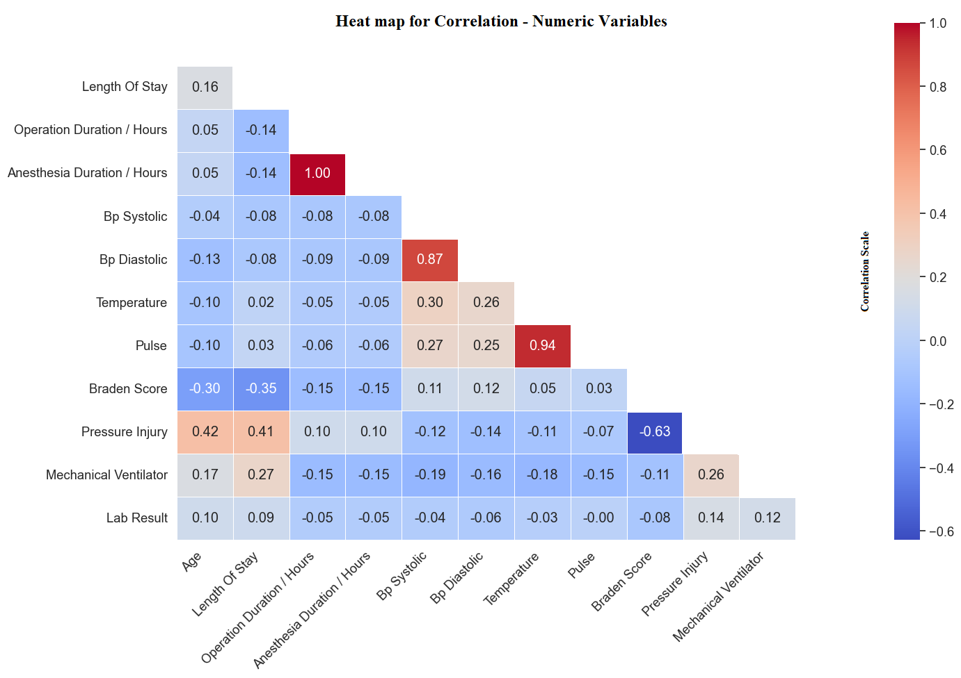
Figure 4.48: Heat map Correlation for Numeric Variables
The correlation of the categorical variables with laboratory tests is presents in Figure (4.49). It showed that there is a strong correlation between pressure injury type and pressure injury grade (0.71), which relies on the fact that pressure injury grade results from pressure injury type. There is a strong positive correlation between the hospital, accreditation status, and department (1, 0.97), which is logical because the department is part of the hospital, and the hospital is mapped to the accreditation status.
There is a strong positive correlation between diagnosis and operation name with anesthesia type (0.83, 0.73), which is related to the fact that some diagnoses are treated via surgical intervention, which needs operations and anesthesia. Finally, the perfect correlation (1) between the test name and the test normal range is logical in that the test normal range is linked with each laboratory test in the dataset.
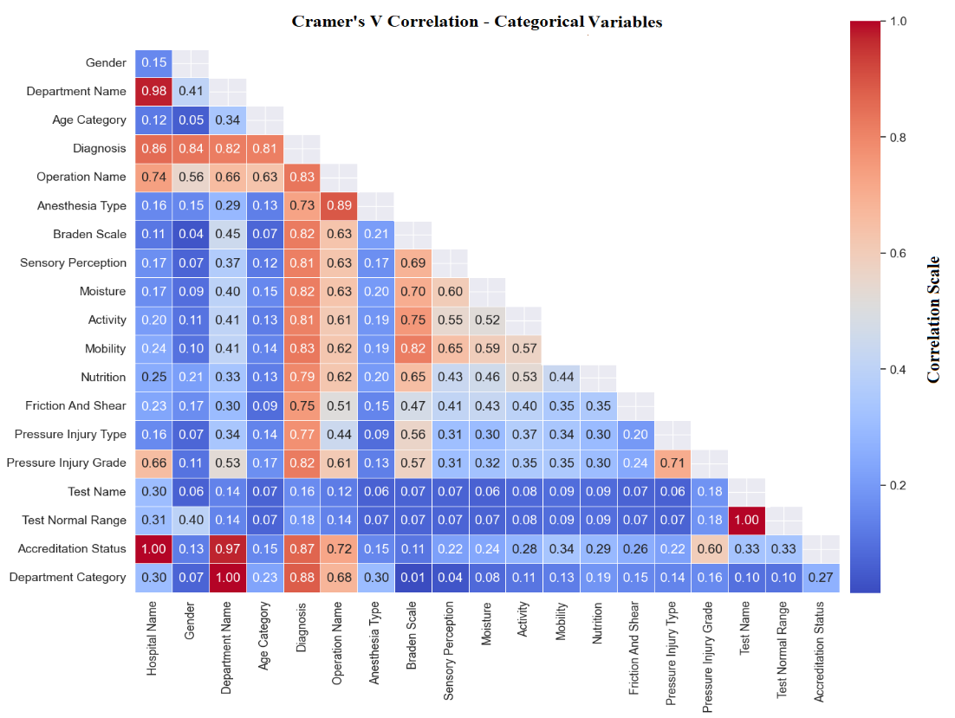
Figure 4.49: Cramer’s V Correlation for Categorical Variables with Laboratory
There is a strong association between Pressure Injury Grade and Department Name, 𝑉= 0.66, indicating a significant variability of pressure injury grades across different departments. A considerable association is also observed between Pressure Injury Grade and Diagnosis, 𝑉= 0.57, suggesting that the nature of the diagnosis significantly affects the grading of pressure injuries. Another notable association exists between Pressure Injury Grade and the Anesthesia Type, 𝑉= 0.71, indicating that the type of anesthesia used may influence the severity grade of pressure injuries.
The correlation of the categorical variables with medications is presents in Figure (4.50). It shows that there is a strong positive correlation between medication names and unit dose, which is logical due to the type of medications being linked with the type of standard protocol of medication administration.
Furthermore, there is a strong positive correlation between medication names and (accreditation status & hospital name) (0.72, 0.68), which stems from the fact that the medication protocols that are used with patients in the dataset are based on policies or protocols by the hospitals.
In addition, there is a moderate positive correlation between medication name and (pressure injury type & the Braden scale) (0.44, 0.49), which may relate to the type of medications used in the treatment or to reduce the risks of pressure injury; this also means that the medication may correlate or lead to pressure injury.
Finally, there is a moderate correlation between medication name and anesthesia types (0.43), and, logically, the anesthesia types use regular or special medications with each type of anesthesia.
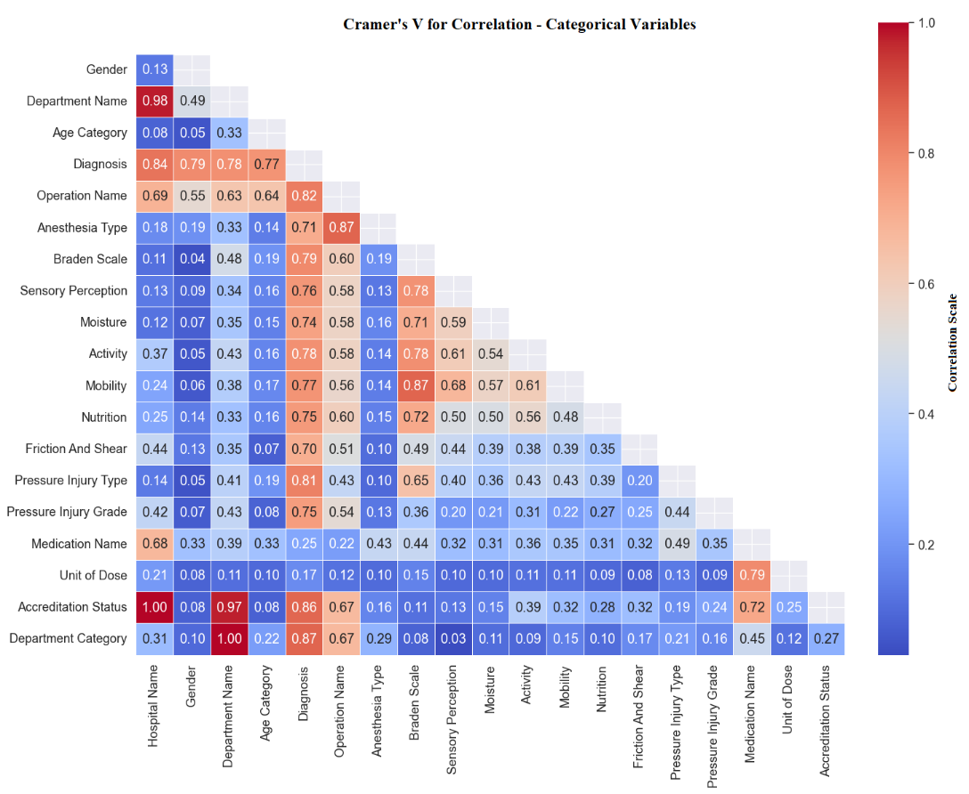
Figure 4.50: Cramer’s V Correlation for Categorical Variables with Medications
There is a strong association between type of anesthesia with operation name, V= 0.87, indicating a substantial relationship between the type of anesthesia used and the operations performed.
There is a strong association between medications with unit dose, V= 0.79, suggesting a significant linkage between medications and their dosage units.
There is a strong association between anesthesia type and Braden scale, V= 0.79. This suggests that the choice of anesthesia might correlate with the risk assessment of pressure injuries as measured by the Braden scale.
There is a strong association between medication and diagnosis, V= 0.68, indicating that certain diagnoses are consistently treated with medications.

4.6.2 Correlation of Pressure Injury with Biomarkers (Laboratory Tests)
The data concerning laboratory test and pressure injury showed that there is a weak negative correlation between the pressure injury and laboratory test results (- 0.06), which may be explained by the correlation of the results of laboratory tests with pressure injury being above or below the normal range for each test. In addition, some laboratory tests had high values in relation to the clinical situation. There are different factors, such as severity or critical status of patient’s condition, that impact and affect the laboratory results significantly, as presents in Figure (4.51).
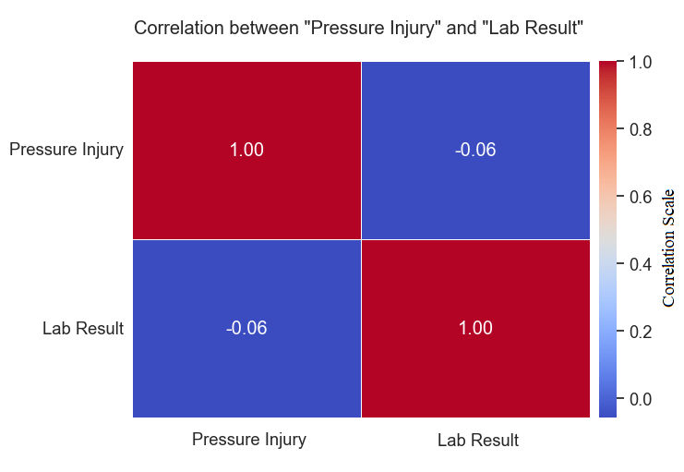
Figure 4.51: Correlation Between Pressure Injury and Lab Results
The data shows that there is a strong negative correlation between pressure injury and Alb, which was (-0.90). There is also a moderate negative correlation between pressure injury and protein, which was (-0.51). The correlation between pressure injury and bilirubin (T) is (-0.39), and the correlation between pressure injury and bilirubin (D) at (-0.38). Moreover, there is a strong positive correlation between pressure injury and WBC, which was (0.71). Finally, there is a weak positive correlation between pressure injury and creatinine, which was (0. 32), and there is a weak positive correlation between pressure injury and CRP, which was (0. 25).
The correlation analysis between pressure injury incidence and laboratory results was conducted using Pearson's correlation coefficient. The analysis revealed a very weak, negative correlation between pressure injury and lab results, r = −0.06. This suggests that there is no significant linear relationship between the incidence of pressure injuries and the laboratory results.

4.7 Statistical Tests
In preparation for applying the t-test and ANOVA to compare group means and compare means among the groups, several assumptions were assessed to ensure the appropriateness of the statistical tests. First, normality was tested in each group's data distribution using the Shapiro-Wilk test, which was suitable given our moderate sample sizes. This was complemented by visual inspections through Q-Q plots. Second, to check the homogeneity of variances between the groups, we employed Levene's Test. Both assumptions were verified, confirming that the variances were similar and the data distributions approximated normality.
Before conducting the Chi-Squared test to explore the association between two categorical variables, the key assumptions were verified to uphold the test’s validity. The expected frequency count for each cell in our contingency table was at least 5, which is critical for the accuracy of the chi-squared approximation to the chi-square distribution. This was achieved by adjusting the categorization of variables and consolidating categories where necessary. It also confirmed the independence of observations, as data from each category was collected from different subjects without overlap. Random sampling was addressed in the study design, ensuring that each sample point was independently and randomly selected, which is vital for the generalizability of the results.

4.7.1 Statistical Test of Pressure Injury with Biomarkers (Laboratory Tests)
The independent sample t-test was used to test the hypothesis of the biomarkers (laboratory test) with pressure injury. However, there are no statistically significant differences in the means of HbA1c related to pressure injury, at level (P ≤ 0.05) where the p-value is equal (0.782), as presented in Table (4.4).
There are statistically significant differences between the means (creatinine, CRP, WBC, Hb, BUN, AST, Alb, bilirubin (T), bilirubin (D), uric acid, and protein) related to pressure injury at level (P ≤ 0.05) as the p-values equal (1.61 e-16, 2.43 e-40, 2.75 e-48, 8.54 e-148, 2.13 e-49, 7.38 e-06, 2.01 e-60, 3.65 e-11, 1.17 e-12, 2.04 e-02, and 1.51 e-04) respectively, as presents in Table (4.4).
Table 4.4: Laboratory Results According to Pressure Injury Status (T. Test)

Biomarkers | Condition | Mean | t | df | P Value | 95% CI
Creatinine | Yes (HAPI) | 1.68 | 8.96 | 3989 | < .001 | [0.26, 0.41]
Creatinine | No (HAPI) | 1.34
CRP | Yes (HAPI) | 94.77 | 8.42 | 2150 | < .001 | [17.18, 28.33]
CRP | No (HAPI) | 71.11
WBC | Yes (HAPI) | 11.59 | 14.85 | 6666 | < .001 | [1.43, 1.86]
WBC | No (HAPI) | 9.94
Hb | Yes (HAPI) | 9.92 | -26.58 | 4647 | < .001 | [-1.41, -1.21]
Hb | No (HAPI) | 11.23
BUN | Yes (HAPI) | 35.61 | 18.79 | 4385 | < .001 | [10.89, 13.53]
BUN | No (HAPI) | 22.74
AST | Yes (HAPI) | 118.30 | -0.48 | 1231 | < .001 | [-83.94, 25.57]
AST | No (HAPI) | 132.53
Alb | Yes (HAPI) | 2.86 | -17.26 | 1639 | < .001 | [-0.47, -0.37]
Alb | No (HAPI) | 3.28
Bilirubin (T) | Yes (HAPI) | 2.11 | -2.47 | 1022 | < .001 | [-1.18, -0.13]
Bilirubin (T) | No (HAPI) | 2.77
Bilirubin (D) | Yes (HAPI) | 1.36 | -2.88 | 931 | < .001 | [-1.01, -0.19]
Bilirubin (D) | No (HAPI) | 1.96
Uric Acid | Yes (HAPI) | 6.37 | 2.91 | 226 | 0.20 | [0.35, 1.85]
Uric Acid | No (HAPI) | 5.27
Hb A1c | Yes (HAPI) | 7.28 | 0.28 | 348 | 0.78 | [-0.38, 0.51]
Hb A1c | No (HAPI) | 7.22
Protein | Yes (HAPI) | 5.81 | -1.14 | 291 | < .001 | [-0.83, 0.22]
Protein | No (HAPI) | 6.14
Abbreviations: df: degree of freedom, CI: confidence interval, HAPI: hospital-acquired pressure injury, CRP: C-reactive protein; WBC: white blood cells; Hb: hemoglobin; BUN: Blood urea nitrogen; AST: aspartate aminotransferase; Alb: albumin; T: Total; D: Direct, Hb A1c: hemoglobin A1c.

4.7.2 Statistical Test of Pressure Injury with Risk Factors
ANOVA was used for the continuous variables and for more than two categories, and included age, LOS, age category, type of anesthesia, operation duration, anesthesia duration, Bp systolic and diastolic, temperature, pulse, pressure injury grade, Braden score, and Braden subscales (perception, moisture, activity mobility, and nutrition). Table (4.5) shows that there are significant differences between the means of age and age category relating to pressure injury at the level (P ≤ 0.05) as the p-values <0.001.
Table 4.5: Risk Factors (Age and LOS) According to Pressure Injury (ANOVA)

Variables |  | Pressure Injury
Variables |  | Mean Square | df | F | Sig.
Age of Patients | Between Groups | 72632.83 | 1 | 227.196 | < 0.001
Age of Patients | Within Groups | 319.69 | 1108 | 227.196 | < 0.001
Age Category | Between Groups | 38.97 | 1 | 113.156 | < 0.001
Age Category | Within Groups | 0.34 | 1108 | 113.156 | < 0.001

Table (4.6) shows that there are significant differences between the means of LOS relating to pressure injury at the level (P ≤ 0.05) as the p-values <0.001.
Table 4.6: Risk Factors (Age and LOS) According to Pressure Injury (ANOVA)

Variables |  | Pressure Injury
Variables |  | Mean Square | df | F | Sig.
LOS | Between Groups | 40405.23 | 1 | 227.855 | < 0.001
LOS | Within Groups | 177.32 | 1108 | 227.855 | < 0.001
LOS | Within Groups | 0.34 | 1108 | 227.855 | < 0.001

Table (4.7) shows that there are significant differences between the means of Bp systolic, Bp diastolic, temperature, and pulse relating to pressure injury at the level (P ≤ 0.05) as the p-values (0.001, < 0.001, 0.001, 0.040) respectively.
Table 4.7: Risk Factors (Vital Signs) According to Pressure Injury (ANOVA)

Variables |  | Pressure Injury
Variables |  | Mean Square | df | F | Sig.
BP Diastolic | Between Groups | 14725.99 | 1 | 11.205 | 0.001
BP Diastolic | Within Groups | 1314.22 | 1108 | 11.205 | 0.001
BP Systolic | Between Groups | 7358.70 | 1 | 16.072 | < 0.001
BP Systolic | Within Groups | 457.86 | 1108 | 16.072 | < 0.001
Temperature | Between Groups | 3561.56 | 1 | 11.195 | 0.001
Temperature | Within Groups | 318.14 | 1108 | 11.195 | 0.001
Pulse | Between Groups | 6937.50 | 1 | 4.231 | 0.040
Pulse | Within Groups | 1639.59 | 1108 | 4.231 | 0.040

Table (4.8) shows that there are significant differences between the means of anesthesia type and anesthesia duration with pressure injury at the level (P ≤ 0.05), as the p-values (0.005 and < 0.001) respectively.
Table 4.8: Risk Factors (Anesthesia Related) According to Pressure Injury (ANOVA)

Variables |  | Pressure Injury
Variables |  | Mean Square | df | F | Sig.
Type of Anesthesia | Between Groups | 61.37 | 1 | 7.779 | 0.005
Type of Anesthesia | Within Groups | 7.88 | 1108 | 7.779 | 0.005
Anesthesia Duration | Between Groups | 104.00 | 1 | 30.019 | < 0.001
Anesthesia Duration | Within Groups | 3.46 | 538 | 30.019 | < 0.001

Table (4.9) shows that there are significant differences between the means of the Braden score and Braden subscales (perception, moisture, activity mobility, and nutrition) relating to pressure injury at the level (P ≤ 0.05), as the p-values (< 0.001, < 0.001, <0.001, < 0.001, < 0.001, < 0.001, < 0.001) respectively.

Table 4.9: Risk Factors (Braden Score and Braden Subscales) According to Pressure Injury (ANOVA)

Variables |  | Pressure Injury
Variables |  | Mean Square | df | F | Sig.
Braden Score | Between Groups | 9858.43 | 1 | 736.727 | < 0.001
Braden Score | Within Groups | 13.38 | 1108 | 736.727 | < 0.001
Braden Subscale Sensory | Between Groups | 573.69 | 1 | 800.564 | < 0.001
Braden Subscale Sensory | Within Groups | 0.717 | 1108 | 800.564 | < 0.001
Braden Subscale Moisture | Between Groups | 355.301 | 1 | 423.218 | < 0.001
Braden Subscale Moisture | Within Groups | 0.840 | 1108 | 423.218 | < 0.001
Braden Subscale Activity | Between Groups | 410.473 | 1 | 493.731 | < 0.001
Braden Subscale Activity | Within Groups | 0.831 | 1108 | 493.731 | < 0.001
Braden Subscale Mobility | Between Groups | 449.041 | 1 | 1086.362 | < 0.001
Braden Subscale Mobility | Within Groups | 0.413 | 1108 | 1086.362 | < 0.001
Braden Subscale Nutrition | Between Groups | 281.514 | 1 | 449.263 | < 0.001
Braden Subscale Nutrition | Within Groups | 0.627 | 1108 | 449.263 | < 0.001
Braden Subscale Friction | Between Groups | 132.152 | 1 | 135.664 | < 0.001
Braden Subscale Friction | Within Groups | 0.974 | 1108 | 135.664 | < 0.001

Table (4.10) shows that there are significant differences between the means of operation duration relating to pressure injury at the level (P ≤ 0.05), as the p-values < 0.001.
Table 4.10: Risk Factors (Operation Duration) According to Pressure Injury (ANOVA)

Variables |  | Pressure Injury
Variables |  | Mean Square | df | F | Sig.
OP Duration | Between Groups | 94.73 | 1 | 30.774 | < 0.001
OP Duration | Within Groups | 3.07 | 538 | 30.774 | < 0.001

Table (4.11) shows that there are significant differences between the means of pressure injury grade relating to pressure injury at the level (P ≤ 0.05), as the p-values < 0.001.

Table 4.11: Risk Factors (Pressure Injury Grade) According to Pressure Injury (ANOVA)

Variables |  | Pressure Injury
Variables |  | Mean Square | df | F | Sig.
Pressure Injury Grade | Between Groups | 538.31 | 1 | 761.586 | < 0.001
Pressure Injury Grade | Within Groups | 0.70 | 1108 | 761.586 | < 0.001

The Chai squared test was used for the categorical variables, which included gender, department type, performed operation, Braden scale, mechanical ventilator, accreditation status, pressure injury type, and medications.
For the gender variable, shows in Table (4.12), there was no significant relationship between gender and pressure injury status at X² (1, N = 1110) =1.81, p-value = 0.670.
Table 4.12: Crosstabulation of Gender and Pressure Injury

Gender of Patients | No Pressure Injury | Pressure Injury | Total
Female | 237 | 230 | 467
Female | (233.5) | (233.5) | 467
Male | 318 | 325 | 643
Male | (321.5) | (321.5) | 643
Total | 555 | 555 | 1110

In the department type variable, shows in Table (4.13), there was a significant relationship between pressure injury type and pressure injury status at X² (1, N = 1110) =81.527, p-value < 0.001.
Table 4.13: Crosstabulation of Department Type and Pressure Injury

Department Type | No Pressure Injury | Pressure Injury | Total
Open Unit | 401 | 253 | 654
Open Unit | (327.0) | (327.0) | 654
Intensive Units | 154 | 302 | 456
Intensive Units | (228.0) | (228.0) | 456
Total | 555 | 555 | 1110

For the performed operation variable, shows in Table (4.14), there was a significant relationship between performed operation and pressure injury status at X² (1, N = 1110) =10.129, p-value = 0.001.
Table 4.14: Crosstabulation of Performed Operation and Pressure Injury

Performed Operation | No Pressure Injury | Pressure Injury | Total
Yes | 297 | 244 | 541
Yes | (270.5) | (270.5) | 541
No | 258 | 311 | 569
No | (284.5) | (284.5) | 569
Total | 555 | 555 | 1110

For the Braden scale variable, shows in Table (4.15), there was a significant relationship between the Braden scale and pressure injury status at X² (1, N = 1110) =619.624, p-value < 0.001.
Table 4.159: Crosstabulation of Braden Scale and Pressure Injury

Braden Scale | No Pressure Injury | Pressure Injury | Total
High Risk | 31 | 441 | 472
High Risk | (236.0) | (236.0) | 472
Low Risk | 524 | 114 | 638
Low Risk | (319.0) | (319.0) | 638
Total | 555 | 555 | 1110

In the mechanical ventilator’s variable, shows in Table (4.16), there was a significant relationship between mechanical ventilators and pressure injury status at X² (1, N = 1110) =75.974, p-value < 0.001.
Table 4.16: Crosstabulation of Mechanical Ventilators and Pressure Injury

Mechanical Ventilators | No Pressure Injury | Pressure Injury | Total
No | 536 | 442 | 978
No | (489.0) | (489.0) | 978
Yes | 19 | 113 | 132
Yes | (66.0) | (66.0) | 132
Total | 555 | 555 | 1110

For the accreditation status variable, shows in Table (4.17), there was a significant relationship between accreditation status and pressure injury status at X² (1, N = 1110) =8.836, p-value = 0.003.
Table 4.17: Crosstabulation of Accreditation Status and Pressure Injury

Accreditation Status | No Pressure Injury | Pressure Injury | Total
Accredited | 262 | 213 | 475
Accredited | (237.5) | (237.5) | 475
Non-Accredited | 293 | 342 | 635
Non-Accredited | (317.5) | (317.5) | 635
Total | 555 | 555 | 1110

For the pressure injury type variable, shows in Table (4.18), there was a significant relationship between pressure injury type and pressure injury status at X2 (1, N = 1110) =1102.029, p-value < 0.001.
Table 4.18: Crosstabulation of Pressure Injury Type and Pressure Injury

Pressure Injury Type | No Pressure Injury | Pressure Injury | Total
HAPI | 0 | 555 | 555
HAPI | (278.5) | (278.5) | 555
No HAPI | 555 | 0 | 555
No HAPI | (278.5) | (278.5) | 555
Total | 555 | 555 | 1110
Finally, for medications variable, shows in Table (4.19), there was a significant relationship between medications and pressure injury status at X2 (1, N = 1151) =6854.12, p-value < 0.001.
Table 4.19: Crosstabulation of Medication and Pressure Injury

Medication | No Pressure Injury | Pressure Injury | Total
Mediations | 297 | 244 | 541
Mediations | (270.5) | (270.5) | 541
No Medications | 258 | 311 | 569
No Medications | (284.5) | (284.5) | 569
Total | 555 | 555 | 1110

4.8 Model Developments Methodology
All constructed models were trained by using eight machine learning algorithms as follows: regression algorithms, including linear regression and SVR, and classification, including LR, RF, GB, KNN, DT, and XG boost. The results of the training were based on performance metrics; these metrics were divided into two types: classification and regression. For regression, the performance metrics were MSE and R²; for classification accuracy, they were AUC, sensitivity, precision, F1 score, TRP, and FPR.
The predictive models were constructed in two phases. The first one, different models were constructed by using different features, and the results of the training with ratio (80% and 20%) were compared; in this phase, four models were constructed, each model having eight algorithms, and these experiments were based on the features included in each model.
The second phase started with selecting the better models to train the predictive model with its features, with a ratio of (80% and 20%) on the multi-fused dataset, and the saved trained model was uploaded to evaluate the predictive model with a testing dataset that has the same structure of the previous dataset to compare the results. Finally, the best model was selected based on performance metrics, and the success model was named by the researcher “EADB Model”, as presented in Figure (4.52).
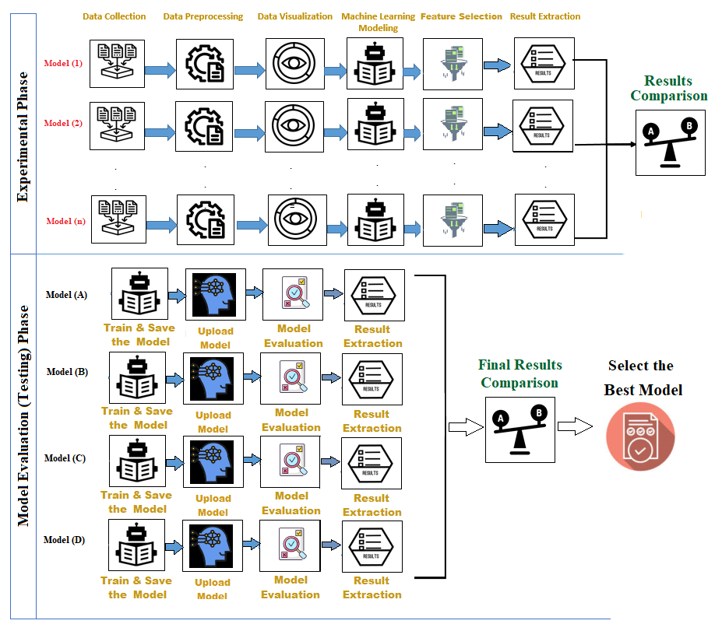
Figure 4.52: Model Results Extraction Methodology
The risk factors in the prediction models of pressure injury were distributed into the training and testing datasets, as presented in Table (4.20).

Table 4.20: Risk Factors Distribution into Training and Testing Dataset

Factors/Features | Sub-Factors/Features | Training Dataset | Testing Dataset
Accreditation Status | Accredited | 359 patients (75.6%) | 116 patients (24.4%)
Accreditation Status | Not Accredited | 499 patients (78.6%) | 136 patients (21.4%)
Department Category | Open Units | 516 patients (87.9%) | 138 patients (21.1%)
Department Category | Intensive Units | 342 patients (73.5%) | 114 patients (26.5%)
Gender | Male | 501 patients (77.9%) | 142 patients (22.1%)
Gender | Female | 357 patients (76.4%) | 110 patients (23.4%)
Age Category | Elderly (65 years and over) | 330 patients (76.0%) | 104 patients (24.0%)
Age Category | Adults (25-64 years) | 459 patients (78.6%) | 125 patients (21.4%)
Age Category | Young Adult (18-24 years) | 69 patients (75.0%) | 23 patients (25.0%)
Performed Operation | Yes | 415 patients (76.7%) | 126 patients (23.4%)
Performed Operation | No | 443 patients (77.9%) | 126 patients (22.1%)
Anesthesia Type | General | 256 patients (74.2%) | 89 patients (25.8%)
Anesthesia Type | Local Anesthesia | 134 patients (82.2%) | 29 patients (17.8 %)
Anesthesia Type | Spinal | 13 patients (0.50%) | 5 patients (0.77%)
Anesthesia Type | Sedation | 11 patients (0.42%) | 2 patients (0.31%)
Anesthesia Type | Epidural | 1 patient (0.04%) | 0 patients (0.00%)
Anesthesia Type | CSE | 0 patients (0.00%) | 1 patient (0.15%)
Mechanical Ventilator | No | 762 patients (29.42%) | 216 patients (33.33%)
Mechanical Ventilator | Yes | 96 patients (3.71%) | 36 patients (5.56%)
Braden Scale Level | Low Risk | 500 patients (19.31%) | 138 patients (21.30%)
Braden Scale Level | High Risk | 358 patients (13.82%) | 114 patients (17.59%)
Subscale / Moisture | Rarely Moist | 393 patients (15.17%) | 117 patients (18.06%)
Subscale / Moisture | Occasionally Moist | 348 patients (13.44%) | 102 patients (15.74%)
Subscale / Moisture | Constantly Moist | 54 patients (2.08%) | 12 patients (1.85%)
Subscale / Moisture | Very Moist | 63 patients (2.43%) | 21 patients (3.24%)
Subscale / Activity | Walks Frequently | 371 patients (14.32%) | 116 patients (17.90%)
Subscale / Activity | Bed Fast | 158 patients (6.10%) | 41 patients (6.33%)
Subscale / Activity | Walks Occasionally | 291 patients (11.24%) | 83 patients (12.81%)
Subscale / Activity | Chair Fast | 38 patients (1.47%) | 12 patients (1.85%)
Sensory Perception | No Impairment | 462 patients (17.84%) | 127 patients (19.60%)
Sensory Perception | Completely Limited | 70 patients (2.70%) | 16 patients (2.47%)
Sensory Perception | Slightly Limited | 284 patients (10.97%) | 98 patients (15.12%)
Sensory Perception | Very Limited | 42 patients (1.62%) | 11 patients (1.70%)
Mobility | No Limitations | 409 patients (15.79%) | 111 patients (17.13%)
Mobility | Completely Immobile | 74 patients (2.86%) | 15 patients (2.31%)
Mobility | Slightly Limited | 137 patients (5.29%) | 53 patients (8.18%)
Mobility | Very Limited | 238 patients (9.19%) | 73 patients (11.27%)
Nutrition Statistics | Excellent | 383 patients (14.79%) | 115 patients (17.75%)
Nutrition Statistics | Adequate | 347 patients (13.40%) | 108 patients (16.67%)
Nutrition Statistics | Probably Inadequate | 78 patients (3.01%) | 22 patients (3.40%)
Nutrition Statistics | Very Poor | 36 patients (1.39%) | 4 patients (0.62%)
Nutrition Statistics | Inadequate | 14 patients (0.54%) | 3 patients (0.46%)
Friction And Shear | No Potential or Apparent | 686 patients (26.49%) | 199 patients (30.71%)
Friction And Shear | Friction and Shear | 101 patients (3.90%) | 21 patients (3.24%)
Friction And Shear | Problem | 67 patients (2.59%) | 31 patients (4.78%)
Friction And Shear | Potential Problem | 2 patients (0.08%) | 0 patients (0.00%)
Friction And Shear | No Apparent Problem | 2 patients (0.08%) | 1 patient (0.15%)
Pressure Injury Type | No Pressure Injury | 437 patients (16.88%) | 118 patients (18.21%)
Pressure Injury Type | Hospital Acquired | 421 patients (16.25%) | 134 patients (20.68%)

4.9 Prediction Models of Pressure Injury
The prediction models were developed after determining the features that used in each experiment to construct the prediction model. Those features were determined as predefined groups, which are considered potential predictive features (factors) based on the results previously explained, and each model and experiment in one of those groups was utilized.
The eight machine learning algorithms, regression algorithms (included linear regression and SVR), and the classification (included LR, RF, GB, KNN, DT, and XG boost) were applied to all models. The performance metrics evaluated the developed model, and a 5-fold cross-validation was conducted to ensure the validation of results and reduce the overfitting.
The prediction models were categorized into four groups based on the previous features: group one (potential factors that had high correlation with pressure injury), group two (potential factors that had statistical significance with pressure injury), group three (potential factors that had high importance of features), and group four (potential factors that had high correlation with pressure injury without Braden scale). The models developed in the experiment were identified and linked to the features group that was recruited in each model. Furthermore, the developed models were 5-fold cross-validated, and the trained models were tested after the validation and evaluated to determine which was the best model. The model evaluation was conducted based on the different performance metrics; the following sections discuss the developed models and experiments in detail.

4.9.1 Model - Potential Factors That Had High Correlation with Pressure Injury
The potential factors that correlate with pressure injury were age, diagnosis, operation, anesthesia type, accreditation status, department category, Braden scale level, pulse, BP systolic, length of stay, medications (Adrenaline, Norepinephrine), and lab tests (Alb, WBC, Protein). These potential factors were used to predict pressure injury by eight machine learning algorithms to find the best model and reliable model results. The developed model with performance metrics results is presented in Table (4.21).

4.9.1.1 Results of Linear Regression Algorithm
Linear regression was used to predict the pressure injury as the targeted variable with potential factors. This algorithm was measured by two key performance metrics: MSE and R²; the MSE was 0.036, and R² was 0.748. This showed that the model indicates a good fit while the average squared of differences between the predicted and actual values is low. The R² is about 75% of the variations in the target variable (pressure injury) detected by the potential factors in the developed model (features).

4.9.1.2 Results of Support Vector Regression Algorithm
SVR was used, and the two-performance metrics showed that the MSE was 0.027 and the R² was 0.810. This indicates that the model is a good fit and the average squared of differences between predicted and actual value is low. The R² is about 81% of the variations in the targeted variable (pressure injury) detected by the potential factors in the developed model (features).

4.9.1.3 Results of Logistic Regression Algorithm
The LR algorithm was measured by the following performance metrics: accuracy, precision, recall, F1 score, and AUC, with accuracy: 0.963, precision: 0.950, recall: 0.918, F1: 0.933, AUC: 0.918, FPR: 0.347, and TPR: 0.907. These metrics showed that the model indicates an excellent performance, and the five metrics, accuracy, precision, recall, and AUC, are considered high. The FPR was moderate, which is considered bad when the model predicts 34% of pressure injury cases for unaffected patients.

4.9.1.4 Results of Random Forest Algorithm
The RF algorithm was measured by the following performance metrics: accuracy, precision, recall, F1 score, and AUC; accuracy: 0.987, precision: 0.979, recall: 0.977, F1: 0.978, AUC: 0.977, FPR: 0.0284, and TPR: 0.880. These metrics showed that the model indicates an excellent performance, and that the five metrics, accuracy, precision, recall, and AUC, are considered high. The FPR was moderate, which is considered bad when the model predicts 28% of pressure injury cases for unaffected patients.

4.9.1.5 Results of Gradient Boosting Algorithm
The GB algorithm was measured by the following performance metrics: accuracy, precision, recall, F1 score, and the AUC; accuracy: 0.975, precision: 0.960, recall: 0.953, F1: 0.956, AUC: 0.9531, FPR: 0.116, and TPR: 0.801. These metrics showed that the model indicates an excellent performance, and that the five metrics, accuracy, precision, recall, and AUC are considered high. The FPR was moderate, which is considered better when the model predicts 11% of pressure injury cases for unaffected patients.

4.9.1.6 Results from the K-Nearest Neighbors Algorithm
The KNN algorithm was measured by the following performance metrics: accuracy, precision, recall, F1 score, and AUC; accuracy: 0.975, precision: 0.960, recall: 0.953, F1: 0.956, AUC: 0.9531, FPR: 0.116, and TPR: 0.801. These metrics showed that the model indicates an excellent performance, and that the five metrics, accuracy, precision, recall, and AUC are considered high, The FPR was moderate, which is considered better when the model predicts 11% of pressure injury cases for unaffected patients.

4.9.1.7 Results of Decision Tree Algorithm
The DT algorithm was measured by performance metrics: accuracy, precision, recall, F1 score, and AUC; accuracy: 0.983, precision: 0.974, recall: 0.967, F1: 0.9710, AUC: 0.967, FPR: 0.336, and TPR: 0.648. These metrics showed that the model indicates an excellent performance, and that the five metrics, accuracy, precision, recall, and AUC are considered high. The FPR was high, which is considered bad, and so is the case for LR when the model predicts 33% of pressure injury cases for unaffected patients.

4.9.1.8 Results of Extreme Gradient Boosting Algorithm
The XG boost algorithm was measured by performance metrics: accuracy, precision, recall, F1 score, and AUC; accuracy: 0.925, precision: 0.930, recall: 0.799, F1: 0.846, AUC: 0.799, FPR: 0.062, and TPR: 0.762. These metrics showed that the model indicates an excellent performance, and the five metrics, accuracy, precision, recall, and AUC are considered high. The FPR was very high, which is considered better when the model predicts 6.3% of pressure injury cases for unaffected patients.

4.9.1.9 Model (A) Results Comparison
Table (5.2) presents the performance metrics that resulted from the eight MLA that developed within the model (A), which include potential factors that had a high correlation with pressure injury. This table is categorized into two type-based regression and classification algorithms with the proper metrics used with each algorithm.

Table 4.11: Comparison of Performance Metrics of ML Algorithms – Model (A)

Classification |  |  |  |  |  |  |  | Regression
Algorithm | Accuracy | Precision | Recall | F1 | AUC | FPR | TPR | MSE | R2
LR | 0.964 | 0.950 | 0.919 | 0.934 | 0.919 | 0.348 | 0.907 | - | -
RF | 0.988 | 0.980 | 0.978 | 0.979 | 0.978 | 0.028 | 0.880 | - | -
GB | 0.976 | 0.960 | 0.953 | 0.957 | 0.953 | 0.116 | 0.802 | - | -
KNN | 0.966 | 0.947 | 0.930 | 0.938 | 0.930 | 0.162 | 0.753 | - | -
DT | 0.984 | 0.974 | 0.968 | 0.971 | 0.968 | 0.336 | 0.648 | - | -
XGBoost | 0.926 | 0.930 | 0.799 | 0.847 | 0.799 | 0.063 | 0.763 | - | -
SVR | - | - | - | - | - | - | - | 0.027 | 0.810
Linear | - | - | - | - | - | - | - | 0.036 | 0.748

The performance metrics (accuracy, precision, recall, F1 score, AUC, FPR, and TPR) were used to compare the machine learning algorithms used in model (A), as presented in Figures (4.53 – 4.59). These metrics showed high performance in general, and the RF had the highest metrics among all algorithms. For accuracy, all algorithms showed excellent performance, and RF was the best algorithm, as presents in Figure (4.53).

Figure 4.53: Comparison Between ML Algorithms: Accuracy – Model (A)
Figure (4.54) shows that the precision for all algorithms had a high performance, and that RF was the best algorithm.

Figure 4.54: Comparison Between ML Algorithms: Precision – Model (A)
Figure (4.55) shows that the recall had a high performance for all algorithms except the XGBoost, which had good performance, and RF was the best algorithm.

Figure 4.55: Comparison Between ML Algorithms: Recall – Model (A)
Figure (4.56) shows that the F1 score had a high performance for all algorithms except the XGBoost, which had a good performance, and RF was the best algorithm.

Figure 4.56: Comparison Between ML Algorithms: F1 Score – Model (A)
Figure (4.57) shows that the AUC had a high performance for all algorithms except the XGBoost, which had a good performance, and RF was the best algorithm.

Figure 4.57: Comparison Between ML Algorithms: AUC – Model (A)
Figure (4.58) shows that the FPR had a good performance for all algorithms except the RF and XGBoost, which had excellent performances, and RF was the best algorithm.

Figure 4.58: Comparison Between ML Algorithms: FPR – Model (A)
Figure (4.59) shows the TPR had a good performance for all algorithms except the LR, which had excellent performance, and LR was the best algorithm.

Figure 4.59: Comparison Between ML Algorithms: TPR – Model (A)
Figure (4.60) shows that the RF model had the best algorithms in the model for most of the performance metrics, followed by Gradient Boost and DT.

Figure 4.60: Comparison Between ML Algorithms – Model (A)
Furthermore, these algorithms were compared in the ROC curve, which was used to highlight the results of the model between FPR and TPR, and that the algorithms showed strong performance in comparison with the chance line (0.05), favoring RF algorithms which had a close to perfect performance; the AUC under ROC was one, as presents in Figure (4.61).
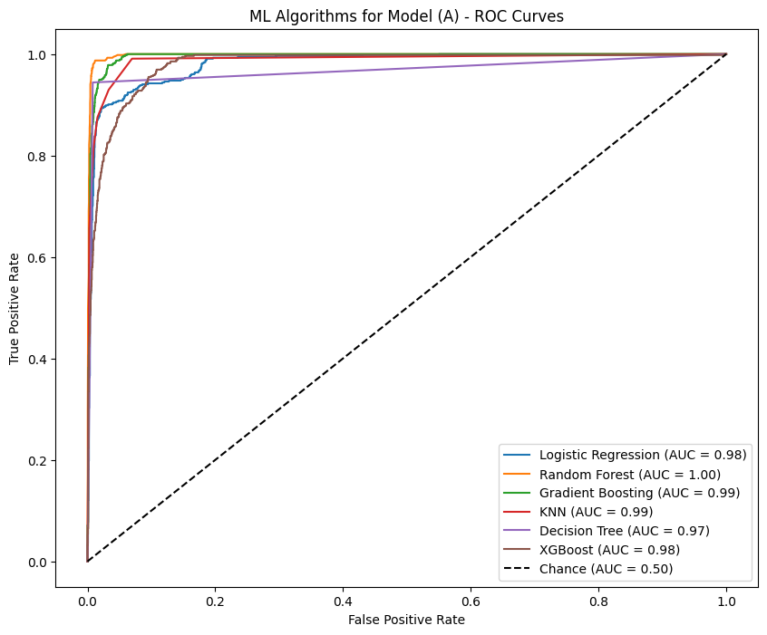
Figure 4.61: ML Algorithms for Model (A) - ROC Curves
Finally, all algorithms used in model (A) had a strong and excellent performance with the following predictive risk factors: age, diagnosis, operation, anesthesia type, accreditation status, department category, Braden scale level, pulse, BP systolic, length of stay, medications (Adrenaline, Norepinephrine), and lab tests (Albumin, WBC, Protein). In this model, RF had the best overall performance metrics in comparison with other classification algorithms tasks, while the SVR was the best among the regression algorithms.

4.9.2 Model - Potential Factors with Significant Statistical Test with Pressure Injury
The potential factors that correlate with pressure injury were gender, age, diagnosis, operation name, anesthesia type, anesthesia duration/hours, operation duration/hours, accreditation status, department category, Braden scale level, bp systolic, bp diastolic, temperature, pulse, length of stay, mechanical ventilator, sensory perception, moisture, activity, mobility, nutrition, friction and shear, lab test (albumin, bilirubin (D), bilirubin (T), blood urea nitrogen (BUN), CRP, creatinine, Hb, uric acid, and WBC), and medications (Adrenalin, Nitroglycerin, and Norepinephrine). These potential factors were used to predict pressure injury by eight machine learning algorithms to find the best model and reliable model results.

4.9.2.1 Results of Linear Regression Algorithm
Linear regression was used to predict the pressure injury as the targeted variable with potential factors. This algorithm was measured by two key performance metrics: Mean Squared Error (MSE) and coefficient of determination (R²⁾); the MSE was 0.033 and R² was 0.769, which indicates that the model is a good fit, while the average squared of differences between the predicted and actual values is low. The R² was about 77% of the variations in the targeted variable (pressure injury) detected by the potential factors in the developed model (features).

4.9.2.2 Results of Support Vector Regression Algorithm
Support Vector Regression (SVR) was used, and the two metrics showed that the MSE was 0.019 and the R² was 0.869; this indicates that the model is a good fit and the average squared of differences between predicted and actual value is low. The R² was about 87% of the variations in the targeted variable (pressure injury) detected by the potential factors in the developed model (features).

4.9.2.3 Results of Logistic Regression Algorithm
Logistic regression algorithm was measured by the following performance metrics: accuracy, precision, recall, F1 score, and AUC; accuracy: 0.956, precision: 0.958, recall: 0.886, F1: 0.917, AUC: 0.886, FPR: 0.277, and TPR: 0.920. These metrics showed that the model indicates an excellent performance, and that the five metrics, accuracy, precision, recall, F1 score, and AUC, are considered high. The FPR was moderate, which is considered bad when the model predicts 27% of pressure injury cases for unaffected patients.

4.9.2.4 Results of Random Forest Algorithm
Random forest algorithm was measured by the following performance metrics: accuracy, precision, recall, F1 score, and the AUC; the accuracy: 0.992, precision: 0.985, recall: 0.986, F1: 0.985, AUC: 0.986, FPR: 0.048, and TPR: 0.882. These metrics indicates that the model has an excellent performance, and that the five metrics, accuracy, precision, recall, and AUC, are considered high. The FPR was low, which is considered the best when the model predicts 4.8% of pressure injury cases for unaffected patients.

4.9.2.5 Results of Gradient Boosting Algorithm
Gradient boosting algorithm was measured by the following performance metrics: accuracy, precision, recall, F1 score, and AUC; accuracy: 0.981, precision: 0.968, recall: 0.967, F1: 0.967, AUC: 0.967, FPR: 0.126, and TPR: 0.876. These metrics indicates that the model has an excellent performance, and that the five metrics, accuracy, precision, recall, and AUC, are considered high. The FPR was moderate, which is considered better when the model predicts 12% of pressure injury cases for unaffected patients.

4.9.2.6 Results of the K-Nearest Neighbors Algorithm
The K-Nearest Neighbors (KNN) algorithm was measured by the following performance metrics: accuracy, precision, recall, F1 score, and AUC; accuracy: 0.961, precision: 0.951, recall: 0.909, F1: 0.928, AUC: 0.909, FPR: 0.158, and TPR: 0.721. These metrics indicates that the model has an excellent performance, and that the five metrics, accuracy, precision, recall, and AUC, are considered high. The FPR was moderate, which is considered better when the model predicts 15% of pressure injury cases for unaffected patients.

4.9.2.7 Results from Decision Tree Algorithm
The decision tree algorithm was measured by the following performance metrics: accuracy, precision, recall, F1 score, and AUC; accuracy: 0.987, precision: 0.977, recall: 0.979, F1: 0.978, AUC: 0.979, FPR: 0.336, and TPR: 0.655. These metrics indicates that the model an excellent performance, and that the five metrics, accuracy, precision, recall, and AUC, are considered high. The FPR was high, which is considered as the case with LR, when the model predicts 33% of pressure injury cases for unaffected patients.

4.9.2.8 Results from Extreme Gradient Boosting Algorithm
The extreme gradient boosting (XG boost) algorithm was measured by the following performance metrics: accuracy, precision, recall, F1 score, and AUC; accuracy: 0.939, precision: 0.946, recall: 0.833, F1: 0.877, AUC: 0.833, FPR: 0.044, and TPR: 0.787. These metrics indicates that the model has an excellent performance, and that the five metrics, accuracy, precision, recall, F1 score, and AUC, are considered high. The FPR was very high, which is considered better when the model predicts 4.4% of pressure injury cases for unaffected patients.

4.9.2.9 Model (B) Results Comparison
Table (4.22) presents the performance metrics that resulted from the eight machine learning algorithms developed within model (B), which include potential factors that had a high correlation with statistically significant with pressure injury. This table is categorized into two types: regression and classification algorithms with the proper metrics used with each one.
Table 4.22: Comparison of Performance Metrics of ML Algorithms – Model (B)

Classification |  |  |  |  |  |  |  | Regression
Algorithm | Accuracy | Precision | Recall | F1 | AUC | FPR | TPR | MSE | R2
LR | 0.956 | 0.958 | 0.886 | 0.917 | 0.886 | 0.277 | 0.920 | NA | NA
RF | 0.992 | 0.985 | 0.986 | 0.985 | 0.986 | 0.048 | 0.882 | NA | NA
GB | 0.981 | 0.968 | 0.967 | 0.967 | 0.967 | 0.126 | 0.876 | NA | NA
KNN | 0.961 | 0.951 | 0.909 | 0.928 | 0.909 | 0.158 | 0.721 | NA | NA
DT | 0.987 | 0.977 | 0.979 | 0.978 | 0.979 | 0.336 | 0.655 | NA | NA
XGBoost | 0.939 | 0.946 | 0.833 | 0.877 | 0.833 | 0.044 | 0.787 | NA | NA
SVR | NA | NA | NA | NA | NA | NA | NA | 0.019 | 0.869
Linear | NA | NA | NA | NA | NA | NA | NA | 0.033 | 0.769
The performance metrics (accuracy, precision, recall, F1 score, AUC, FPR, and TPR) were used to compare the machine learning algorithms used in model (B), as presented in Figures (4.62 – 4.68). These metrics showed high performance in general, and the RF had the highest metrics performance. For accuracy, all algorithms showed excellent performance, and the RF was the best algorithm, as presents in Figure (4.62).

Figure 4.62: Comparison Between ML Algorithms: Accuracy – Model (B)
Figure (4.63) shows that the precision for all algorithms had a high performance and that RF was the best algorithm.

Figure 4.63: Comparison Between ML Algorithms: Precision – Model (B)
Figure (4.64) shows that the recall had a high performance for all algorithms except the XGBoost; LR had good performance, and RF was the best algorithm.

Figure 4.64: Comparison Between ML Algorithms: Recall – Model (B)
Figure (4.65) shows that the F1 score had a high performance for all algorithms except the XGBoost, which had good performance, and RF was the best algorithm.

Figure 4.65: Comparison Between ML Algorithms: F1 Score – Model (B)
Figure (4.66) shows that AUC had a high performance for all algorithms except the XGBoost, for which it had good performance, RF was the best algorithm.

Figure 4.66: Comparison Between ML Algorithms: AUC – Model (B)
Figure (4.67) shows that FPR had a good performance for all algorithms except the RF; XGBoost had excellent performance was the best algorithm.

Figure 4.67: Comparison Between ML Algorithms: FPR – Model (B)
Figure (4.68) shows that TPR had a good performance for all algorithms and an excellent performance for LR, which was the best algorithm.

Figure 4.68: Comparison Between ML Algorithms: TPR – Model (B)
Figure (4.69) shows that the RF model had the best algorithms in the model, along with the performance metrics.

Figure 4.69: Comparison Between ML Algorithms – Model (B)
Furthermore, these algorithms were compared in the ROC curve, which was used to highlight the results of the model between FPR and TPR; the algorithms showed strong performance in comparison with the chance line (0.05), favoring to the RF and Gradient Boosting algorithms which shows close to perfect performance as AUC under ROC was 1, as presented in Figure (4.70).
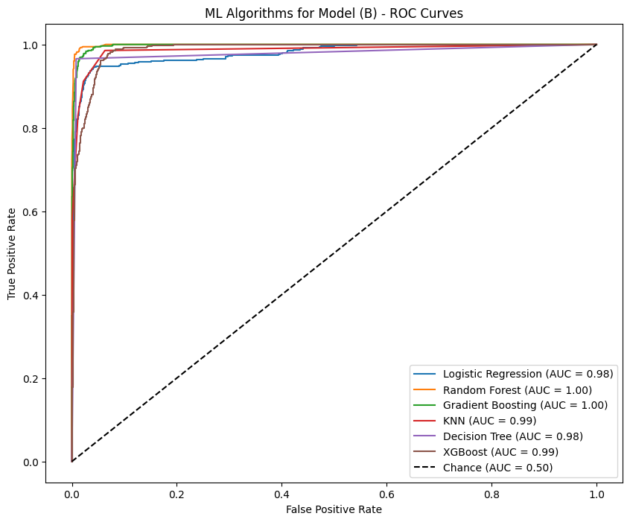
Figure 4.70: ML Algorithms for Model (B) - ROC Curves
Finally, all algorithms used in model (B) had strong and excellent performance with the following predictive risk factors: gender, age, diagnosis, operation name, anesthesia type, anesthesia duration/hours, operation duration/hours, accreditation status, department category, Braden scale level, bp systolic, bp diastolic, temperature, pulse, length of stay, mechanical ventilator, sensory perception, moisture, activity, mobility, nutrition, friction and shear, lab test (albumin, bilirubin (D), bilirubin (T), blood urea nitrogen (BUN), CRP, creatinine, Hb, PLT, Urea, uric acid, and WBC), and medications (Adrenalin, Nitroglycerin, and Norepinephrine). RF had the best overall performance metrics in comparison with other classification algorithms, and SVR had the best among the regression algorithms in this model.

4.9.3 Model - Potential Factors with Features Importance Related to Pressure Injury
The potential factors that have features importance with pressure injury were gender, length of stay, hospital name, accreditation status, department category, diagnosis, operation name, sensory perception, moisture, activity, mobility, nutrition, friction and shear, laboratory test (albumin), temperature, Braden scale level, Braden score, and medications (Budicort and Vancomycin). These potential factors were used to predict pressure injury by eight machine learning algorithms to find the best model and reliable model results.

4.9.3.1 Results from Support Linear Regression Algorithm
Linear regression was used to predict pressure injury as the targeted variable with potential factors. This algorithm was measured by two key performance metrics: Mean Squared Error (MSE) and R² (R-squared); the MSE was 0.191, and R² was (- 0.343). This indicates that the model it is not fit, as R² was negative ( -0.343), and that below the basic function of linear model and the model cannot predict the variations in the targeted variable (pressure injury) by the potential factors in the developed model (features).

4.9.3.2 Results from Support Vector Regression Algorithm
Support Vector Regression (SVR) was used, and for the two metrics, MSE was 0.080 and the R² was 0.438. This indicates that the model is fit and the average squared of differences between predicted and actual value are low; but for the R² only about 43% of the variations in the targeted variable (pressure injury) were detected by the potential factors in the developed model (features).

4.9.3.3 Results from Logistic Regression Algorithm
The logistic regression algorithm was measured by the following performance metrics: accuracy, precision, recall, F1 score, and AUC; accuracy: 0.827, precision: 0.648, recall: 0.513, F1: 0.485, AUC: 0.513, FPR: 0.579, and TPR: 0.400. These metrics indicates that the model had a bad performance, and that the five metrics, accuracy, precision, recall, F1 score, and AUC, were overall low except for accuracy, which was 0.827. The FPR was high, which is considered bad when the model predicts 58% of pressure injury cases for unaffected patients.

4.9.3.4 Results from Random Forest Algorithm
The random forest algorithm was measured by the following performance metrics: accuracy, precision, recall, F1 score, and AUC; accuracy: 0.838, precision: 0.718, recall: 0.583, F1: 0.601, AUC: 0.583, FPR: 0.317, and TPR: 0.317. These metrics indicates that the model had a bad performance, and that the five metrics, accuracy, precision, recall, F1 score, and AUC, were overall low except for accuracy, which was 0.838, and precision, which was 0.718. The FPR was moderate, which is considered bad when the model predicts 31% of pressure injury cases for unaffected patients.

4.9.3.5 Results from Gradient Boosting Algorithm
The gradient boosting algorithm was measured by the following performance metrics: accuracy, precision, recall, F1 score, and AUC; accuracy: 0.713, precision: 0.498, recall: 0.498, F1: 0.498, AUC: 0.498, FPR: 0.631, and TPR: 0.396. These metrics indicates that the model had a bad performance, and that the five metrics, accuracy, precision, recall, F1 score, and AUC, were overall low. The FPR was very high, which is considered the worst value among the algorithms, as the model predicts 63% of pressure injury cases for unaffected patients.

4.9.3.6 Results from the K-Nearest Neighbors Algorithm
The K-Nearest Neighbors (KNN) algorithm was measured by the following performance metrics: accuracy, precision, recall, F1 score, and AUC; accuracy: 0.840, precision: 0.83, recall: 0.541, F1: 0.534, AUC: 0.541, FPR: 0.152, and TPR: 0.231. These metrics indicates that the model had a good performance. The accuracy and precision were good, but the other metrics had a bad performance (recall and AUC). The FPR was moderate, which is considered the best among the algorithms in this model, as the model predicts 15% of pressure injury cases for unaffected patients.

4.9.3.7 Results from Decision Tree Algorithm
The decision tree algorithm was measured by the following performance metrics: accuracy, precision, recall, F1 score, and AUC; accuracy: 0.827, precision: 0.676, recall: 0.591, F1: 0.609, AUC: 0.591, FPR: 0.349, and TPR: 0.410. These metrics indicates that the model moderate performance, and the metrics, precision, recall, F1 score, and AUC were bad, but the accuracy was 0.827. The FPR was high, as the model predicted that 35% of pressure injury cases for unaffected patients.

4.9.3.8 Results from Extreme Gradient Boosting Algorithm
The extreme gradient boosting (XG boost) algorithm was measured by the following performance metrics: accuracy, precision, recall, F1 score, and AUC; accuracy: 0.834, precision: 0.696, recall: 0.583, F1: 0.599, AUC: 0.583, FPR: 0.542, and TPR: 0.411. These metrics indicates that the model had a bad performance among the metrics, (namely in precision, recall, and AUC), except the accuracy. The FPR was high, as the model predicted 54% of pressure injury cases for unaffected patients.

4.9.3.9 Model (C) Results Comparison
Table (4.23) presents the performance metrics that resulted from the eight machine learning algorithms developed within model (C), which included potential factors that had a high correlation with significant statistical tests with pressure injury. This table is categorized into two type-based regression and classification algorithms with the proper metrics used with each one.
Table 4.23: Comparison of Performance Metrics of ML Algorithms – Model (C)

Classification |  |  |  |  |  |  |  | Regression
Algorithm | Accuracy | Precision | Recall | F1 | AUC | FPR | TPR | MSE | R2
LR | 0.828 | 0.649 | 0.514 | 0.486 | 0.514 | 0.580 | 0.400 | NA | NA
RF | 0.838 | 0.718 | 0.584 | 0.601 | 0.584 | 0.318 | 0.317 | NA | NA
GB | 0.713 | 0.498 | 0.498 | 0.498 | 0.498 | 0.631 | 0.396 | NA | NA
KNN | 0.840 | 0.834 | 0.541 | 0.534 | 0.541 | 0.153 | 0.231 | NA | NA
DT | 0.828 | 0.677 | 0.592 | 0.609 | 0.592 | 0.350 | 0.411 | NA | NA
XGBoost | 0.834 | 0.696 | 0.583 | 0.600 | 0.583 | 0.542 | 0.411 | NA | NA
SVR | NA | NA | NA | NA | NA | NA | NA | 0.080 | 0.438
Linear | NA | NA | NA | NA | NA | NA | NA | 0.191 | -0.343
The performance metrics (accuracy, precision, recall, F1 score, AUC, FPR, and TPR) were used to compare the machine learning algorithms used in model (C) as presented in Figures (4.71 – 4.77). These metrics showed moderate performance in general, and the KNN had the highest metrics. For accuracy, all algorithms showed a good performance, and RF was the best algorithm, as presents in Figure (4.71).

Figure 4.71: Comparison Between ML Algorithms: Accuracy – Model (C)
Figure (4.72) showed that the precision for all algorithms had a moderate performance, and the KNN had a good performance; KNN was the best algorithm.

Figure 4.72: Comparison Between ML Algorithms: Precision – Model (C)
Figure (4.73) shows that the recall had a moderate to bad performance for all algorithms, and DT was the best algorithm.

Figure 4.73: Comparison Between ML Algorithms: Recall – Model (C)
Figure (4.74) shows that the F1 score had a high performance for all algorithms, except the XGBoost which only had good performance, and RF was the best algorithm.

Figure 4.74: Comparison Between ML Algorithms: F1 Score – Model (C)
Figure (4.75) shows that the AUC had a moderate to bad performance for all algorithms, and DT was the best algorithm.

Figure 4.75: Comparison Between ML Algorithms: AUC – Model (C)
Figure (4.76) shows that the FPR had a bad performance for most algorithms except KNN, DT, and RF, which had a moderate to good performance, and KNN was the best algorithm.

Figure 4.76: Comparison Between ML Algorithms: FPR – Model (C)
Figure (4.77) shows that the TPR had a bad performance for all algorithms except KNN, which had a good performance, and KNN was the best algorithm.

Figure 4.77: Comparison Between ML Algorithms: TPR – Model (C)
Figure (4.78) shows that the RF model had the best algorithms in the model, along with the performance metrics.

Figure 4.78: Comparison Between ML Algorithms – Model (C)
Furthermore, these algorithms were compared in the ROC curve, which was used to highlight the results of the model between FPR and TPR, and the algorithms showed bad performance in comparison with the chance line (0.05), favouring the KNN algorithms where the AUC under ROC was 1, as presents in Figure (4.79).
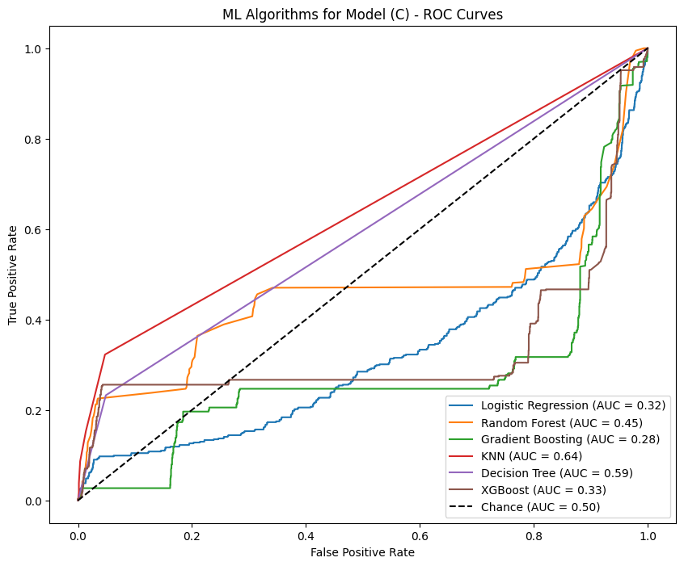
Figure 4.79: ML Algorithms for Model (C) - ROC Curves
Finally, all algorithms used in model (C) had bad performance with the following predictive risk factors: gender, length of stay, hospital name, accreditation status, department category, diagnosis, operation name, sensory perception, moisture, activity, mobility, nutrition, friction and shear, albumin, temperature, Braden scale level, Braden score, and medications (Budicort and Vancomycin). KNN had the best overall performance metrics in comparison with other classification algorithms, and SVR was the best in comparison with other regression algorithms in this model.

4.9.4 Model - Potential Factors with High Correlation without Braden Scale Level
The potential factors that had a high correlation with pressure injury are age, moisture, activity, length of stay, blood pressure systolic (BP), and albumin. These potential factors were used to predict pressure injury by eight machine learning algorithms to find the best model and reliable model results.

4.9.4.1 Results from Linear Regression Algorithm
Linear regression was used to predict pressure injury as the targeted variable with potential factors. This algorithm was measured by two key performance metrics: Mean Squared Error (MSE) and R² (R-squared); the MSE was 0.058, and R² was 0.590. This indicates that the model is a good fit, as the average squared of differences between the predicted and actual values is low, but the R² is moderate - about 59% of the variations in the targeted variable (pressure injury) detected by the potential factors in the developed model (features).

4.9.4.2 Results from Support Vector Regression Algorithm
Support Vector Regression (SVR) was used; MSE was 0.030 and R² was 0.782; this indicates that the model is a good fit, and the average squared of differences between predicted and actual value is low. The R² is about 78% of the variations in the targeted variable (pressure injury) detected by the potential factors in the developed model (features).

4.9.4.3 Results from Logistic Regression Algorithm
The logistic regression algorithm was measured by the following performance metrics: accuracy, precision, recall, F1 score, AUC, FPR, and TR; accuracy: 0.936, precision: 0.903, recall: 0.863, F1: 0.881, AUC: 0.863, FPR: 0.261, and TPR: 0.859. These metrics indicates that the model had an excellent performance, and the metrics, accuracy, precision, recall, F1 score and AUC are considered high. The FPR was high, which is considered bad as the model predicts 26% of pressure injury cases for unaffected patients.

4.9.4.4 Results from Random Forest Algorithm
The random forest algorithm was measured by the following performance metrics: accuracy, precision, recall, F1 score, AUC, FPR, and TPR; accuracy: 0.987, precision: 0.976, recall: 0.978, F1: 0.977, AUC: 0.978, FPR: 0.023, and TPR: 0.833. These metrics indicated that the model had an excellent performance, and that the five metrics, accuracy, precision, recall, F1 score, and AUC, are considered very high. The FPR was low, which is considered good in comparison to other algorithms in the same model, as the model predicts 23% of pressure injury cases for unaffected patients.

4.9.4.5 Results from Gradient Boosting Algorithm
The gradient boosting algorithm was measured by the following performance metrics: accuracy, precision, recall, F1 score, AUC, FPR, and TPR; accuracy: 0.966, precision: 0.938, recall: 0.945, F1: 0.942, AUC: 0.9457, FPR: 0.04787, and TPR: 0.742. These metrics indicated that the model had an excellent performance, and that the five metrics, accuracy, precision, recall, F1 score, and AUC had a high performance. The FPR was high, which is considered the worst among all algorithms as the model predicts 48% of pressure injury cases for unaffected patients.

4.9.4.6 Results from the K-Nearest Neighbors Algorithm
The K-Nearest Neighbors (KNN) algorithm was measured by the following performance metrics: accuracy, precision, recall, F1 score, AUC, FPR, and TPR; accuracy: 0.958, precision: 0.929, recall: 0.923, F1: 0.926, AUC: 0.923, FPR: 0.163, and TPR: 0.737. These metrics indicated that the model had an excellent performance, and that the five metrics, accuracy, precision, recall, F1 score and AUC had a high performance. The FPR was low, which is the best among all algorithms as the model predicts 16% of pressure injury cases for unaffected patients.

4.9.4.7 Results from Decision Tree Algorithm
The decision tree algorithm was measured by the following performance metrics: accuracy, precision, recall, F1 score, AUC, FPR, and TPR; accuracy: 0.984, precision: 0.976, recall: 0.969, F1: 0.973, AUC: 0.969, FPR: 0.254, and TPR: 0.727. These metrics indicated that the model had an excellent performance, and that the five metrics, accuracy, precision, recall, F1 score and AUC had a high performance. The FPR was moderate, which close to the cases of LR and RF, as the model predicts 25% of pressure injury cases for unaffected patients.

4.9.4.8 Results from Extreme Gradient Boosting Algorithm
The extreme gradient boosting (XG boost) algorithm was measured by the following performance metrics: accuracy, precision, recall, F1 score, and AUC; accuracy: 0.939, precision: 0.928, recall: 0.850, F1: 0.883, AUC: 0.850, FPR: 0.177, and TPR: 0.790. These metrics indicated that the model had an excellent performance, and that the five metrics, accuracy, precision, recall, F1 score, and AUC had a high performance. The FPR was low, which is considered better as the model predicts 17% of pressure injury cases for unaffected patients.

4.9.4.9 Model (D) Results Comparison
Table (4.24) presents the performance metrics that resulted from the eight machine learning algorithms that developed within model (D), which included potential factors that had a high correlation with statistically significant tests with pressure injury. This table is categorized into two type-based regression and classification algorithms with the proper metrics used with each one.
Table 4.24: Comparison of Performance Metrics of ML Algorithms – Model (D)

Classification |  |  |  |  |  |  |  | Regression
Algorithm | Accuracy | Precision | Recall | F1 | AUC | FPR | TPR | MSE | R2
LR | 0.936 | 0.903 | 0.864 | 0.882 | 0.864 | 0.262 | 0.859 | NA | NA
RF | 0.987 | 0.977 | 0.979 | 0.978 | 0.979 | 0.023 | 0.833 | NA | NA
GB | 0.967 | 0.939 | 0.946 | 0.942 | 0.946 | 0.048 | 0.742 | NA | NA
KNN | 0.959 | 0.930 | 0.924 | 0.927 | 0.924 | 0.163 | 0.738 | NA | NA
DT | 0.985 | 0.977 | 0.969 | 0.973 | 0.969 | 0.254 | 0.728 | NA | NA
XGBoost | 0.939 | 0.928 | 0.851 | 0.883 | 0.851 | 0.178 | 0.790 | NA | NA
SVR | NA | NA | NA | NA | NA | NA | NA | 0.031 | 0.782
Linear | NA | NA | NA | NA | NA | NA | NA | 0.058 | 0.591

The performance metrics (accuracy, precision, recall, F1 score, AUC, FPR, and TPR) were used to compare the machine learning algorithms used in model (D) as presents in Figures (4.80 – 4.86). These metrics shows high performance in general, and RF had the higher metrics among all algorithms. For accuracy, all algorithms showed excellent performance, and RF was the best algorithm, as presents in Figure (4.80).

Figure 4.80: Comparison Between ML Algorithms: Accuracy – Model (D)
Figure (4.81) shows that the precision for all algorithms had a high performance, and RF was the best algorithm.

Figure 4.81: Comparison Between ML Algorithms: Precision – Model (D)
Figure (4.82) shows the recall had a high performance for all algorithms; XGBoost and LR had a good performance, and RF was the best algorithm.

Figure 4.82: Comparison Between ML Algorithms: Recall – Model (D)
Figure (4.83) shows that the F1 score had a high performance for all algorithms except XGBoost and LR, which had good performance, and RF was the best algorithm.

Figure 4.83: Comparison Between ML Algorithms: F1 Score – Model (D)
Figure (4.84) shows that AUC had a high performance for all algorithms except for XGBoost and LR, which had good performance, and RF was the best algorithm.

Figure 4.84: Comparison Between ML Algorithms: AUC – Model (D)
Figure (4.85) shows that FPR had a good performance for all algorithms; RF and Gradient Boost had excellent performance, and RF was the best algorithm.

Figure 4.85: Comparison Between ML Algorithms: FPR – Model (D)
Figure (4.86) shows that TPR had a good performance for all algorithms, and LR was the best algorithm.

Figure 4.86: Comparison Between ML Algorithms: TPR – Model (D)
Figure (4.87) shows that the RF had the best algorithms in the model, with strong performance metrics among all algorithms.

Figure 4.87: Comparison Between ML Algorithms – Model (D)
Furthermore, these algorithms were compared in the ROC curve, which was used to highlight the results of the model between FPR and TPR, and the algorithms showed strong performance in comparison with the chance line (0.05), favouring RF algorithms which shows close to perfect performance as AUC under ROC was 1, as presents in Figure (4.88).
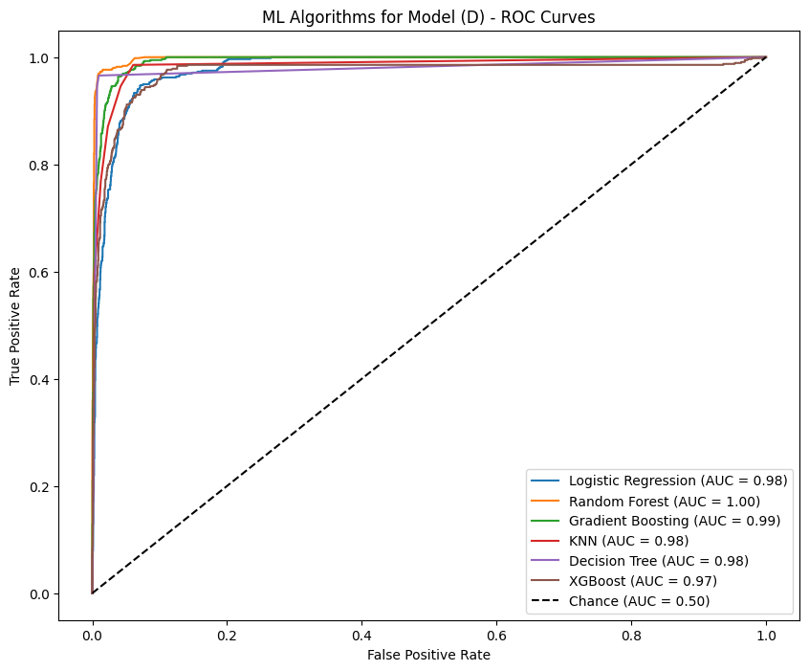
Figure 4.88: ML Algorithms for Model (D) - ROC Curves
Finally, all algorithms used in model (D) had a strong and excellent performance. The following predictive risk factors are age, moisture, activity, length of stay, blood pressure systolic (BP), and albumin. RF had the best overall performance metrics in comparison with other classification algorithms and SVR was the best among the regression algorithms in this model.

4.10 Summary
The exploratory data analysis and modeling development chapter presents the datasets that were collected, explains all demographics, and focuses on the understanding of all risk factors and biomarkers that correlate with pressure injury. The data visualization was performed to get a better understanding of the data and of the relation or correlation with pressure injury, in order to decide which variables were important to be among the features in the development of prediction models. Furthermore, all risk factors and biomarkers were tested by statistical tests with pressure injury. Finally, the process of model development was carried out, followed by the experimental results.

CHAPTER FIVE

DISCUSSION OF FINDINGS & CONCLUSION

5.1 Introduction
In this chapter, a summary of the findings is presented, and an interpretation of the results and the performance metrics for each model are discussed in detail. The best model with predictive features is discussed in relation to previous work and literature. Finally, the research questions and results of the statistical tests are long discussed with literature.

5.2 Summary of Findings
A pressure injury is considered one of the significant issues in providing healthcare and maintaining patient safety, and pressure injuries impact patients' quality of life and mortality. Many factors are associated with pressure injury such as age, gender, length of hospital stay, limited mobility, and skin condition (Hu et al., 2020; Rondinelli et al., 2018). This study was conducted to develop prediction models for pressure injury. It utilized the routine data in the electronic patient medical records to construct the model and not rely only on traditional assessment tools to identify patients at risk of pressure injury. The researcher used the experimental design method and collected data from 49,500 patients from the three hospitals, using SQL to collect the data and machine learning algorithms to construct a fused multi-channel prediction model for pressure injury.
The findings of the study showed that the incidence rate of HAPI was 1.21 per 100 patients. The performance metrics among all algorithms showed excellent performance; accuracy was (0.969 – 0.814), precision (0.964 – 0.679), recall (0.926 – 0.552), F1 score (0.942 – 0.555), AUC (0.926 – 0.552), FPR (0.429 – 0.155), and TPR (0.807 – 0.361). The best model was random forest, in which the accuracy was 0.962, precision was 0.942, recall was 0.922, F1 was 0.931, AUC was 0.922, FPR was 0.155, and TPR was 0.782. Finally, the predictive variables were age, moisture, activity, LOS, (BP) systolic, and Alb.
Furthermore, the study findings indicate that the data from medical records can predict PI and help nurses identify patients at risk of PI earlier, which improves the quality of care and promotes patient safety. Furthermore, the study found that predictive factors in the developed model for predicting pressure injuries are not included in the traditional tools used routinely by nurses for assessing pressure injuries.

5.3 Results Comparison with Previous Studies

5.3.1 The Predictive Risk Factors with Pressure Injury
This study shows that there are significant differences at the level (P ≤ 0.05) between the means of age and LOS relating to pressure injury. This means that the age group, or older patients are associated with pressure injury, as in the Aloweni et al. (2019) study, which concludes that elderly patients have a significant association with pressure injury in comparison with other patient groups. The study found that the increase in hospitalization days is associated with pressure injury; this result is compatible with Melo et al. (2023) study, which found that long hospitalization stays increase the risk of pressure injury.
This study shows that there are significant differences at the level (P ≤ 0.05) between the means of blood pressure, temperature, and pulse relating to pressure injury. This means that the attributes and values of the vital signs, increasing or decreasing, may be associated with pressure injury. These results are compatible with Hu et al. (2020) study, which found that blood pressure, pulse, and temperature are associated with pressure injury and considered predictive risk factors.
This study shows that there are significant differences at the level (P ≤ 0.05) between the means of the type of anesthesia, operation duration, and anesthesia duration relating to pressure injury. This means that the patients who had performed procedures under any type of anesthesia are associated with pressure injury and with the duration of the procedure. These results are compatible with the Alderden et al. (2021) study, which found that the duration of operation and duration of anesthesia are associated with pressure injury and considered as predictor risk factors. It is also compatible with the Walther et al. (2022) study, which found that anesthesia is associated with pressure injury.
This study shows that there are significant differences at the level (P ≤ 0.05) between the means of the Braden score and Braden subscales (perception, moisture, activity mobility, and nutrition) relating to pressure injury. This means that the Braden score with the assessment of Braden of subscales is associated with pressure injury. These results are compatible with those of Cheng et al. (2020), who found that the Braden subscales are considered predictive risk factors, and that they have a strong association with pressure injury. Also, these results are compatible with the Alderden et al. (2021) study, which found that the Braden score is associated with a pressure injury and considered a predictor risk factor, and Tang et al. (2021) study, which found that the Braden scale was a significant factor in pressure injury.
This study shows that there are significant differences at the level (P ≤ 0.05) between the means of pressure injury grade relating to pressure injury. This means that the pressure injury stage or grade is associated with the incidence of pressure injury, which is logical since any pressure injury is described by it is grade.
For the gender variable, the study showed no significant relationship between gender and pressure injury status at X2 (1, N = 1110) =1.81, p-value = 0.670. This means that gender is not considered a predictor of risk factors for pressure injury. This result is compatible with the Lichterfeld-Kottner et al. (2020) study, which found that gender is not an independent factor affecting pressure injury.
Regarding the ‘performed operation’ variable, this study found there was a significant relationship between performed operation and pressure injury status at X2 (1, N = 1110) =10.129, p-value = 0.000. This means that the patients performing the operations are associated with a pressure injury. This result is consistent with Cheng et al. (2020) study that found the patient suffered from surgery during the hospitalization period considered as predictive risk factor and associated with pressure injury.
For the mechanical ventilator variable, this study showed that there was a significant relationship between mechanical ventilators and pressure injury status at X2 (1, N = 1110) =75.974, p-value = 0.000. This means that the patient on mechanical ventilation is associated with pressure injury; this result is compatible with the Walther et al. (2022), study which found that mechanical ventilation is associated with pressure injury.
The medications variable shows that there is a significant relationship between medications and pressure injury status at X2 (1, N = 1151) =6854.12, p-value = 0.000. This means that the medications administered to patients during the hospitalization period are associated with pressure injury. This result is compatible with the Ji-Yu et al. (2021) and Tang et al. (2021) studies, both of which found that vasopressor medication is associated with pressure injury.
For the department type variable, this study shows that there is a significant relationship between department type and pressure injury status at X2 (1, N = 1110) =81.527, p-value = 0.000. This result means that the type of department, open unit or intensive unit, is associated with pressure injury. This is compatible with the Sun et al. (2020) study which found that patients staying in ICU are associated with pressure injury.
Finally, regarding the accreditation status variable, the study found that there was a significant relationship between accreditation status and pressure injury status at X2 (1, N = 1110) =8.836, p-value = 0.003. This means that the hospital accreditation status is associated with pressure injury, and this result is compatible with the Rodriguez-Garcia (2020) study, which found that the accreditation program reduces pressure injury incidences.

5.3.2 The Predictive Biomarkers with Pressure Injury
This research showed that there are no significant differences at the level (P ≤ 0.05) between the means of HbA1c relating to pressure injury at level (P ≤ 0.05) as the p-value equal (0.782). This means that HBA1c does not affect the incidence of pressure injury; which is consistent with the findings of Xian et al. (2019), who found that HbA1c is not associated with the incidence of pressure injury.
There are statistically significant differences between the means of (creatinine, CRP, WBC, Hb, BUN, AST, albumin, bilirubin (T), bilirubin (D), uric acid, and protein) related to pressure injury at level (P ≤ 0.05) where the p-values equal (1.61 e-16, 2.43 e-40, 2.75 e-48, 8.54 e-148, 2.13 e-49, 7.38 e-06, 2.01 e-60, 3.65 e-11, 1.17 e-12, 2.04 e-02, and 1.51 e-04) respectively. This means that the above laboratory tests are associated with pressure injury, which is consistent with the findings of the Wang et al. (2022), who found that the combination of CRP, Albumin, and Hb that are associated with the development of pressure injury, and these tests were available in the patient's medical records. Moreover, these results are consistent with those of Do et al. (2022), who found that there is a strong association between creatinine level and pressure injury. Moreover, these results are compatible with those of Dweekat et al. (2023) and Song et al. (2021), which found that BUN, Hb, and WBC are associated with pressure injury and are considered predictive risk factors. The bilirubin and protein results are compatible with the findings of the Saghaleini et al. (2018), which showed that protein and bilirubin levels may affect pressure injury. Furthermore, Kumar et al. (2021) found that the increased level of uric acid increases the antioxidants that play a role in formatting leg pressure injury. This is also compatible with a study conducted by Inui et al. (2007). Which found that AST affects pressure injury.

5.5 Interpretation of Results - Models Comparison and Model Selection
The proposed models had different factors (features) that were used in each model, and the developed models were measured and evaluated by standard performance metrics for both types of algorithms (classifications and regression tasks). The results of model (A), model (B), and model (D) are considered high, and there is a strong performance for the three models based on their performance metrics.
The average of each performance metric for model (A) I was as follows: accuracy was 0.967, precision was 0.957, recall was 0.924, F1 was 0.938, AUC was 0.924, FPR was 0.176, and TPR was 0.792. For model (B), it was as follows: accuracy was 0.969, precision was 0.964, recall was 0.926, F1 score was 0.942, AUC was 0.926, FPR was 0.165, and TPR was 0.807. For model (C), it was as follows: accuracy was 0.814, precision was 0.679, recall was 0.552, F1 score was 0.555, AUC was 0.552, FPR was 0.429, and TPR was 0.361. For model (D), it was as follows: accuracy was 0.962, precision was 0.942, recall was 0.922, F1 score was 0.931, AUC was 0.922, FPR was 0.155, and TPR was 0.782., as presents in Figure (5.1).

Figure 5.1: Comparison of Models Performance Metrics
Model (A) predicts PI with the 12 predictive risk factors and three biomarkers as follows: gender, age, diagnosis, operation name, anesthesia type, anesthesia duration/hours, operation duration/hours, accreditation status, department category, Braden scale, Bp systolic, Bp diastolic, temperature, pulse, LOS, mechanical ventilator, sensory perception, moisture, activity, mobility, nutrition, friction and shear, Alb, bilirubin (D), bilirubin (T), (BUN), CRP, creatinine, Hb, Uric Acid, WBC, Adrenalin, Nitroglycerin, and Norepinephrine. While model (B) predicts PI with 24 predictive risk factors and nine biomarkers as follows: age, diagnosis, operation, anesthesia type, accreditation status, department category, Braden scale, pulse, BP systolic, LOS, adrenaline, norepinephrine, Alb, WBC, and protein. Model (D) predicts PI with the five predictive risk factors age, moisture, activity, LOS, and systolic (BP), and the one biomarker Alb.
Model (D)’s performance is high, as the performance metrics were as follows: accuracy: 0.962, precision: 0.942, recall: 0.922, F1 score: 0.931, AUC: 0.922, FPR: 0.155, and TPR: 0.782. The slight differences between the three models in the performance metrics are as follows: accuracy: (model A: 0.967, model B: 0.969, model D: 0.962), precision: (model A: 0.957, model B: 0.964, model D: 0.942), recall: (model A: 0.924, model B: 0.926, model D: 0.922), F1: (model A: 0.938, model B: 0.942, model D: 0.931), AUC: (model A: 0.924, model B: 0.926, model D: 0.922), FPR: (model A: 0.176, model B: 0.165, model D: 0.155), and TPR: (model A: 0.792, model B: 0.807, model D: 0.782), as presents in Table (5.1).
Table 5.1: Performance Metrics for Developed Models

Model | Accuracy | Precision | Recall | F1 | AUC | FPR | TPR
Model A | 0.967 | 0.957 | 0.924 | 0.938 | 0.924 | 0.176 | 0.792
Model B | 0.969 | 0.964 | 0.926 | 0.942 | 0.926 | 0.165 | 0.807
Model C | 0.814 | 0.679 | 0.552 | 0.555 | 0.552 | 0.429 | 0.361
Model D | 0.962 | 0.942 | 0.922 | 0.931 | 0.922 | 0.155 | 0.782

Based on the comparison between performance metrics among all models, the data showed that model (B) has the best performance metrics, followed by model (A) and model (D), and the RF algorithm was the best for the three models.
The major issue in the comparison is that model (B) utilized double features of model (A) to predict pressure injury with an advanced setup, such as a mechanical ventilator that may not be used in many patients' conditions, especially for patients treated in the open units. In addition, the biomarkers utilized in model (B) were 9, which is the triple the biomarkers utilized in model (A), which means that they were not captured some of the patients, in addition to the efficiency that has taken high considerations in the healthcare industry.
Model (D), in comparison with the two models (A) and (B), has a reasonable number of features with only six predictive risk factors, and does not use the medications used in the two previous models, which overlooks the patients who were not in intensive units and do not need any vasopressors medications. Also, this model didn’t rely on the department category (open or intensive units) or the accreditation status of the hospital, which makes it more fit for all types of hospitals.
In addition, this model did not require many biomarkers to predict pressure injury and only utilized the Alb level, which made this model efficient and more practical. Finally, model (D) does not rely on the screening results of the traditional screening tool (Braden scale) as (A and B), which makes this model more flexible with hospitals that use other tools for assessing the patients, or do not use structure screening tools.
Having taken all these considerations, and given the excellent performance metrics in all models (A, B, and D) with slight differences, which were not significant, I recommend model (D) with the following performance metrics: accuracy: 0.962, precision: 0.942, recall: 0.922, F1: 0.931, AUC: 0.922, FPR: 0.155, and TPR: 0.782. It will be more effective and practical in the real world, and can be utilized by all hospitals adult’s settings.
Model (D) shows excellent performance metrics among all eight algorithms; for the classification algorithms, all performance metrics were high, such as accuracy, precision, recall, F1 score, and AUC. For regression algorithms, the model had a good fit, and the average squared of differences between predicted and actual value was low, as the MSE was 0.031. The R2 is about 78% of the variations in the targeted variable (pressure injury) detected by the potential factors in the developed model (features). In this model, the RF algorithms had the best overall performance metrics in comparison with other classification algorithms and SVR for the regression algorithms.
Finally, the results of RF as the best algorithm are compatible with the findings of Qu et al. (2022) meta-analysis study, which found that the RF was the best algorithm to predict pressure injury with high-performance metrics; and with the Song et al. (2021) study, which found that RF is the best algorithm with high accuracy; and with the Hu et al. (2020) study, which found that RF was the best algorithm among all algorithms to predict the pressure injury. Moreover, Dweekat et al. (2023) systematic review study, also found that RF was the best out of the 16 reviewed algorithms to predict pressure injury, and Anderson et al. (2021) study found that RF was the best algorithm with excellent performance metrics.
This study utilized a novel fused multi-channel prediction model and utilized eight machine learning algorithms, which makes these models unique and more comprehensive. The number of algorithms and prediction models discussed in some previous studies utilized four algorithms, such as Song et al. (2021), which utilized LR, RF, SVM, and NN. Other studies utilized six algorithms, such as the Qu et al. (2022) meta-analysis study, which reviewed 25 studies, and the maximum number was six algorithms (DT, diagnostic odds ratio, LR, NN, RF, and SVR). Other studies ranged from one to six algorithms, such as the Dweekat et al. (2023) systematic reviewed study, and those algorithms were (LR, DT, SVR, KNN, MLP, and XGBoost). Another study showed using only two algorithms, such as Anderson et al. (2021), which was utilized two algorithms (RF and LR).
This study also developed model (D) that can predict pressure injury among different departments or different specialties in adult hospital settings, which is considered an added value to the knowledge. Previous prediction models developed in previous literatures were designated to certain departments such as ICU or CCU (Aloweni et al., 2019; Hyun et al., 2019; Cramer et al., 2019; Šín et al., 2022; Xu et al., 2022; Cheng et al. (2020; Deschepper, 2022; Choi et al., 2020; Shui et al., 2021; James. 2021; Ladios-Martin et al., 2020), or to certain diseases, such Sun et al., 2020 which developed a model for oncology, and Ji-Yu et al. (2021) which developed a model for cardiac surgery, and for certain patients’ group such as (Anderson et al., 2021; Alderden et al., 2018) which developed a model for surgical patients.

5.6 Nursing Implications:
Based on the results obtained from this research, it is recommended that nursing scientists and nursing practitioners need to upgrade their methods of assessing pressure injuries. This upgrade should include the factors that were not assessed in traditional tools, such as (age, length of stay, systolic blood pressure, and albumin levels), and consider the findings of the different prediction models of pressure injury.
In addition to that, the accuracy and validity of the nurses’ documentation in the patient's medical records should be considered and highlighted in relation to the importance of reliable and completed data for the different usage of this data. Finally, machine learning has a promising future in assisting healthcare professionals and nurses by providing them with many applications and models that assist them in maintaining patient safety and improving the quality of care.
This study will influence patient satisfaction, and the benefits and impediments to the prediction model may be identified. In addition, the findings of this study can be used in future research to determine if the patients at risk of pressure injury can be identified earlier and protected, making him more satisfied than other patients who acquired pressure injury during the hospitalization period.

5.7 Recommendations
The prediction model of pressure injury will assist nurses and healthcare providers in enhancing the quality of care and improving patient experience and satisfaction through minimizing the harm that may affect the patient’s quality of life and the care process.
The rapid progression in utilizing electronic medical records in the healthcare industry is leading healthcare facilities to gain the technological benefits of using electronic medical records, and look for additional features that can be generated from these technologies. This includes the ability to ensure that the essential or required components of the medical and nursing documentation available in the medical record, visualizing the key performance indicators (KPI) through smart dashboards, and using the machine learning technology can be a valuable tool to analyze and manage the bid data of some areas in the electronic medical records.
In this study, the prediction model was constructed based on the data collected from the electronic patient medical records of 49,500 patients from three datasets, which included the risk factors of pressure injury, biomarkers (lab tests), and incident report system. All these datasets were preprocessed before being analyzed; the results of the study showed that there are many issues related to the of HIS that impacted the quality of data of the datasets.
These issues need to be taken into consideration as an area for improvement to enhance the quality of data in the electronic patient medical record, which would be reflected in the quality of care, improve the continuity of care, and ensure that the patient medical records and HIS will help hospitals in their mission and goals. Therefore, it is applicable for the three hospitals to:
- Deploy and Implement the Pressure Injury Prediction Model “EADB Model” within the hospital which is capable to identify pressure injury earlier and enhance the quality of nursing care and maintain patient safety.
- Conduct system analysis for the hospital information system (HIS) to ensure that all routine data and attributes in the modules and screens are stored in the database in the proper data format.
- Conduct system analysis for the hospital information system (HIS) to ensure that the routine and important data in the modules and screens are mandatory fields to fill, which will improve the quality of data and prevent missing data.
- Conduct gap analysis for the hospital information system (HIS) with expert staff in quality and healthcare to ensure that all data entered in the modules and screens is entered in a structured approach, so that the quality of data in the patient medical records is maintained.
- Improve the accuracy of the information documented in the electronic medical records by initiating standard guidelines and protocols related to the main process of care, such as assessment, screening, and diagnostics tests. This will ensure that the patient's medical records have the same structure, and maintain equity in providing the care for all patients who have the same diagnoses or have been admitted to same departments.
- Conduct special training for all healthcare providers on proper documentation to ensure that the data is accurate and supports diagnosis, treatment, and follow up.
- Conduct a workshop for healthcare professionals, mainly nurses and physicians, to present the meaning of machine learning and its implementation in the healthcare industry, in order to encourage nurses and healthcare providers to improve the quality of data during the documentation process.

5.8 Further Studies
- The study was conducted in three hospitals only; it is recommended to conduct the study among all hospitals and different health information systems (HIS) to validate the predictive model.
- The study utilized eight machine-learning algorithms with a supervised learning approach; it is recommended to conduct other learning approaches with pressure injury.
- The study developed the prediction models of pressure injury considering it one of the major challenges in the healthcare industry. Thus, it is further recommended to develop other prediction models in hospitals in Palestine for challenges, such as readmission, ventilator-associated pneumonia (VAP), central line-associated bloodstream infection (CLABSI), catheter urinary associated tract infection (CAUTI) …etc.
- Conducting quantitative and qualitative studies to measure the perception of nurses and other healthcare professionals towards using artificial intelligence in healthcare.
- Conducting quantitative and qualitative studies to measure the perception, attitude, and knowledge of Palestinian patients towards the use of artificial intelligence in healthcare.

5.9 Limitations and Strengths of the Study
- The findings of the study are based on three hospital records in Palestine. Getting medical records is a difficult task, and not all hospitals allow researchers to access their medical records or datasets. However, the datasets used in this research are first-hand datasets, which makes this research interesting, novel in terms of findings, and searchable in the field of machine learning and nursing.
- Quality of data documented by the healthcare providers in the medical records. This challenge was overcome through data cleaning and data preparation before building the model to achieve the best accuracy and make sure that the data is valid and reliable.
- Data availability and accessibility was a strength, as the researcher received permission to access the datasets of three hospitals based on ethical approval from Arab American University and agreement from hospitals.
- Building such a novel model using machine learning algorithms was a difficult task to achieve. This challenge was overcome by searching literature, trying different machine-learning approaches, and assessing these approaches using different types of performance metrics.

5.10 Summary
This chapter provides evidence of the feasibility of developing multi-fused prediction models to predict pressure injury for hospitalized patients by utilizing the potential risk factors and biomarkers that are routinely available in electronic patient medical records. The developed prediction models had strong performance metrics, which means that the final model is reliable and valid with different approaches to validation. These models recruit multiple potential factors (features) that can detect pressure injury in different levels of care and at different rates of severity or acuity of patient conditions.
The approach used in developing a prediction model of pressure injury provides evidence that the prediction of pressure injury utilizing different potential factors that it is hard for healthcare providers and nurses to follow predictive risk factors on a daily basis. This will provide valuable assistance to nurses, which will reflect on the quality of nursing care provided to the patients and maintain patient safety through preventing or reducing the risk of pressure injury for patients.
Finally, the predictive model of pressure injury, based on the novelty of the new approach and on the strong performance metrics in predicting pressure injury, is considered a promising tool for the future.

REFERENCES
Aghazadeh, A., Lotfi, M., Asgarpour, H., Khajehgoodari, M., & Nobakht, A. (2021). Frequency and risk factors of pressure injuries in clinical settings of affiliated to Tabriz University of Medical Sciences. Nursing Open, 8, 808-814. https://doi.org/10.1002/nop2.685.

Ahmad, B., Rubio-Sefati, M., & Yacob, M. M. (2023). Incidence and risk factors for pressure injuries in patients who have undergone vascular operations: a scoping review. European Journal of Medical Research, 28, 77. https://doi.org/10.1186/s40001-023-01036-3

Alanazi, F. K., Lapkin, S., Molloy, L., & Sim, J. (2023). Safety culture, quality of care, missed care, nurse staffing and their impact on pressure injuries: A cross-sectional multi-source study. International journal of nursing studies advances, 5, 100-125. https://doi.org/10.1016/j.ijnsa.2023.100125

Alderden, J., Drake, K. P., Wilson, A., Dimas, J., Cummins, M. R., & Yap, T. L. (2021). Hospital acquired pressure injury prediction in surgical critical care patients. BMC Medical Informatics and Decision Making, 21, 1-11.
https://doi.org/10.1186/s12911-020-01371-z
Alderden, J., Pepper, G. A., Wilson, A., Whitney, J. D., Richardson, S., Butcher, R., ... & Cummins, M. R. (2018). Predicting pressure injury in critical care patients: a machine-learning model. American Journal of Critical Care, 27, 461-468.
https://doi.org/10.4037/ajcc2018525

Aloweni, F., Ang, S. Y., Fook‐Chong, S., Agus, N., Yong, P., Goh, M. M., ... & Soh, R. C. (2019). A prediction tool for hospital‐acquired pressure ulcers among surgical patients: Surgical pressure ulcer risk score. International wound journal, 16, 164-175.
https://doi.org/10.1111/iwj.13007

Alshahrani, B., Sim, J., & Middleton, R. (2021). Nursing interventions for pressure injury prevention among critically ill patients: A systematic review. Journal of Clinical Nursing, 30, 2151-2168.
https://doi.org/10.1111/jocn.15709

Alshboul, O., Shehadeh, A., Almasabha, G., & Almuflih, A. S. (2022). Extreme gradient boosting-based machine learning approach for green building cost prediction. Sustainability, 14, 6651.
https://doi.org/10.3390/su14116651
Alsubhi, H., Meskell, P., Shea, D. O., & Doody, O. (2020). Missed nursing care and nurses' intention to leave: An integrative review. Journal of nursing management, 28, 1830-1840.
https://doi.org/10.1111/jonm.13069

Amirah, M., Rasheed, A., Parameaswari, P., Awajeh, A., Issa, M., & Abdallah, M. (2019). Pressure injury prevalence and risk factors among adult critically ill patients at a large intensive care unit. J Intensive Crit Care, 5, 9.
https//doi.org/10.21767/2471-8505.100128

Anderson, C., Bekele, Z., Qiu, Y., Tschannen, D., & Dinov, I. D. (2021). Modeling and prediction of pressure injury in hospitalized patients using artificial intelligence. BMC Medical Informatics and Decision Making, 21, 1-13.
https://doi.org/10.1186/s12911-021-01608-5

Anthony, D., Alosaimi, D., Shiferaw, W. S., Korsah, K., & Safari, R. (2021). Prevalence of pressure ulcers in Africa: A systematic review and meta-analysis. Journal of Tissue Viability, 30, 137-145.
https://doi.org/10.1016/j.jtv.2020.10.003

Aslan, A. and M. Y. van Giersbergen (2016). Nurses' attitudes towards pressure ulcer prevention in Turkey. Journal of tissue viability, 25: 66-73.
https://doi.org/10.1016/j.jtv.2015.10.001

Assadi, A., Laussen, P. C., Goodwin, A. J., Goodfellow, S., Dixon, W., Greer, R. W., ... & Mazwi, M. L. (2022). An integration engineering framework for machine learning in healthcare. Frontiers in Digital Health, 4, 932411.
https://doi.org/10.3389/fdgth.2022.932411

Ateeq, I., Baby, T., Amer, I., Chehab, F., & Salim, N. A. (2022). Associated Risk Factors and Barriers of Pressure Injury Wound Healing Process: A Retrospective Study of Single-Center Experience. Dubai Medical Journal, 5, 163-170.
https://doi.org/10.1159/000525202

Aufenanger, T. (2017). EconStor: Machine learning to improve experimental design. EconStor: Machine Learning to Improve Experimental Design.
http://hdl.handle.net/10419/169116

Bader, D. and C. Oomens. (2018). The potential of biomarkers in the early detection of pressure ulcers. Science and practice of pressure ulcer management, Springer: 1-15. https://doi.org/10.1007/978-1-4471-7413-4_1

Barghouthi, E. A. D., Owda, A. Y., Asia, M., & Owda, M. (2023). Systematic Review for Risks of Pressure Injury and Prediction Models Using Machine Learning Algorithms. Diagnostics, 13, 2739.
https://doi.org/10.3390/diagnostics13172739

Barghouthi E D. Patient Satisfaction: Comparative Study Between Pre-Hospital Accreditation and Post-Hospital Accreditation. IJIEPR 2024; 35 :57-73.
https://doi.org/ 10.22068/ijiepr.35.2.1987

Baškarada, S., & Koronios, A. (2018). A philosophical discussion of qualitative, quantitative, and mixed methods research in social science. Qualitative Research Journal, 18(1), 2-21. https://doi.org/10.1108/QRJ-D-17-00042

Bhardwaj, A. (2022). Promise and Provisos of Artificial Intelligence and Machine Learning in Healthcare. Journal of Healthcare Leadership, 14: 113-118.
https://doi.org/10.2147/JHL.S369498
Blasdell, N. (2017). The meaning of caring in nursing practice. International Journal of Nursing &amp; Clinical Practices, 4.
https://doi.org/10.15344/2394-4978/2017/238

Bogie, K. M., Schwartz, K., Li, Y., Wang, S., Dai, W., & Sun, J. (2020). Exploring adipogenic and myogenic circulatory biomarkers of recurrent pressure injury risk for persons with spinal cord injury. Journal of Circulating Biomarkers, 9, 1-7.
https://doi.org/10.33393/jcb.2020.2121

Bain, M., Hara, J., & Carter, M. J. (2020). The Pathophysiology of Skin Failure vs. Pressure Injury: Conditions That Cause Integument Destruction and Their Associated Implications. Wounds: a compendium of clinical research and practice, 32(11), 319-327. PMID: 33465042.

Brownlee, J. (2016). Master Machine Learning Algorithms: Discover How They Work and Implement Them from Scratch. Jason Brownlee, 2016.
http://MachineLearningMastery.com.

CAI, J. Y., ZHA, M. L., SONG, Y. P., & CHEN, H. L. (2020). Predicting the Development of Surgery-Related Pressure Injury Using a Machine Learning Algorithm Model. Journal of Nursing Research, 29(1), e135.
https://doi.org/10.1097/jnr.0000000000000411

Chaboyer, W., Harbeck, E., Lee, B., & Grealish, L. (2020). Missed nursing care: An overview of reviews. The Kaohsiung Journal of Medical Sciences, 37, 82–91.
https://doi.org/10.1002/kjm2.12308

Charbuty, B., & Abdulazeez, A. (2021, March 24). Classification Based on Decision Tree Algorithm for Machine Learning. Journal of Applied Science and Technology Trends, 2, 20–28.
https://doi.org/10.38094/jastt20165

Chen, I. Y., Joshi, S., Ghassemi, M., & Ranganath, R. (2021). Probabilistic Machine Learning for Healthcare. Annual Review of Biomedical Data Science, 4, 393–415.
https://doi.org/10.1146/annurev-biodatasci-092820-033938

Chen, I. Y., Pierson, E., Rose, S., Joshi, S., Ferryman, K., & Ghassemi, M. (2021). Ethical Machine Learning in Healthcare. Annual Review of Biomedical Data Science, 4, 123–144.
https://doi.org/10.1146/annurev-biodatasci-092820-114757

Cheng, H., Sun, X., Ji, X., Zhang, J., Lv, J., Li, T., & Ding, L. (2020). Risk factors and the potential of nomogram for predicting hospital‐acquired pressure injuries. International Wound Journal, 17, 974–986.
https://doi.org/10.1111/iwj.13362

Chicco, D., Warrens, M. J., & Jurman, G. (2021). The coefficient of determination R-squared is more informative than SMAPE, MAE, MAPE, MSE and RMSE in regression analysis evaluation. PeerJ Computer Science, 7, e623.
https://doi.org/10.7717/peerj-cs.623

Choi, B. K., Kim, M. S., & Kim, S. H. (2020). Risk prediction models for the development of oral-mucosal pressure injuries in intubated patients in intensive care units: A prospective observational study. Journal of Tissue Viability, 29, 252–257.
https://doi.org/10.1016/j.jtv.2020.06.002
Chung, M. L., Widdel, M., Kirchhoff, J., Sellin, J., Jelali, M., Geiser, F., Mücke, M., & Conrad, R. (2022). Risk Factors for Pressure Injuries in Adult Patients: A Narrative Synthesis. International Journal of Environmental Research and Public Health, 19, 761.
https://doi.org/10.3390/ijerph19020761

Cohen, J.F., Deeks, J.J., Hooft, L., Salameh, J.-P., Korevaar, D.A., Gatsonis, C., Hopewell, S., Hunt, H.A., Hyde, C.J., and Leeflang, M.M. (2021). Preferred reporting items for journal and conference abstracts of systematic reviews and meta-analyses of diagnostic test accuracy studies (PRISMA-DTA for Abstracts): checklist, explanation, and elaboration. BMJ. 2021, 372.
https://doi.org/10.1136/bmj.n265

Cohen, J. (2013). Statistical power analysis for the behavioral sciences. Routledge. https://doi.org/10.4324/9780203771587

Chen, H., Cohen, P., & Chen, S. (2010) How big is a big odds ratio? Interpreting the magnitudes of odds ratios in epidemiological studies. Communications in Statistics - Simulation and Computation, 39, 860-864.
https://doi.org/10.1080/03610911003650383
Cramer, E. M., Seneviratne, M. G., Sharifi, H., Ozturk, A., & Hernandez-Boussard, T. (2019). Predicting the Incidence of Pressure Ulcers in the Intensive Care Unit Using Machine Learning. EGEMs (Generating Evidence & Methods to Improve Patient Outcomes), 7, 49.
https://doi.org/10.5334/egems.307

DalPezzo, N. K. (2009). Nursing Care: Concept Analysis. Nursing Forum, 44, 256-264.
https://doi.org/10.1111/j.1744-6198.2009.00151.x

Deschepper, M., Labeau, S. O., Waegeman, W., & Blot, S. I. (2022). Heterogeneity hampers the identification of general pressure injury risk factors in intensive care populations: A predictive modelling analysis. Intensive and Critical Care Nursing, 68, 103117. https://doi.org/10.1016/j.iccn.2021.103117

Do, Q., Lipatov, K., Ramar, K., Rasmusson, J., Pickering, B. W., & Herasevich, V. (2022). Pressure Injury Prediction Model Using Advanced Analytics for At-Risk Hospitalized Patients. Journal of Patient Safety, 18, e1083–e1089. https://doi.org/10.1097/pts.0000000000001013

Dunyach-Remy, C., Salipante, F., Lavigne, J. P., Brunaud, M., Demattei, C., Yahiaoui-Martinez, A., Bastide, S., Palayer, C., Sotto, A., & Gélis, A. (2021). Pressure ulcers microbiota dynamics and wound evolution. Scientific Reports, 11.
https://doi.org/10.1038/s41598-021-98073-x

Dweekat, O. Y., Lam, S. S., & McGrath, L. (2023). Machine Learning Techniques, Applications, and Potential Future Opportunities in Pressure Injuries (Bedsores) Management: A Systematic Review. International Journal of Environmental Research and Public Health, 20, 796.
https://doi.org/10.3390/ijerph20010796

Eshetie, T. C., Moldovan, M., Caughey, G. E., Lang, C., Sluggett, J. K., Khadka, J., Whitehead, C., Crotty, M., Corlis, M., Visvanathan, R., Wesselingh, S., & Inacio, M. C. (2023). Development of a Multivariable Prediction Model for Risk of Hospitalization With Pressure Injury After Entering Residential Aged Care. Journal of the American Medical Directors Association, 24, 299-306.e9.
https://doi.org/10.1016/j.jamda.2022.12.009

Euser, A. M., Zoccali, C., Jager, K. J., & Dekker, F. W. (2009). Cohort Studies: Prospective versus Retrospective. Nephron Clinical Practice, 113, c214–c217.
https://doi.org/10.1159/000235241
Ferizi, U., Besser, H., Hysi, P., Jacobs, J., Rajapakse, C. S., Chen, C., Saha, P. K., Honig, S., & Chang, G. (2018). Artificial Intelligence Applied to Osteoporosis: A Performance Comparison of Machine Learning Algorithms in Predicting Fragility Fractures From MRI Data. Journal of Magnetic Resonance Imaging, 49, 1029–1038.
https://doi.org/10.1002/jmri.26280

Flannelly, K. J., Flannelly, L. T., & Jankowski, K. R. (2018). Threats to the internal validity of experimental and quasi-experimental research in healthcare. Journal of health care chaplaincy, 24, 107-130.
https://doi.org/10.1080/08854726.2017.1421019

Floyd, N. A., Dominguez-Cancino, K. A., Butler, L. G., Rivera-Lozada, O., Leyva-Moral, J. M., & Palmieri, P. A. (2021). The Effectiveness of Care Bundles Including the Braden Scale for Preventing Hospital Acquired Pressure Ulcers in Older Adults Hospitalized in ICUs: A Systematic Review. The Open Nursing Journal, 15(1), 74–84.
https://doi.org/10.2174/1874434602115010074

Galetto, S. G. D. S., do Nascimento, E. R. P., Hermida, P. M. V., Busanello, J., de Malfussi, L. B. H., & Lazzari, D. D. (2021). Medical device-related pressure injuries in critical patients: prevalence and associated factors. Revista Da Escola De Enfermagem Da USP, 55.
https://doi.org/10.1590/1980-220x-reeusp-2020-0397

Gamage, T. A., Dabarera, W. N. S., Nethmini, K. K. H., Uwanthika, G. A. I., Kalansooriya, L. P., & Wijay, B. (2020). A Systematic Review and Comparative Study of Electronic Medical Record (EMR) Systems to Support Healthcare. General Sir John Kotelawala Defence University. 13th International Research Conference. 276-283.
http://ir.kdu.ac.lk/handle/345/3007

García-Gutiérrez, M. S., Navarrete, F., Sala, F., Gasparyan, A., Austrich-Olivares, A., & Manzanares, J. (2020). Biomarkers in Psychiatry: Concept, Definition, Types and Relevance to the Clinical Reality. Frontiers in Psychiatry, 11. https://doi.org/10.3389/fpsyt.2020.00432

Gefen, A. (2018). "The sub-epidermal moisture scanner: the principles of pressure injury prevention using novel early detection technology." Wounds International, 9: 30-35. https://doi.org/10.12968/jowc.2020.29.Sup2c.S10
Getie, A., Baylie, A., Bante, A., Geda, B., & Mesfin, F. (2020). Pressure ulcer prevention practices and associated factors among nurses in public hospitals of Harari regional state and Dire Dawa city administration, Eastern Ethiopia. PLOS ONE, 15, e0243875.
https://doi.org/10.1371/journal.pone.0243875

Glasofer, A., & Townsend, A. B. (2019, November). Determining the level of evidence. Nursing Critical Care, 14, 22–25.
https://doi.org/10.1097/01.ccn.0000580120.03118.1d

González-Ruiz, J. M., Sebastián-Viana, T., Losa-Iglesias, M. E., Lema-Lorenzo, I., Crespo, F. J. N., Martín-Merino, G., García-Martín, M. R., Velayos-Rodríguez, E., & Nogueiras-Quintas, C. G. (2014). Braden Scale and Norton Scale Modified by INSALUD in an Acute Care Hospital. Advances in Skin & Wound Care, 27, 506–511.
https://doi.org/10.1097/01.asw.0000455077.71857.30

Gunningberg, L., Sedin, I. M., Andersson, S., & Pingel, R. (2017, July). Pressure mapping to prevent pressure ulcers in a hospital setting: A pragmatic randomised controlled trial. International Journal of Nursing Studies, 72, 53–59. https://doi.org/10.1016/j.ijnurstu.2017.04.007
Habehh, H., & Gohel, S. (2021). Machine Learning in Healthcare. Current Genomics, 22, 291–300.
https://doi.org/10.2174/1389202922666210705124359

Hallaj, F. (2017). Effect of Applying Nursing Interventions for Preventing Pressure Ulcers among Hospitalized Geriatric Patients. Alexandria Scientific Nursing Journal, 19, 57–68.
https://doi.org/10.21608/asalexu.2017.208351

Hamsagayathri, P., & Sampath, P. (2017). PERFORMANCE ANALYSIS OF BREAST CANCER CLASSIFICATION USING DECISION TREE CLASSIFIERS. International Journal of Current Pharmaceutical Research, 9, 19.
https://doi.org/10.22159/ijcpr.2017v9i2.17383

Han, Y., Jin, Y., Jin, T., Lee, S. M., & Lee, J. Y. (2019). Impact of Pressure Injuries on Patient Outcomes in a Korean Hospital. Journal of Wound, Ostomy & Continence Nursing, 46, 194–200.
https://doi.org/10.1097/won.0000000000000528

Holmberg, M., Hammarbäck, S., & Andersson, H. (2020). Registered nurses’ experiences of assessing patients with mental illness in emergency care: A qualitative descriptive study. Nordic Journal of Nursing Research, 40, 151–161.
https://doi.org/10.1177/2057158520941753

Hoogendoorn, I., Reenalda, J., Koopman, B. F., & Rietman, J. S. (2017). The effect of pressure and shear on tissue viability of human skin in relation to the development of pressure ulcers: a systematic review. Journal of Tissue Viability, 26, 157–171.
https://doi.org/10.1016/j.jtv.2017.04.003

Hu, Y. H., Lee, Y. L., Kang, M. F., & Lee, P. J. (2020). Constructing Inpatient Pressure Injury Prediction Models Using Machine Learning Techniques. CIN: Computers, Informatics, Nursing, 38, 415–423.
https://doi.org/10.1097/cin.0000000000000604

Hyun, S., Moffatt-Bruce, S., Cooper, C., Hixon, B., & Kaewprag, P. (2019). Prediction Model for Hospital-Acquired Pressure Ulcer Development: Retrospective Cohort Study. JMIR Medical Informatics, 7, e13785.
https://doi.org/10.2196/13785
INUI, S., HARADA, T., NAKAJIMA, T., & ITAMI, S. (2007). Two cases of pressure ulcer healing after liver transplantation in cirrhosis patients. The Journal of Dermatology, 34, 400–402.
https://doi.org/10.1111/j.1346-8138.2007.00298.x

James, A. (2021). Machine Learning Risk Assessment Model for Hospital Acquired Pressure Injuries. Faculty of the School of Information and Library Science, University of North Carolina.
https://cdr.lib.unc.edu/downloads/hq37vz18s

Jiang, M., Ma, Y., Guo, S., Jin, L., Lv, L., Han, L., & An, N. (2021). Using Machine Learning Technologies in Pressure Injury Management: Systematic Review. JMIR Medical Informatics, 9, e25704.
https://doi.org/10.2196/25704

Kalisch, B. J., Landstrom, G. L., & Hinshaw, A. S. (2009). Missed nursing care: a concept analysis. Journal of Advanced Nursing, 65, 1509–1517.
https://doi.org/10.1111/j.1365-2648.2009.05027.x

Kim, J., Lee, J., & Lee, E. (2020). Risk factors for newly acquired pressure ulcer and the impact of nurse staffing on pressure ulcer incidence. Journal of Nursing Management, 30.
https://doi.org/10.1111/jonm.12928

Kottner, J., Cuddigan, J., Carville, K., Balzer, K., Berlowitz, D., Law, S., Litchford, M., Mitchell, P., Moore, Z., Pittman, J., Sigaudo-Roussel, D., Yee, C. Y., & Haesler, E. (2019). Prevention and treatment of pressure ulcers/injuries: The protocol for the second update of the international Clinical Practice Guideline 2019. Journal of Tissue Viability, 28, 51–58.
https://doi.org/10.1016/j.jtv.2019.01.001

Kumar, R. (2018). Research methodology: A step-by-step guide for beginners. Research methodology, 1-528.

Kumar, S., Theis, T., Tschang, M., Nagaraj, V., & Berthiaume, F. (2021). Reactive Oxygen Species and Pressure Ulcer Formation after Traumatic Injury to Spinal Cord and Brain. Antioxidants, 10, 1013.
https://doi.org/10.3390/antiox10071013

Labeau, S. O., Afonso, E., Benbenishty, J., Blackwood, B., Boulanger, C., Brett, S. J., Calvino-Gunther, S., Chaboyer, W., Coyer, F., Deschepper, M., François, G., Honore, P. M., Jankovic, R., Khanna, A. K., Llaurado-Serra, M., Lin, F., Rose, L., Rubulotta, F., Saager, L., . . . Blot, S. I. (2021). Correction to: Prevalence, associated factors and outcomes of pressure injuries in adult intensive care unit patients: the DecubICUs study. Intensive Care Medicine, 47, 503–520.
https://doi.org/10.1007/s00134-020-06327-5

Ladios-Martin, M., Fernández-de-Maya, J., Ballesta-López, F. J., Belso-Garzas, A., Mas-Asencio, M., & Cabañero-Martínez, M. J. (2020). Predictive Modeling of Pressure Injury Risk in Patients Admitted to an Intensive Care Unit. American Journal of Critical Care, 29, e70–e80.
https://doi.org/10.4037/ajcc2020237

Lakens, D. (2013). Calculating and reporting effect sizes to facilitate cumulative science: a practical primer for t-tests and ANOVAs. Frontiers in psychology, 4, 62627.
https://doi.org/10.3389/fpsyg.2013.00863.

Lao, Y., Jia, B., Yan, P., Pan, M., Hui, X., Li, J., Luo, W., Li, X., Han, J., Yan, P., & Yao, L. (2019). Diagnostic accuracy of machine-learning-assisted detection for anterior cruciate ligament injury based on magnetic resonance imaging. Medicine, 98, e18324. https://doi.org/10.1097/md.0000000000018324

Lichterfeld-Kottner, A., Lahmann, N., & Kottner, J. (2020). Sex-specific differences in prevention and treatment of institutional-acquired pressure ulcers in hospitals and nursing homes. Journal of Tissue Viability, 29, 204–210.
https://doi.org/10.1016/j.jtv.2020.05.001

Lovegrove, J., Fulbrook, P., & Miles, S. (2018). Prescription of pressure injury preventative interventions following risk assessment: An exploratory, descriptive study. International Wound Journal, 15, 985–992.
https://doi.org/10.1111/iwj.12965

Maddah, S. A., & Modanloo, M. (2020). The challenges of keeping psychiatric patients safe in rehabilitation centers during coronavirus outbreak. Archives of Psychiatric Nursing, 34, 580–581.
https://doi.org/10.1016/j.apnu.2020.07.024
Maulud, D., & Abdulazeez, A. M. (2020, December 31). A Review on Linear Regression Comprehensive in Machine Learning. Journal of Applied Science and Technology Trends, 1, 140–147. https://doi.org/10.38094/jastt1457

McEvoy, N., Patton, D., Curley, G., Boland, F., Kearney, C., Hogan, G., Keogh, A., Clarke, J., & Moore, Z. (2022). Biomarkers for the early detection of pressure ulcers in the intensive care setting: A comparison between sub‐epidermal moisture measurements and interleukin‐1α. International Wound Journal, 20, 831–844.
https://doi.org/10.1111/iwj.13930

McKinney, S. M., Sieniek, M., Godbole, V., Godwin, J., Antropova, N., Ashrafian, H., Back, T., Chesus, M., Corrado, G. S., Darzi, A., Etemadi, M., Garcia-Vicente, F., Gilbert, F. J., Halling-Brown, M., Hassabis, D., Jansen, S., Karthikesalingam, A., Kelly, C. J., King, D., . . . Shetty, S. (2020). Addendum: International evaluation of an AI system for breast cancer screening. Nature, 586, E19–E19.
https://doi.org/10.1038/s41586-020-2679-9

Mehrad, A. and M. H. T. Zangeneh (2019). Comparison between qualitative and quantitative research approaches: Social sciences. International Journal For Research In Educational Studies, 5, 1-7.
https://doi.org/10.53555/es.v5i7.998
Melo, C. M. D., Bueno, A. D. L. G., Rossetto, T. L., Almeida, B. G. D., Moretto, L. B., & Diniz, M. B. C. (2023). Pressure Injury in Intensive Care Unit: prevalence and associated factors in patients with COVID-19. Revista Gaúcha De Enfermagem, 44. https://doi.org/10.1590/1983-1447.2023.20210345.en

Mervis, J. S., & Phillips, T. J. (2019). Pressure ulcers: Pathophysiology, epidemiology, risk factors, and presentation. Journal of the American Academy of Dermatology, 81, 881-890.
https://doi.org/10.1016/j.jaad.2018.12.069

Miao, J., & Zhu, W. (2021). Precision–recall curve (PRC) classification trees. Evolutionary Intelligence, 15, 1545–1569.
https://doi.org/10.1007/s12065-021-00565-2

Mishra, P., Pandey, C. M., Singh, U., Gupta, A., Sahu, C., & Keshri, A. (2019). Descriptive statistics and normality tests for statistical data. Annals of cardiac anaesthesia, 22, 67-72.
https://doi.org/10.4103/aca.ACA_157_18

Misra, S., Li, H., & He, J. (2020). Noninvasive fracture characterization based on the classification of sonic wave travel times. Machine learning for subsurface characterization, 4, 243-287.
https://doi.org/10.1016/B978-0-12-817736-5.00009-0

Moore, Z., Johansen, E., Etten, M. V., Strapp, H., Solbakken, T., Smith, B. E., & Faulstich, J. (2015). Pressure ulcer prevalence and prevention practices: a cross-sectional comparative survey in Norway and Ireland. Journal of Wound Care, 24, 333–339. https://doi.org/10.12968/jowc.2015.24.8.333

Najjar, Y. W., Saleh, M. Y., & Hassan, Z. M. (2022). Medical device related pressure ulcers in Jordan: Prevalence study among critically ill patients. Health science reports, 5, e620.
https://doi.org/10.1002/hsr2.620

Nakagami, G., Yokota, S., Kitamura, A., Takahashi, T., Morita, K., Noguchi, H., Ohe, K., & Sanada, H. (2021). Supervised machine learning-based prediction for in-hospital pressure injury development using electronic health records: A retrospective observational cohort study in a university hospital in Japan. International Journal of Nursing Studies, 119, 103932.
https://doi.org/10.1016/j.ijnurstu.2021.103932

Negro-Calduch, E., Azzopardi-Muscat, N., Krishnamurthy, R. S., & Novillo-Ortiz, D. (2021). Technological progress in electronic health record system optimization: Systematic review of systematic literature reviews. International Journal of Medical Informatics, 152, 104507.
https://doi.org/10.1016/j.ijmedinf.2021.104507

Nyelisani, M., Makhado, L., & Luhalima, T. (2023). A professional nurse’s understanding of quality nursing care in Limpopo province, South Africa. Curationis, 46.
https://doi.org/10.4102/curationis.v46i1.2322

Padula, W. V., & Delarmente, B. A. (2019). The national cost of hospital‐acquired pressure injuries in the United States. International Wound Journal, 16, 634–640.
https://doi.org/10.1111/iwj.13071

Panel, N. P. U. A. (2016). "Pressure injury staging or classification " https://www.rch.org.au/uploadedFiles/Main/Content/rchcpg/hospital_clinical_guideline_index/NPIAP-Pressure-Injury-Staging-Poster.pdf 2016. Access Date: 16-10-2022.
Parashar, G., Chaudhary, A., & Rana, A. (2021). Systematic Mapping Study of AI/Machine Learning in Healthcare and Future Directions. Computer Science, 2.
https://doi.org/10.1007/s42979-021-00848-6

Park, S. K. and H. Park (2017). Factors affecting the time to occurrence of hospital-acquired pressure ulcers using EHR data. International Medical Informatics Association (IMIA) and IOS Press, MEDINFO 2017: Precision Healthcare through Informatics, (1113-1117).
https://doi.org/10.3233/978-1-61499-830-3-1113

Parveen, N., Zaidi, S., & Danish, M. (2016). Support vector regression model for predicting the sorption capacity of lead (II). Perspectives in Science, 8, 629–631. https://doi.org/10.1016/j.pisc.2016.06.040

Pasandideh, S., AliAbadi, M., Taher, M., Kamali, A., Hoseini Azizi, T., & Hejazi, S. S. (2021). Relationship between Nurses' Knowledge and Quality of Nursing Care Regarding Pressure Ulcers in Intensive Care Units of Bojnurd Hospitals in 2017. Navid No, 24, 55-64.
https://doi.org/10.22038/NNJ.2021.54396.1253

Pihal, A., Debora, S. J., & Singh, S. (2022). Commingling Conceptual Framework to Ludwig Von Bertalanffy’s General System Theory in Evidence Based Research.

Pittman, J., Beeson, T., Dillon, J., Yang, Z., Mravec, M., Malloy, C., & Cuddigan, J. (2021). Hospital-Acquired Pressure Injuries and Acute Skin Failure in Critical Care. Journal of Wound, Ostomy & Continence Nursing, 48, 20–30.
https://doi.org/10.1097/won.0000000000000734

Plana, D., Shung, D. L., Grimshaw, A. A., Saraf, A., Sung, J. J. Y., & Kann, B. H. (2022). Randomized Clinical Trials of Machine Learning Interventions in Health Care. JAMA Network Open, 5, e2233946.
https://doi.org/10.1001/jamanetworkopen.2022.33946

Popow, A., Szewczyk, M. T., Cierzniakowska, K., Kozłowska, E., Mościcka, P., & Cwajda-Białasik, J. (2019). Risk factors for bedsore development among hospitalised patients. Surgical and Vascular Nursing, 12, 152-158.
https://www.termedia.pl/Risk-factors-for-bedsore-development-among-hospitalised-patients,50,36084,1,1.html

Pruinelli, L. (2021). Nursing and Data: Powering Nursing Leaders for Big Data Science. Revista Brasileira De Enfermagem, 74.
https://doi.org/10.1590/0034-7167.2021740401

Qaddumi, J., Almahmoud, O., Khurasani, A., Alkhawaldeh, A., & Khraisat, O. (2019). Incidence of pressure ulcers and its related variables among critically ill adult patients in Palestine. Palestinian Medical and Pharmaceutical Journal, 4.
https://doi.org/10.59049/2790-0231.1044

Qu, C., Luo, W., Zeng, Z., Lin, X., Gong, X., Wang, X., Zhang, Y., & Li, Y. (2022). The predictive effect of different machine learning algorithms for pressure injuries in hospitalized patients: A network meta-analyses. Heliyon, 8, e11361.
https://doi.org/10.1016/j.heliyon.2022.e11361

Ranganathan, P., Pramesh, C. S., & Aggarwal, R. (2017). Common pitfalls in statistical analysis: Logistic regression. Perspectives in Clinical Research, 8, 148-151. http://doi.org/10.4103/picr.PICR_87_17

Recio‐Saucedo, A., Dall’Ora, C., Maruotti, A., Ball, J., Briggs, J., Meredith, P., Redfern, O. C., Kovacs, C., Prytherch, D., Smith, G. B., & Griffiths, P. (2017). What impact does nursing care left undone have on patient outcomes? Review of the literature. Journal of Clinical Nursing, 27), 2248–2259.
https://doi.org/10.1111/jocn.14058

Reed, F., & Fitzgerald, L. (2005). The mixed attitudes of nurse’s to caring for people with mental illness in a rural general hospital. International Journal of Mental Health Nursing, 14, 249–257.
https://doi.org/10.1111/j.1440-0979.2005.00389.x

Renghea, A., Cuevas-Budhart, M. A., Yébenes-Revuelto, H., Gómez del Pulgar, M., & Iglesias-López, M. T. (2022). “Comprehensive Care” Concept in Nursing: Systematic Review. Investigación Y Educación En Enfermería, 40.
https://doi.org/10.17533/udea.iee.v40n3e05

Rodríguez‐García, M. C., Márquez‐Hernández, V. V., Granados‐Gámez, G., Aguilera‐Manrique, G., & Gutiérrez‐Puertas, L. (2020). Magnet hospital attributes in nursing work environment and its relationship to nursing students’ clinical learning environment and satisfaction. Journal of Advanced Nursing, 77, 787–794. https://doi.org/10.1111/jan.14629
Rondinelli, J., Zuniga, S., Kipnis, P., Kawar, L. N., Liu, V., & Escobar, G. J. (2018). Hospital-Acquired Pressure Injury. Nursing Research, 67, 16–25.
https://doi.org/10.1097/nnr.0000000000000258

Roth, G. A., Abate, D., Abate, K. H., Abay, S. M., Abbafati, C., Abbasi, N., ... & Borschmann, R. (2018). Global, regional, and national age-sex-specific mortality for 282 causes of death in 195 countries and territories, 1980–2017: a systematic analysis for the Global Burden of Disease Study 2017. The Lancet, 392, 1736-1788. https://doi.org/10.1016/S0140-6736(18)32203-7

Saghaleini SH, Dehghan K, Shadvar K, Sanaie S, Mahmoodpoor A, Ostadi Z. (2018). Pressure Ulcer and Nutrition. Indian Journal of Critical Care Medicine. 4(283-289). https://doi.org/10.4103/ijccm.IJCCM_277_17

Schwartz, K., Henzel, M., Ann Richmond, M., Zindle, J. K., Seton, J. M., Lemmer, D. P., Alvarado, N., & Bogie, K. (2019). Biomarkers for recurrent pressure injury risk in persons with spinal cord injury. The Journal of Spinal Cord Medicine, 43, 696–703.
https://doi.org/10.1080/10790268.2019.1645406

Setia, M. S. (2016). Methodology series module 2: Case-control studies. Indian Journal of Dermatology, 61, 146-151.
https://doi.org/10.4103/0019-5154.177773

Sharma, M., Savage, C., Nair, M., Larsson, I., Svedberg, P., & Nygren, J. M. (2022). Artificial Intelligence Applications in Health Care Practice: Scoping Review. Journal of Medical Internet Research, 24, e40238.
https://doi.org/10.2196/40238

Shui, A. M., Kim, P., Aribindi, V., Huang, C. Y., Kim, M. O., Rangarajan, S., Schorger, K., Aldrich, J. M., & Lee, H. (2021). Dynamic Risk Prediction for Hospital-Acquired Pressure Injury in Adult Critical Care Patients. Critical Care Explorations, 3, e0580.
https://doi.org/10.1097/cce.0000000000000580

Šín, P., Hokynková, A., Marie, N., Andrea, P., Krč, R., & Podroužek, J. (2022). Machine Learning-Based Pressure Ulcer Prediction in Modular Critical Care Data. Diagnostics, 12, 850.
https://doi.org/10.3390/diagnostics12040850

Siotos, C., Bonett, A. M., Damoulakis, G., Becerra, A. Z., Kokosis, G., Hood, K., ... & Shenaq, D. S. (2022). Burden of Pressure Injuries: Findings From the Global Burden of Disease Study. Eplasty, 22.
https://www.ncbi.nlm.nih.gov/pmc/articles/PMC9275412/

Song, W., Kang, M. J., Zhang, L., Jung, W., Song, J., Bates, D. W., & Dykes, P. C. (2021). Predicting pressure injury using nursing assessment phenotypes and machine learning methods. Journal of the American Medical Informatics Association, 28, 759–765.
https://doi.org/10.1093/jamia/ocaa336

Soper, D.S. (2024). A-priori Sample Size Calculator for Student t-Tests [Software]. Available https://www.danielsoper.com/statcalc. Retrieved Date: 25/05/2024.

Spurlock Jr, D. R., Taylor, J., & Spurlock Jr, D. (2018). Statistical power in nursing education research. Journal of Nursing Education, 57, 262-264.
https://doi.org/10.3928/01484834-20180420-02

Sun, Z. W., Guo, M. R., Yang, L. Z., Chen, Z. J., & Zhang, Z. Q. (2020). Risk Factor Analysis and Risk Prediction Model Construction of Pressure Injury in Critically Ill Patients with Cancer: A Retrospective Cohort Study in China. Medical Science Monitor, 26.
https://doi.org/10.12659/msm.926669

Syriopoulos, P. K., Kotsiantis, S. B., & Vrahatis, M. N. (2022). Survey on KNN methods in data science. In: Simos, D.E., Rasskazova, V.A., Archetti, F., Kotsireas, I.S., Pardalos, P.M. (eds). International Conference on Learning and Intelligent Optimization (pp. 379-393). Cham: Springer International Publishing. https://doi.org/10.1007/978-3-031-24866-5_28

Tamata, A. T., & Mohammadnezhad, M. (2022). A systematic review study on the factors affecting shortage of nursing workforce in the hospitals. Nursing Open, 10, 1247–1257.
https://doi.org/10.1002/nop2.1434

Tang, Z., Li, N., & Xu, J. (2021). Construction of a Risk Prediction Model for Intraoperative Pressure Injuries: A Prospective, Observational Study. Journal of PeriAnesthesia Nursing, 36, 473–479.
https://doi.org/10.1016/j.jopan.2020.11.006
Tariq, G., Hamed, J., George, B., Cruz, S., & Jose, J. (2019). Pressure ulcer prevalence and prevention rates in Abu Dhabi: an update. Journal of Wound Care, 28, S4–S11.
https://doi.org/10.12968/jowc.2019.28.sup4.s4

Triantafyllou, C., Chorianopoulou, E., Kourkouni, E., Zaoutis, T. E., & Kourlaba, G. (2021). Prevalence, incidence, length of stay and cost of healthcare-acquired pressure ulcers in pediatric populations: A systematic review and meta-analysis. International Journal of Nursing Studies, 115, 103843. https://doi.org/10.1016/j.ijnurstu.2020.103843

Tschannen, D., & Anderson, C. (2020). The pressure injury predictive model: A framework for hospital‐acquired pressure injuries. Journal of Clinical Nursing, 29(7–8), 1398–1421.
https://doi.org/10.1111/jocn.15171

Valles, J. H. H., Monsiváis, M. G. M., Guzmán, M. G. I., & Arreola, L. V. (2016). Nursing care missed in patients at risk of or having pressure ulcers. Revista Latino-Americana De Enfermagem, 24.
https://doi.org/10.1590/1518-8345.1462.2817
Vayena, E., Blasimme, A., & Cohen, I. G. (2018). Machine learning in medicine: Addressing ethical challenges. PLOS Medicine, 15, e1002689.
https://doi.org/10.1371/journal.pmed.1002689

Walker, L. O. and K. C. Avant (2005). Strategies for theory construction in nursing, Pearson/Prentice Hall Upper Saddle River, NJ.
https://www.pearsonhighered.com/assets/preface/0/1/3/4/0134803523.pdf

Walther, F., Heinrich, L., Schmitt, J., Eberlein-Gonska, M., & Roessler, M. (2022). Prediction of inpatient pressure ulcers based on routine healthcare data using machine learning methodology. Scientific Reports, 12.
https://doi.org/10.1038/s41598-022-09050-x

Wang, N., Lv, L., Yan, F., Ma, Y., Miao, L., Foon Chung, L. Y., & Han, L. (2022). Biomarkers for the early detection of pressure injury: A systematic review and meta-analysis. Journal of Tissue Viability, 31, 259–267.
https://doi.org/10.1016/j.jtv.2022.02.005

Wang, X., & Kattan, M. W. (2020). Cohort Studies. Chest, 158, S72–S78.
https://doi.org/10.1016/j.chest.2020.03.014
Weissler, E. H., Naumann, T., Andersson, T., Ranganath, R., Elemento, O., Luo, Y., Freitag, D. F., Benoit, J., Hughes, M. C., Khan, F., Slater, P., Shameer, K., Roe, M., Hutchison, E., Kollins, S. H., Broedl, U., Meng, Z., Wong, J. L., Curtis, L., Ghassemi, M. (2021). The role of machine learning in clinical research: transforming the future of evidence generation. Trials, 22.
https://doi.org/10.1186/s13063-021-05489-x

Xiang, J., Wang, S., He, Y., Xu, L., Zhang, S., & Tang, Z. (2018). Reasonable Glycemic Control Would Help Wound Healing During the Treatment of Diabetic Foot Ulcers. Diabetes Therapy, 10, 95–105.
https://doi.org/10.1007/s13300-018-0536-8

Xin, C., Wang, Z., Lee, C., Lin, P. S., Chen, T., Guo, R., & Lu, Q. (2019). Development of crash modification factors of horizontal curve design features for single-motorcycle crashes on rural two-lane highways: A matched case-control study. Accident Analysis & Prevention, 123, 51-59.
https://doi.org/10.1016/j.aap.2018.11.008

Xu, H., Wang, Y., Takashi, E., Kamijo, A., Miura, D., Karasawa, K., Kitayama, A., Lu, J., & Zhang, L. (2021). Predicting the different progressions of early pressure injury by ultraviolet photography. International Wound Journal, 19, 834-844.
Xu, J., Chen, D., Deng, X., Pan, X., Chen, Y., Zhuang, X., & Sun, C. (2022). Development and validation of a machine learning algorithm–based risk prediction model of pressure injury in the intensive care unit. International Wound Journal, 19, 1637–1649.
https://doi.org/10.1111/iwj.13764

Yang, K. L., Chen, L., Kang, Y. Y., Xing, L. N., Li, H. L., Cheng, P., & Song, Z. H. (2020). Identification of risk factors of developing pressure injuries among immobile patient, and a risk prediction model establishment. Medicine, 99, e23640. https://doi.org/10.1097/md.0000000000023640

Zhang, Z., Zhao, Y., Canes, A., Steinberg, D., & Lyashevska, O. (2019). Predictive analytics with gradient boosting in clinical medicine. Annals of Translational Medicine, 7, 152–152.
https://doi.org/10.21037/atm.2019.03.29

Appendices

Appendix (1): Letter from AAUP to Arab Hospitals Group


Appendix (2): Research Ethical Approval from Arab Hospitals Group

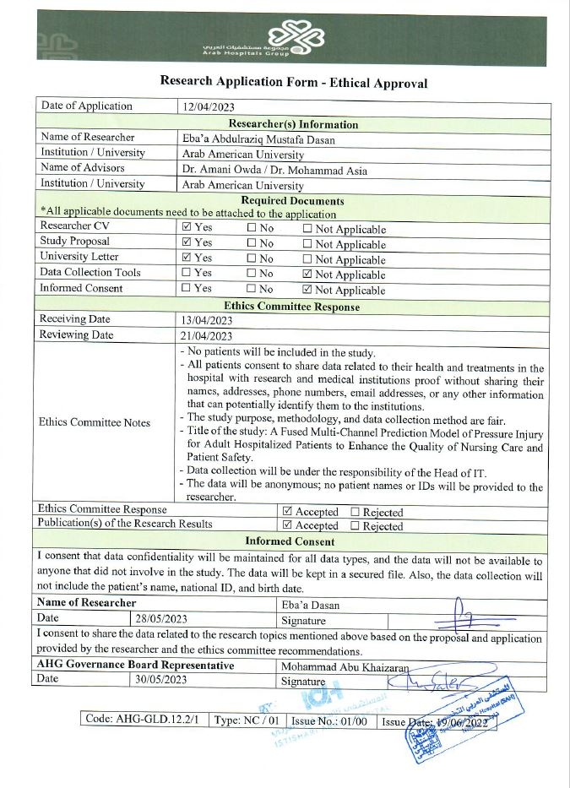

Appendix (3): IRB Approval from AAUP
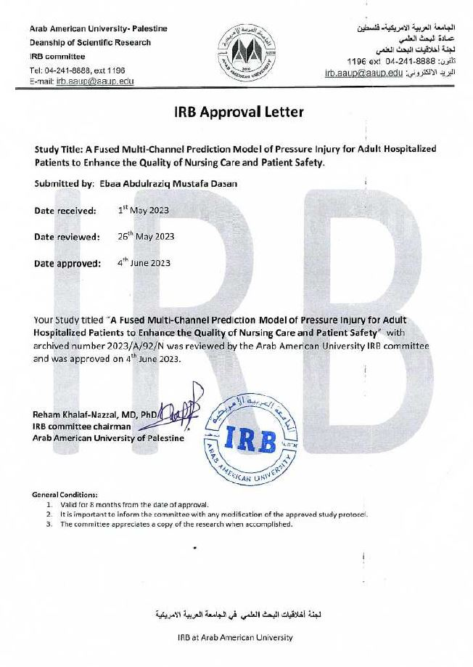

الملخص
المقدمة: تتزايد إصابات التقرحات الناجمة عن الضغط في جميع أنحاء العالم، ولم يكن هناك تحسن كبير في الوقاية منها. تُستخدم أدوات تقييم المخاطر التقليدية على نطاق واسع لتحديد المرضى المعرضين لخطر الإصابة بالتقرحات الناجمة عن الضغط. ومع ذلك، تفشل هذه الأدوات في تحديد عوامل الخطر للإصابة بالتقرحات الناجمة عن الضغط. تهدف هذه الدراسة إلى بناء نماذج تنبؤية متعددة القنوات مدمجة لإصابات التقرحات الناجمة عن الضغط لدى المرضى البالغين المنومين في المستشفى باستخدام خوارزميات التعلم الآلي.
المنهجية: تم استخدام منهجية البحث العلمي الكمي متعدد المراحل بنوعيه دراسة الحالات والشواهد والمنهج التجريبي لبناء نماذج تنبؤية متعددة القنوات مدمجة لإصابات التقرحات الناجمة عن الضغط باستخدام خوارزميات التعلم الآلي. تم جمع البيانات وفي الفترة بين آذار/ 2022 وآب/ 2023، من السجلات الطبية للمرضى من ثلاثة مستشفيات خاصة في فلسطين للمرضى الذين تم إدخالهم إلى المستشفيات ولم يكن لديهم تقرحات ناجمة عن الضغط في يوم الدخول وتم فحصهم عند الدخول بواسطة مقياس (Braden). حيث كان عدد سجلات المرضى (49,500)، تم استخدام مجموعة بيانات متوازنة مع إجمالي عدد (1,110) سجل طبي لمرضى )80% لتدريب الخوارزميات و20% للتقييم). تم تطوير أربع نماذج واستخدام ثماني خوارزميات للتعلم الآلي في كل نموذج، والتحقق من صحتها من خلال تقنية التحقق المتقاطع من خمس طبقات، وتقييم النماذج من خلال مقاييس الأداء.
النتائج: تتكون مجموعة بيانات المتوازنة من 1,110 مريضاً، شملت كل المرضى اللذين لديهم إصابات التقرحات الناجمة عن الضغط المكتسبة من المستشفى وعددهم (555 مريضاً) وعينة عشوائية من المرضى الذين لا يعانون من إصابات الضغط المكتسبة من المستشفى وعددهم (555 مريضاً). أظهرت مقاييس الأداء من النماذج الأربعة بين جميع الخوارزميات أداءً ممتازاً. وكما تبين أن أفضل نموذج هو الغابة العشوائية (Random Forest)، حيث كانت صحة النتائج: (0.962(، الدقة: (0.942(، الاستدعاء: (0.922(، درجة المتوسط التوافقي للدقة والاستراجع (0.093)، المساحة تحت المنحنى (0.922(، معدل النتائج الايجابية الخاطئة (0.155(، معدل النتائج الايجابية الخاطئة (0.782(. أخيراً، كانت المتغيرات التنبؤية هي عمر المريض، ورطوبة الجلد، ونشاط المريض، ومدة الإقامة، وضغط الدم، وفحص الألبومين.
الخاتمة: تم تطوير نماذج تنبؤ جديدة متعددة القنوات لإصابات التقرحات الناجمة عن الضغط من مجموعات بيانات مختلفة واعتمدت على البيانات الموجودة في السجلات الطبية، مما يساعد التمريض على تحديد المرضى الذين لديهم خطر الإصابة للتقرحات الناجمة عن بالضغط في وقت مبكر، مما يساهم في تحسين رضا المريض الذي يؤثر على جودة الرعاية التمريضية، وتعزيز سلامة المرضى. علاوة على ذلك، وجدت هذه الدراسة أن بعض العوامل التنبؤية في النماذج المطورة للتنبؤ بإصابات التقرحات الناجمة الضغط لم تكن مدرجة في الأدوات التقليدية لتقييم إصابات التقرحات الناجمة عن الضغط، مثل العمر، ومدة الإقامة، وضغط الدم، وفحص الألبومين.

الكلمات المفتاحية: إصابة التقرحات الناجمة عن الضغط، نموذج التنبؤ، الرعاية التمريضية، التعلم الآلي، سلامة المرضى، جودة الرعاية.

